**Information Retrieval System**

**Sample Questions**

**MOD1****MOD3****MOD5**

**MOD2****MOD4****MOD6**

#### Module 1:

**1. What is an information system? What are the components of an information system? What are the types of information systems?**

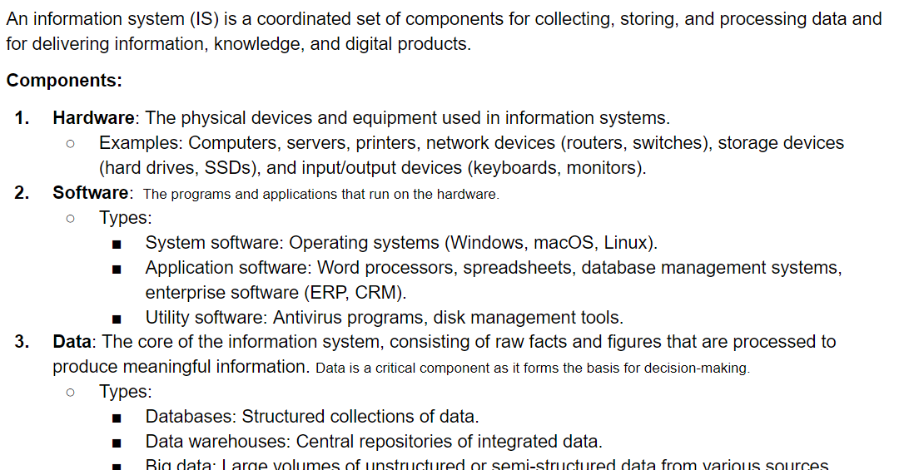

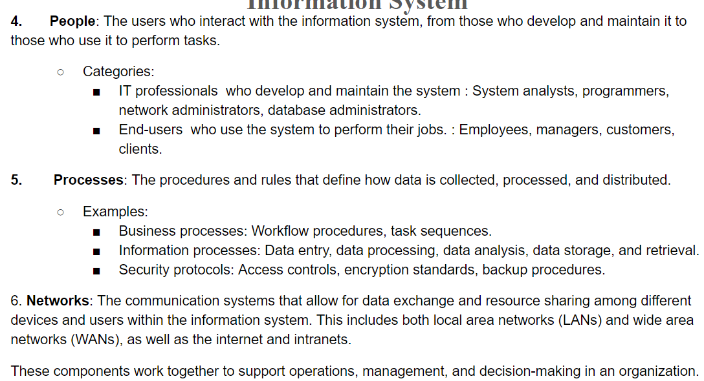

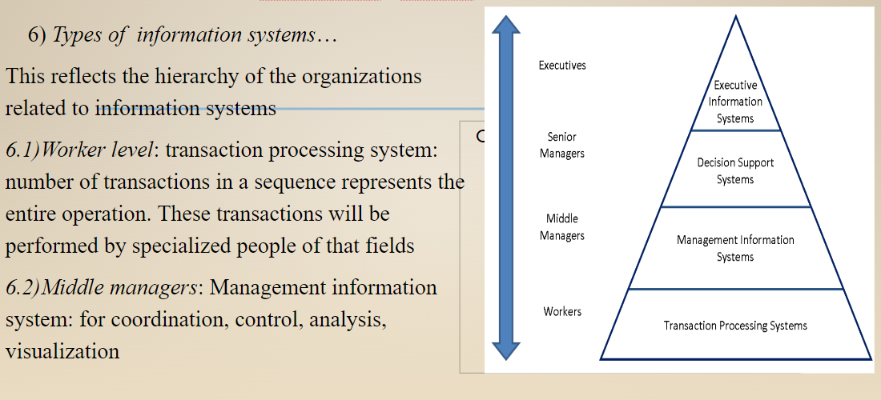

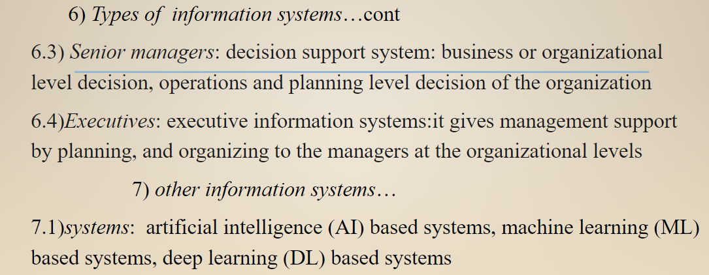

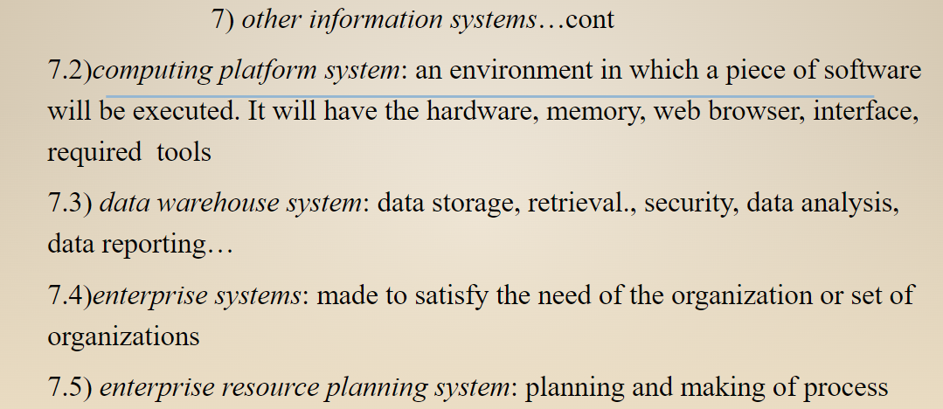

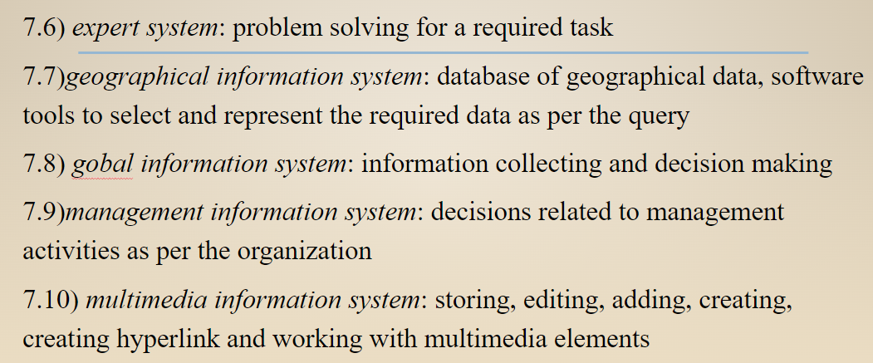

**2. What is Information retrieval? What are the key components of information retrieval?**

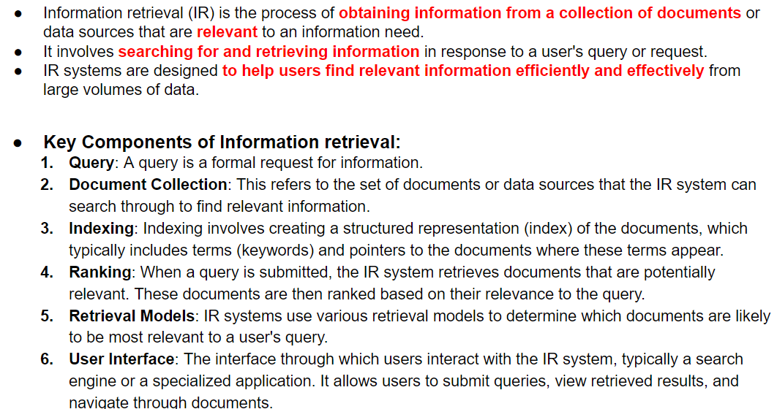

**3. State and explain the metrics used for evaluating the performance of the IR system. (GPT ans)**

Evaluating the performance of an Information Retrieval (IR) system is critical to understanding its effectiveness in retrieving relevant information. Several metrics are commonly used to assess how well an IR system performs. These metrics primarily focus on relevance, efficiency, and user satisfaction. Here are the key metrics:

**1. Precision**

Precision is a measure of the accuracy of the retrieval process. It is defined as the proportion of retrieved documents that are relevant to the user's query. Mathematically, it is expressed as:



* **High Precision**: Indicates that most of the documents retrieved by the system are relevant, making it a crucial metric when the focus is on the quality of results rather than quantity.
* **Example**: If a search retrieves 10 documents, and 8 of them are relevant, the precision is 0.8 or 80%.

**2. Recall**

Recall measures the ability of the IR system to retrieve all relevant documents from the entire collection. It is defined as the proportion of relevant documents retrieved out of all relevant documents available in the collection:

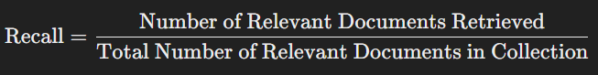

* **High Recall**: Indicates that the system has retrieved most of the relevant documents, making it essential in situations where missing relevant information is critical.
* **Example**: If there are 20 relevant documents in the collection and the system retrieves 15, the recall is 0.75 or 75%.

**3. F-Measure (F1 Score)**

The F-Measure or F1 Score is the harmonic mean of precision and recall, providing a single metric that balances both. It is particularly useful when there is a need to balance precision and recall:

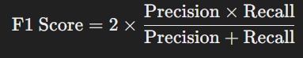

**High F1 Score**: Indicates a good balance between precision and recall, making it a useful metric when both are equally important.

**Example**: If precision is 0.8 and recall is 0.6, the F1 score would be 0.6857 or 68.57%.

**4. Mean Average Precision (MAP)**

Mean Average Precision (MAP) is used to evaluate the precision of an IR system across multiple queries. It is the average of the precision values calculated at each relevant document retrieved, averaged across all queries:

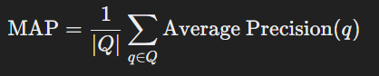

* **High MAP**: Indicates that the system consistently retrieves relevant documents at the top of the result list across various queries.
* **Example**: MAP is especially useful in comparing different IR systems or algorithms on a benchmark dataset.

**5. Mean Reciprocal Rank (MRR)**

Mean Reciprocal Rank (MRR) measures the rank of the first relevant document in the search results. It is the average of the reciprocal ranks of the first relevant document across multiple queries:

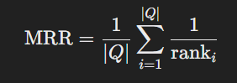

**High MRR**: Indicates that the first relevant document is usually found near the top of the search results, which is crucial for user satisfaction.

**Example**: If the first relevant document is at rank 1 in most queries, the MRR will be close to 1.0.

**6. Query Throughput and Response Time**

Query Throughput refers to the number of queries an IR system can handle per unit of time, while Response Time is the average time it takes for the system to return results for a query:

* High Throughput and Low Response Time: Indicate that the system is efficient and capable of handling large volumes of queries quickly, which is essential for real-time applications like web search engines.

**4. State and explain with a diagram the steps in the information retrieval process. PYQ**

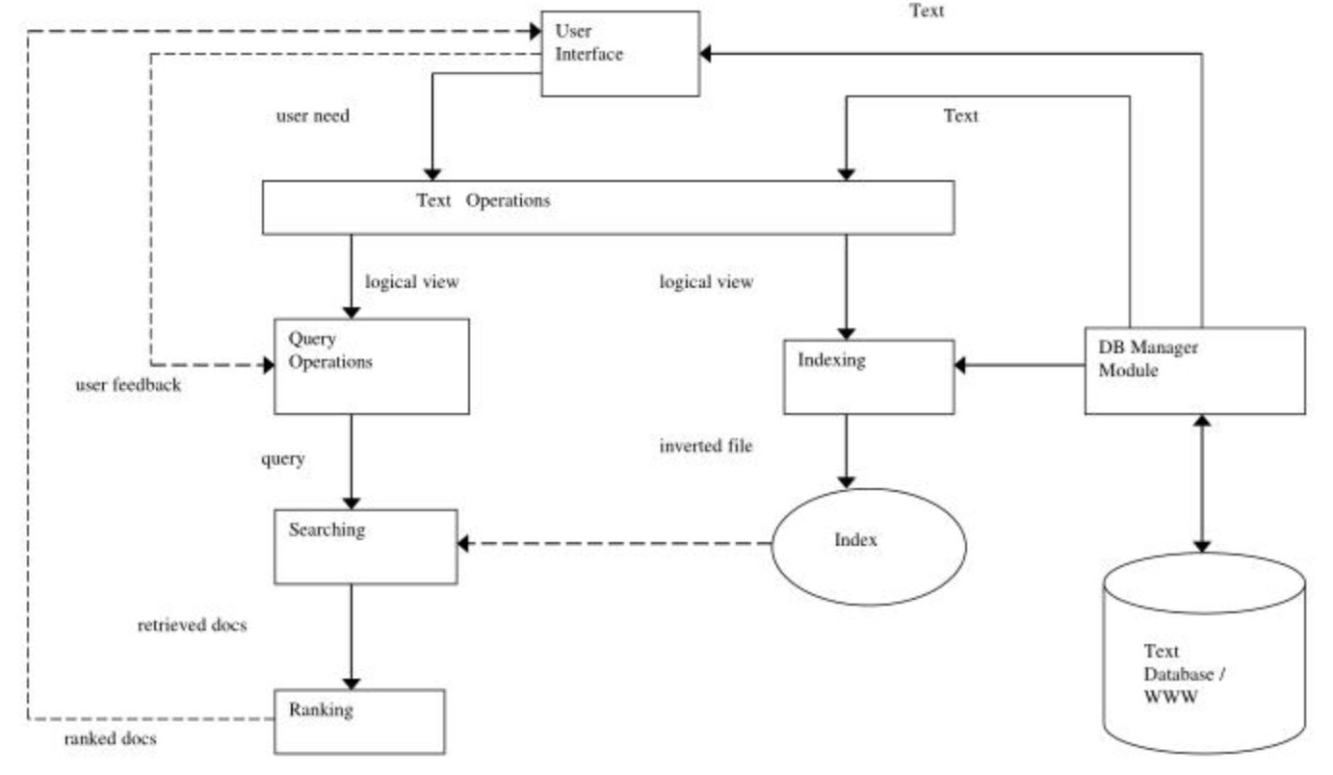

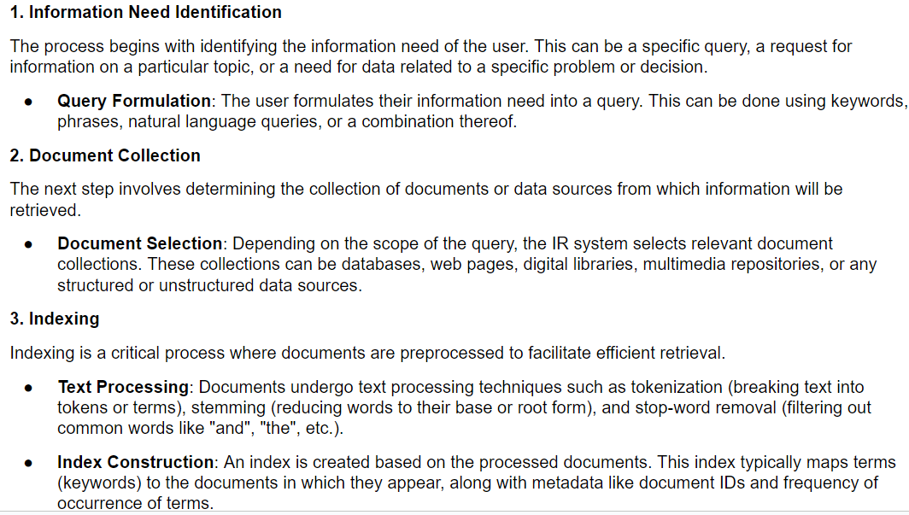

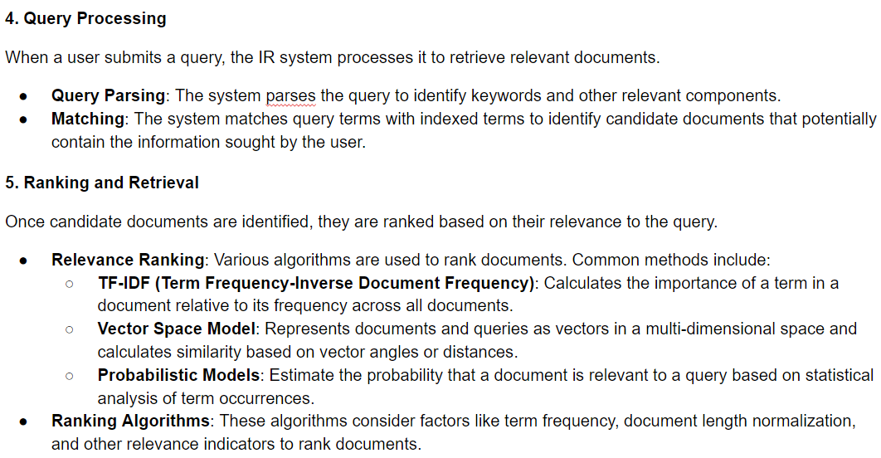

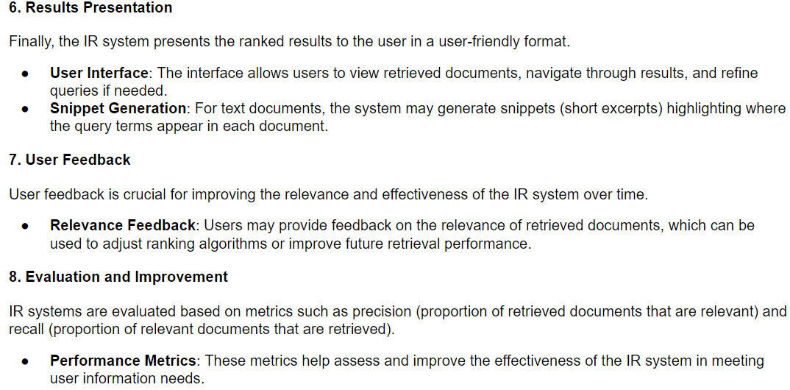

**5. What are the objectives of the IR system?**

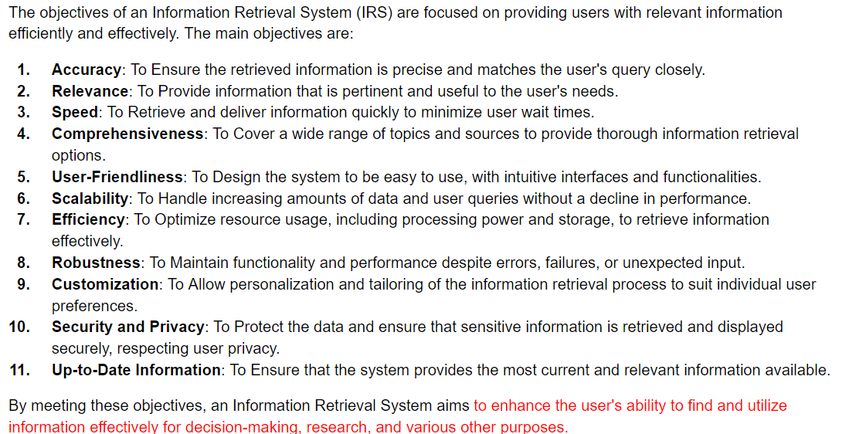

**6. Differentiate between data retrieval and information retrieval. PYQ**

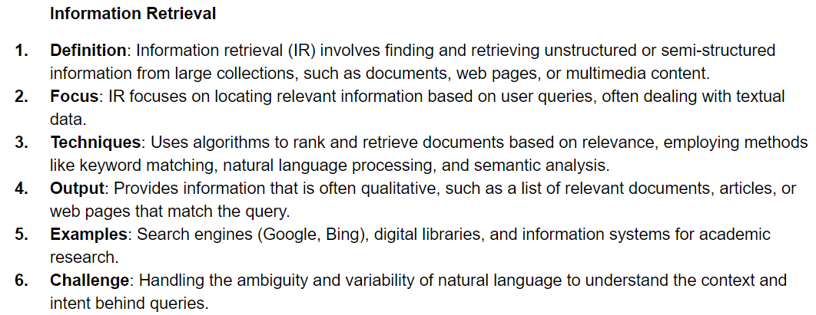

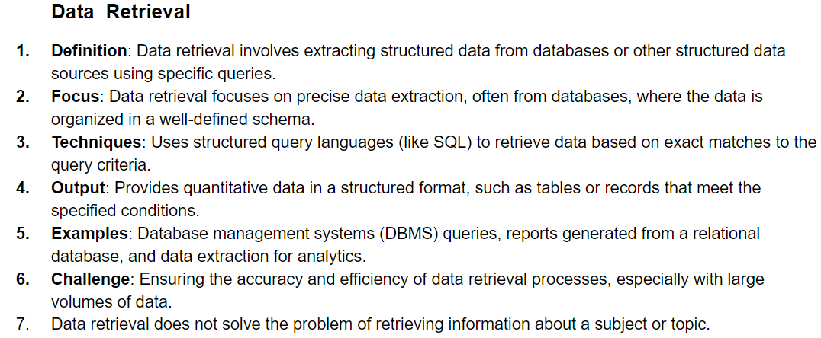

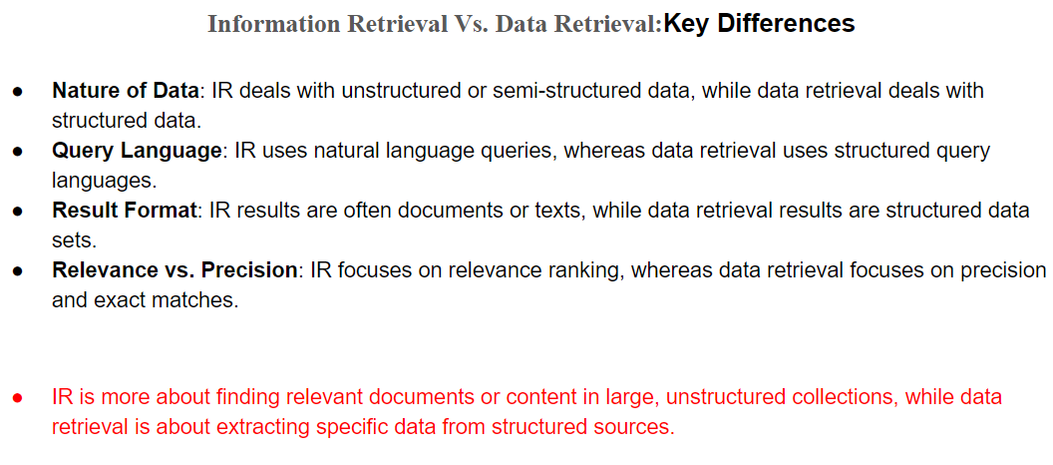

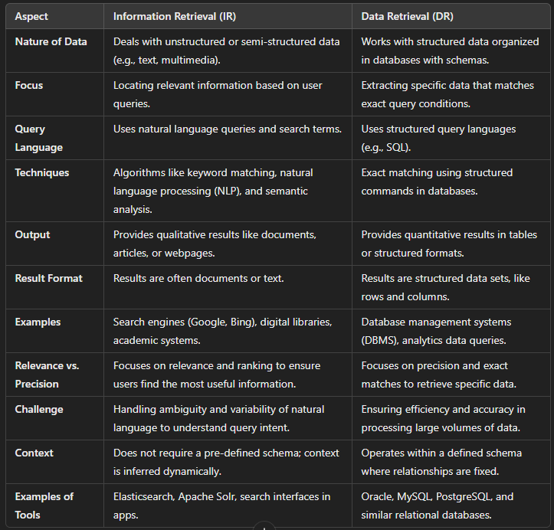

**7. State and explain the components of the search engines and browsers. PYQ ISKA PURA PROCESS OF WORKING**

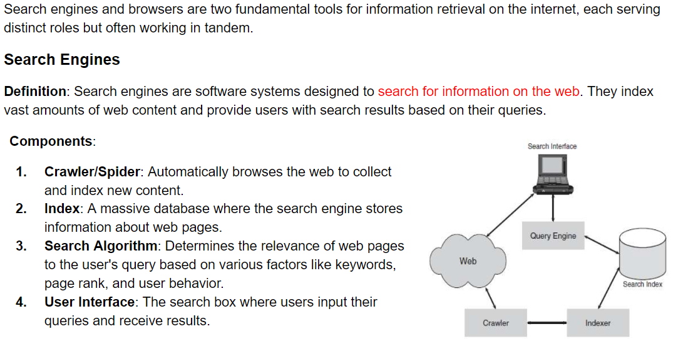

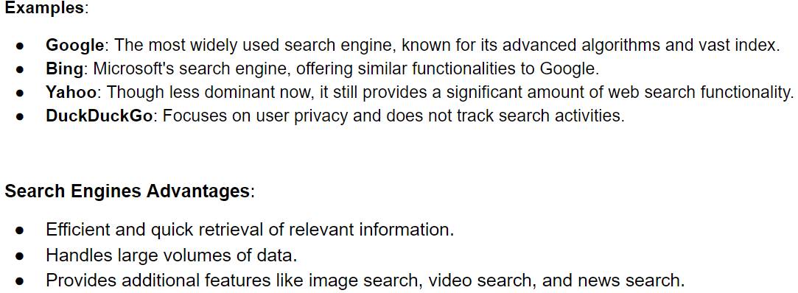

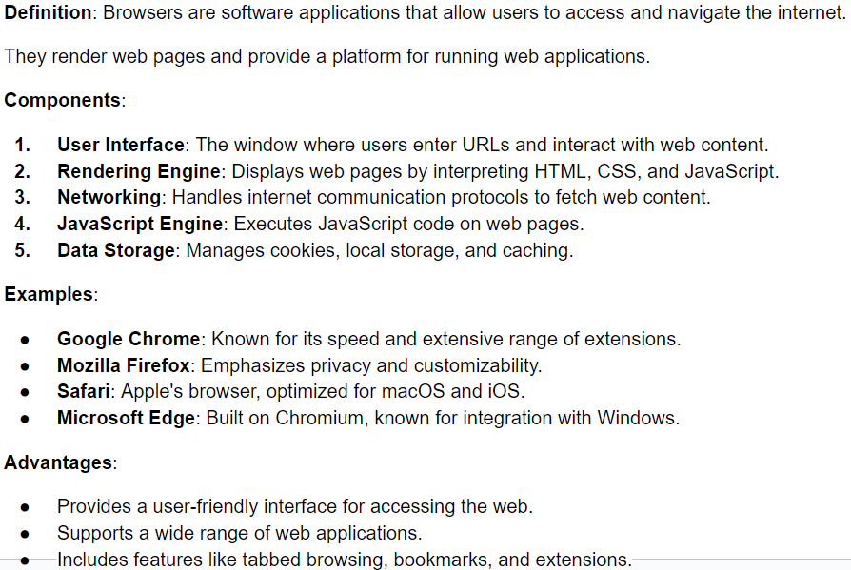

#### Module 2:

**1. Write a formal definition of the IR model.**

**2. Explain the formal characteristics of IR models. PYQ**

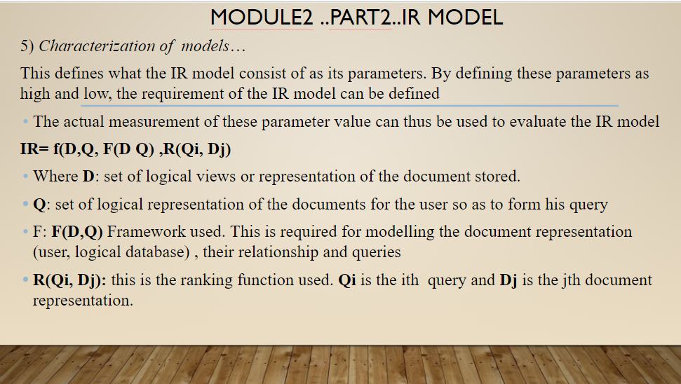

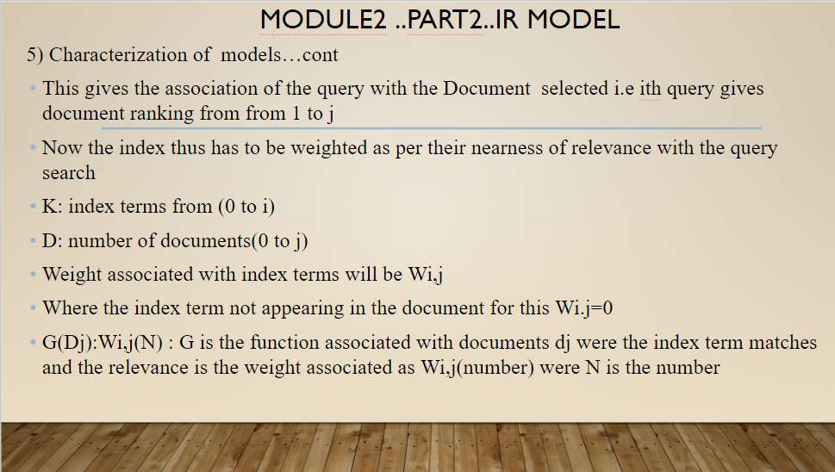

**3. Explain the taxonomy of IR models.** **PYQ**

(Apne ppt bohot scattered he iska ans)

D20B ka (kafi models ko diagram me he hi nahi)

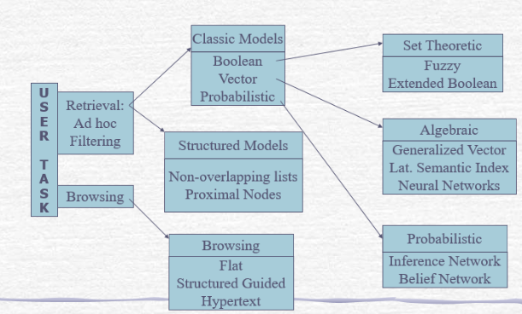

1. **Classical Models**

* Boolean Model: Represents documents and queries as sets of index words. Hence the model is set theoretic.
* Vector Space Model: Represents documents and queries as vectors in a multidimensional space. Hence the model is Algebraic.
* Probabilistic Model: The framework for modeling documents and query representation is based on probability theory. Hence the model is probabilistic.

2. **Structured Models**

* Extended Boolean Model: Enhances the Boolean model by incorporating partial matching and term weighting.
* Fuzzy Set Model: Uses fuzzy logic to handle the vagueness and ambiguity in information retrieval, allowing partial membership.

**4. Explain the working of the boolean model/vector-space model / probabilistic model /Extended boolean model / fuzzy set model with an example**

**Boolean classic model:**

a) simplest model and based on set theory and Boolean algebra.

b) It requires exact matching of documents thus only a few documents are retrieved.

c) non binary weighting of index terms not present as weights are only binary (1:document selected, 0: not selected)

d) no ranking of documents possible

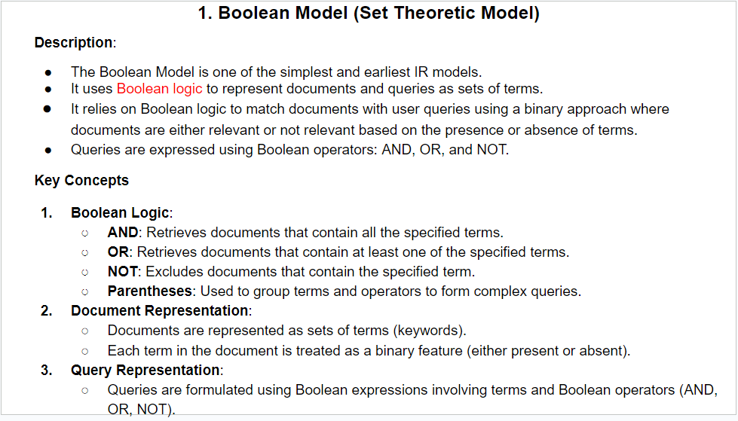

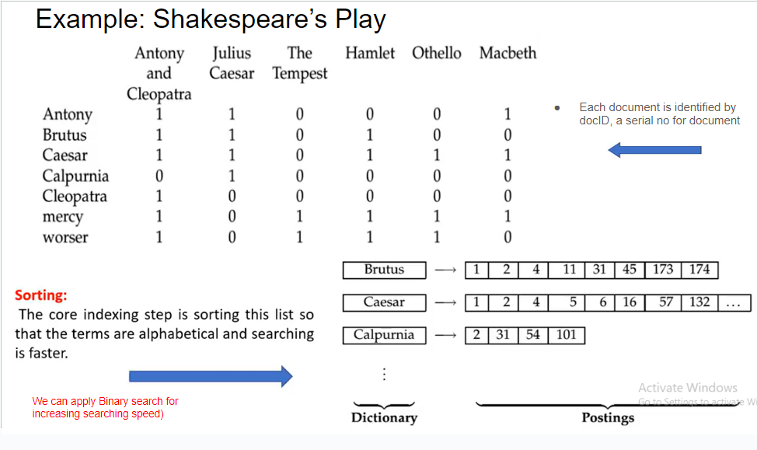

Vector Space Model

Vector model:

a) partial matching also possible,

b) no binary weights assigned to index terms, this weighting scheme improves the performance,

c) partial matching strategy allows retrieval of documents by approximating the query conditions

d) the cosine ranking formula sorts the documents according to their degree of similarity to the query

e) As the weights assigned to indexing are only numerical they are non-sementic thus are not dependent i.e if 6 is related to query that doesnot mean that 7 is also related. It works on rang i.e from 0 to 6 . This forms one set.

f) To improve the performance either the query has to be modified or the feedback system has to be provided to the user

g) but still this model being more fast , simple and superior is mostly preferred

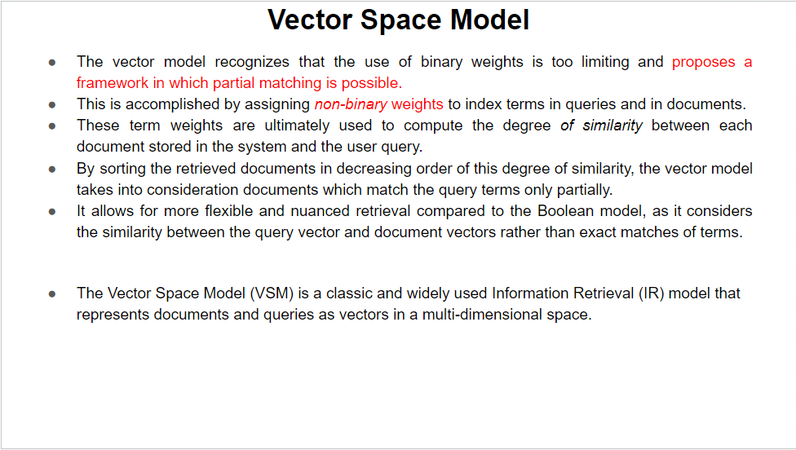

**probabilistic model**

a) Probability is almost like guessing as relevant and irrelevant and then forming two sets as the relevant and the nonrelevant sets

b) As it doesnot consider the frequency of relevance or non relevance of document so every time it has to go from the same cycle as it does not have memory information for self learning

c) The index terms are independent of each other after the indexed are weighted

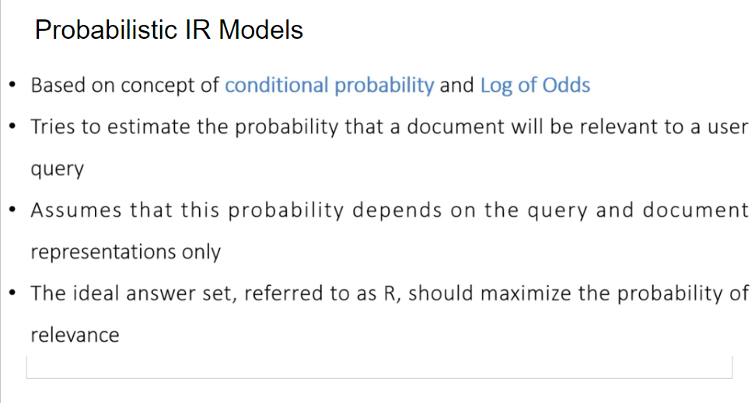

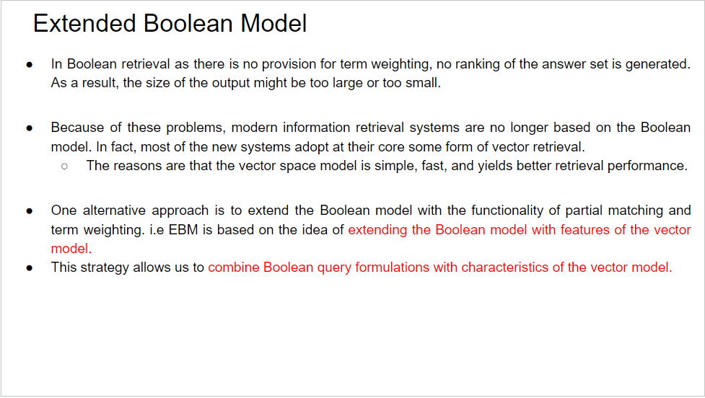

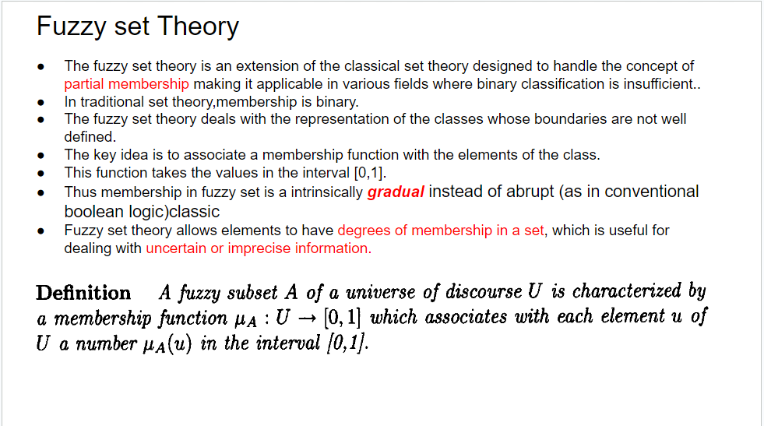

5. State Advantages and disadvantages of each type of model.

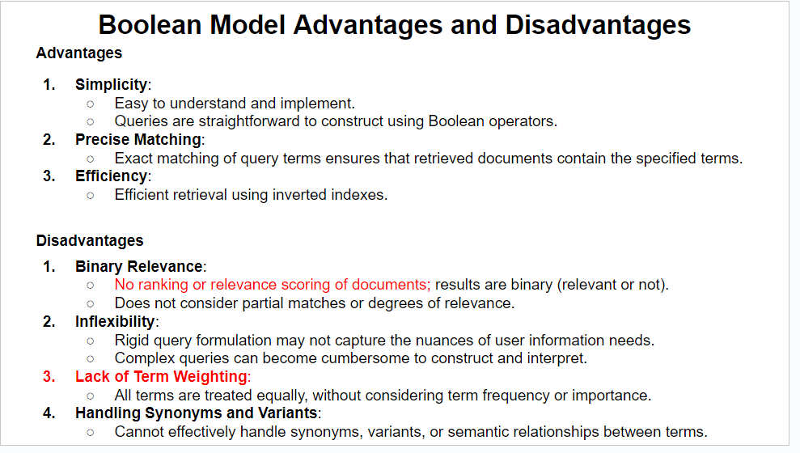

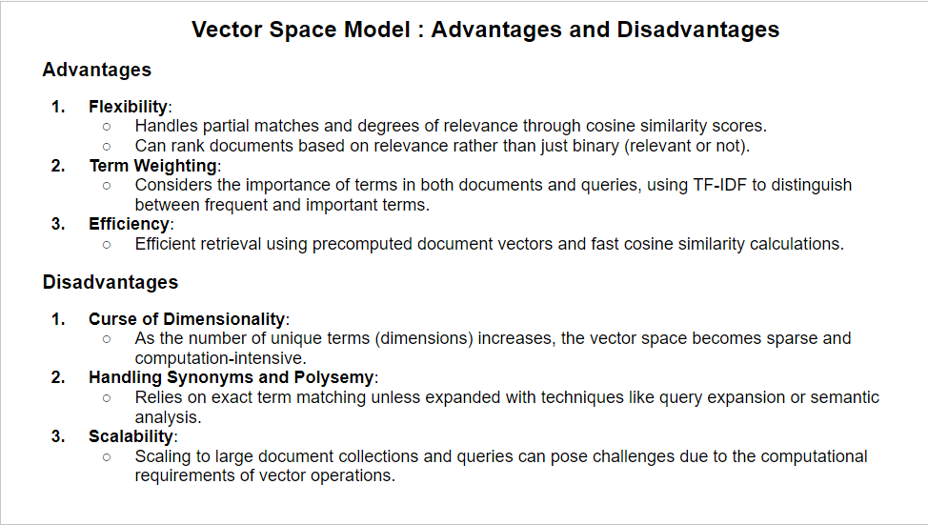

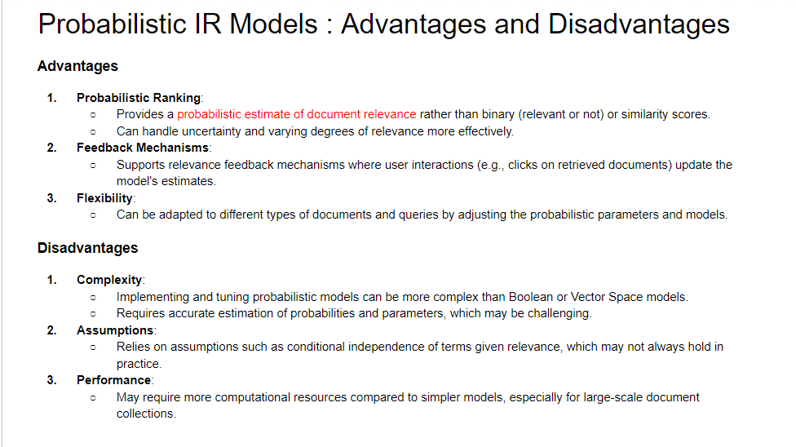

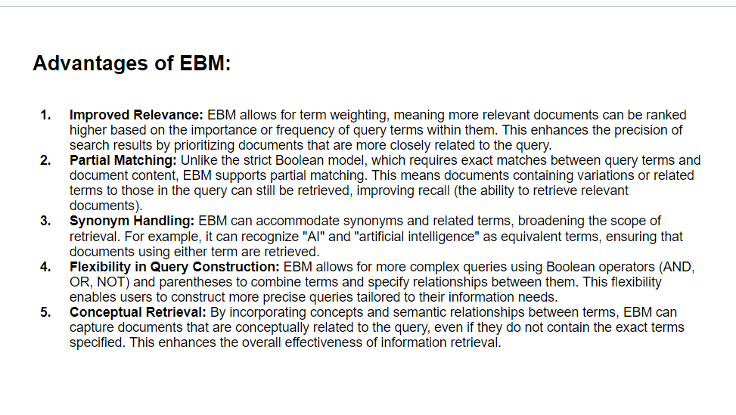

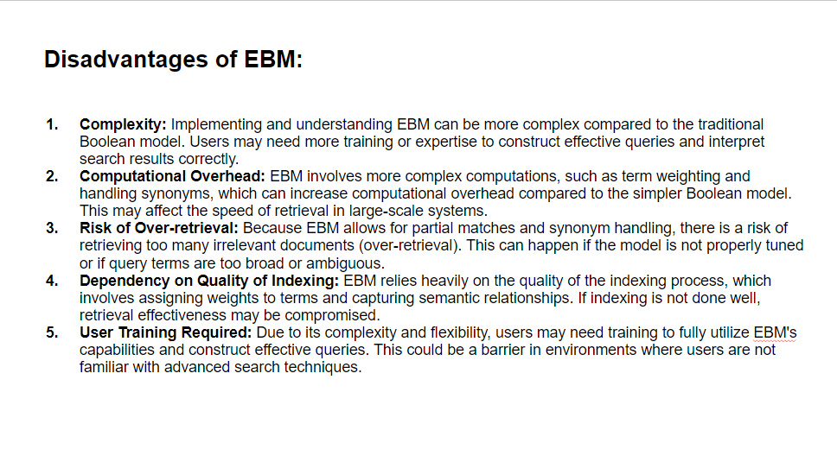

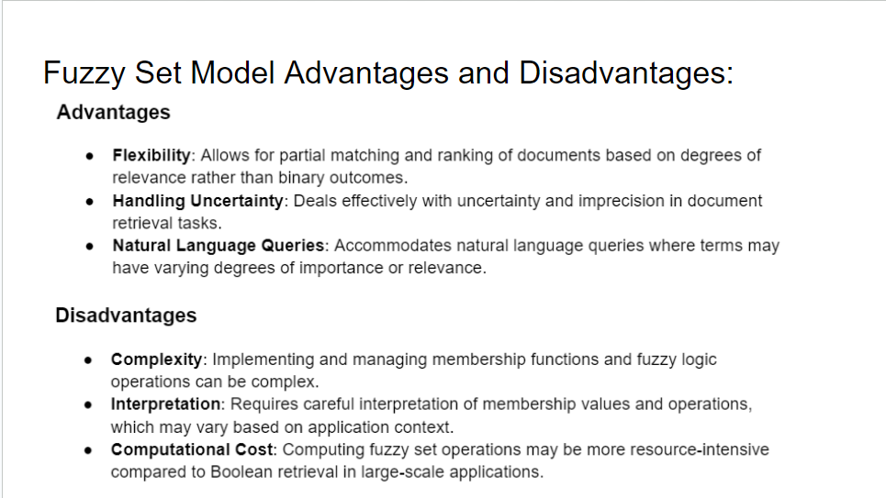

**6. What are the different approaches for ranking the documents? State the advantages and disadvantages of each approach.**

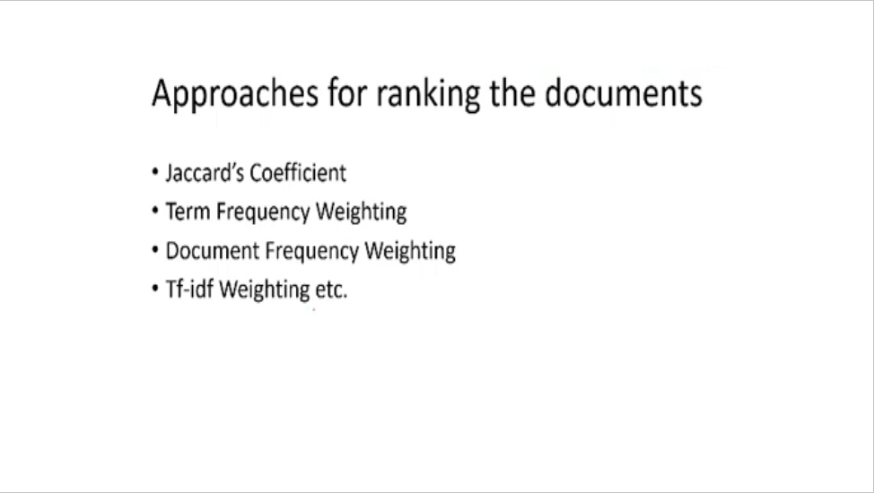

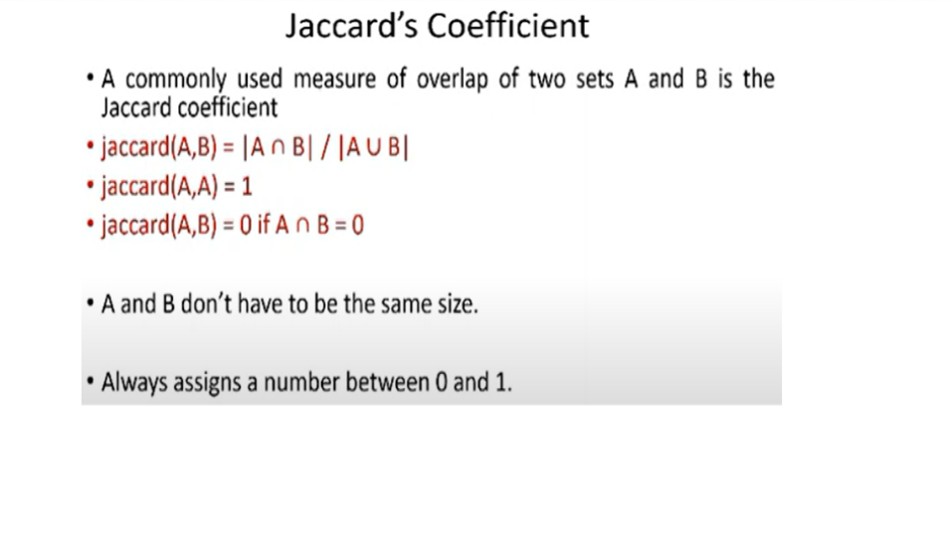

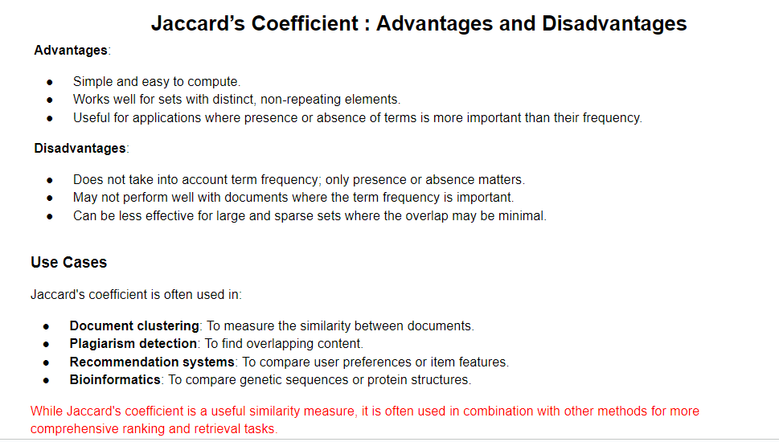

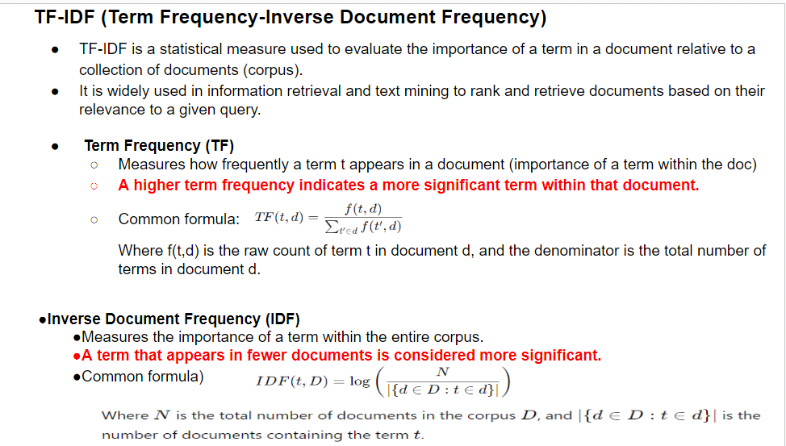

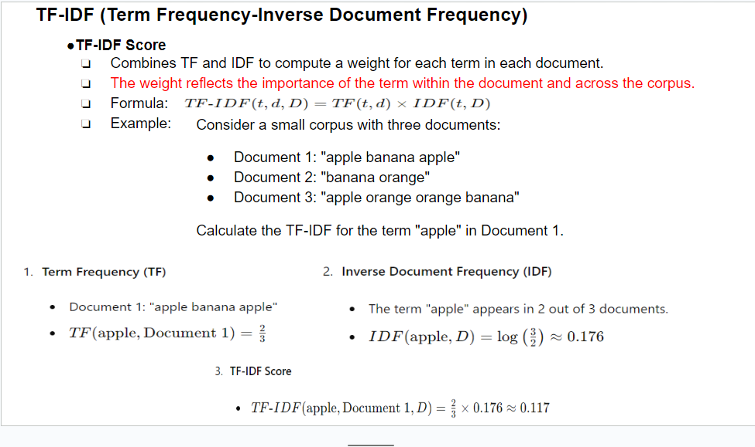

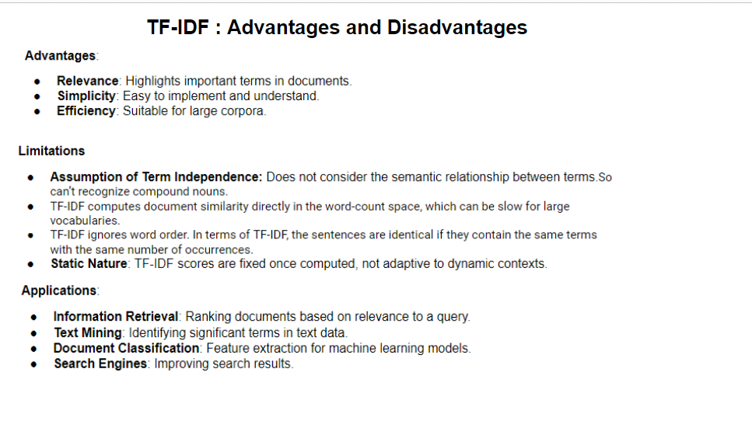

7. How do we calculate cosine similarity between query vector and document vector?

**8. Explain the different types of browsing.**

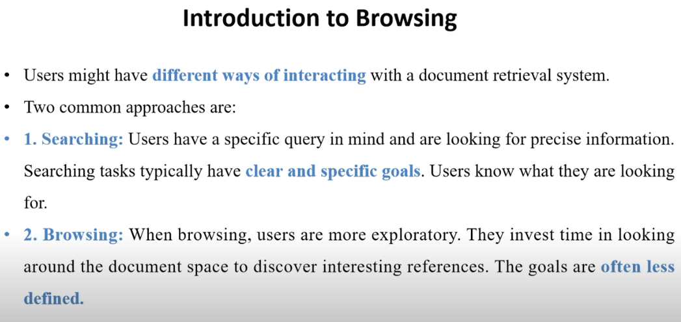

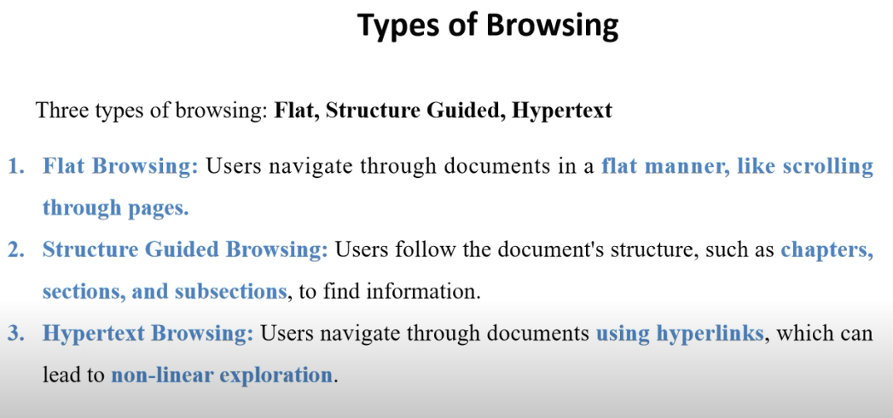

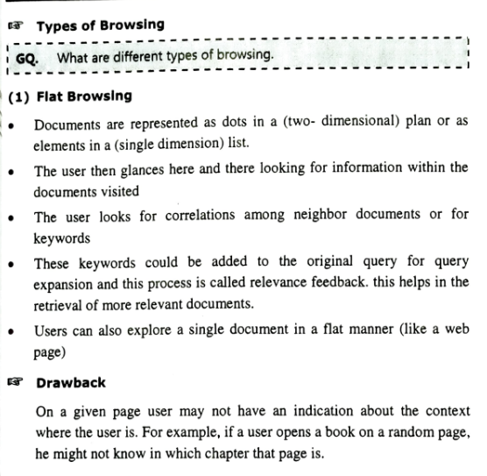

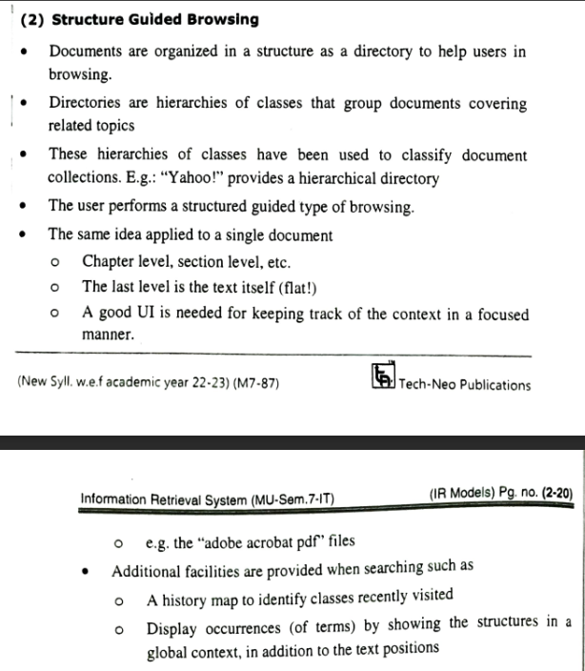

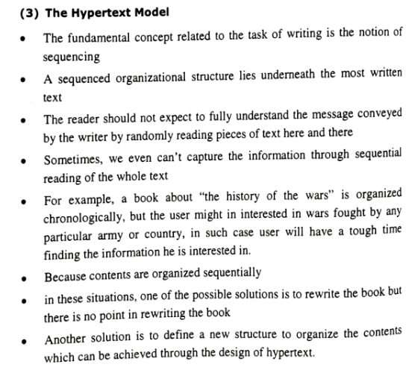

**9. Compare the boolean and extended boolean models.**

**10. Explain a structured retrieval model based on non-overlapping lists.**

**Ye topic meine pure class ko explain kara tha lol -ajinkya**

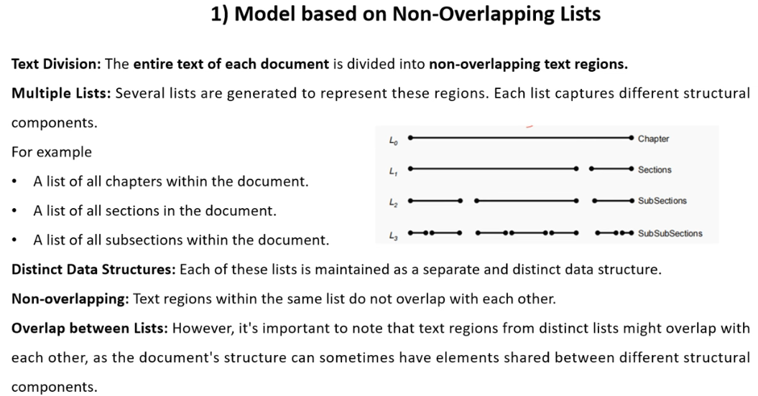

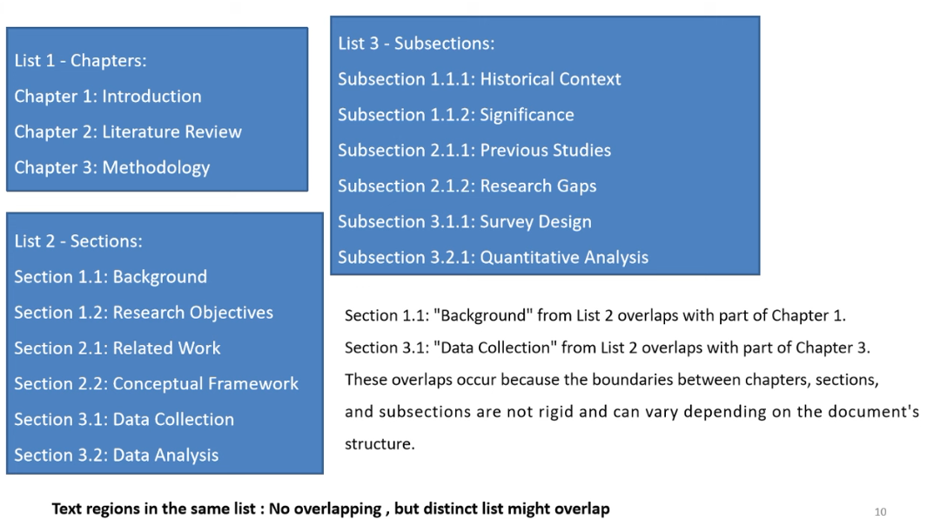

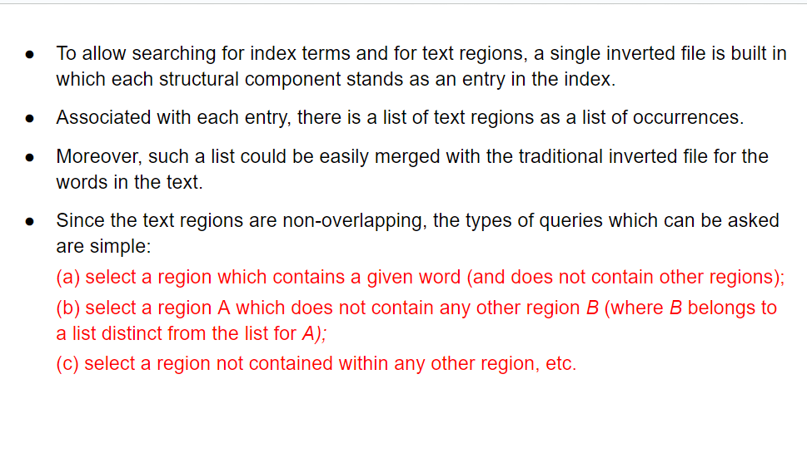

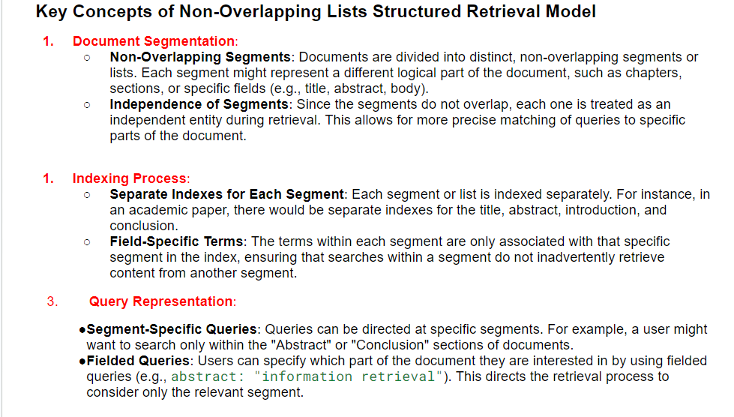

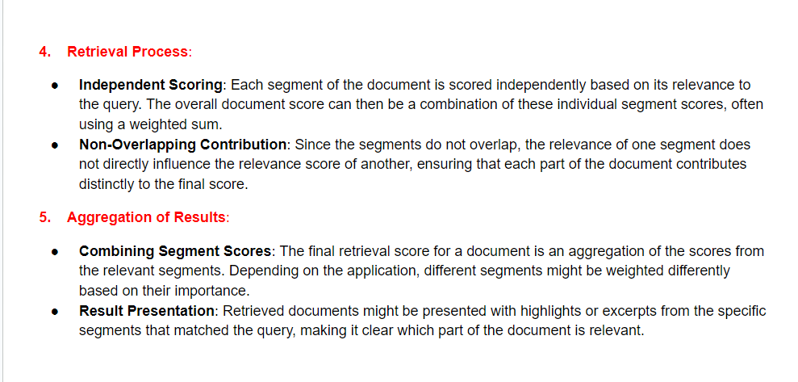

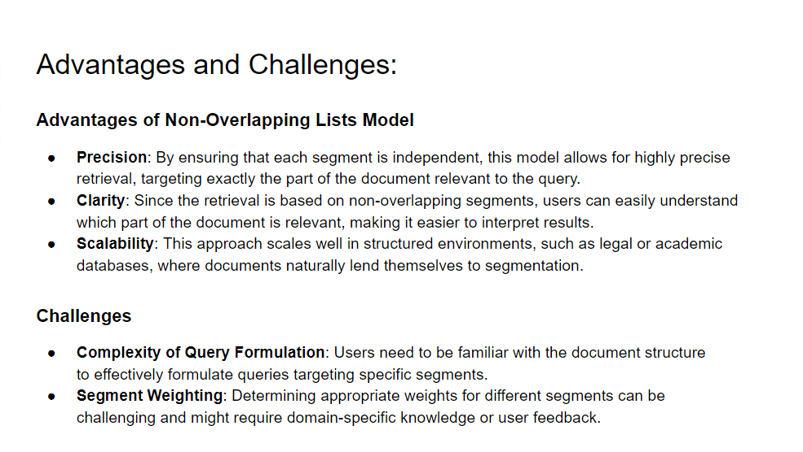

**11. Explain the structured retrieval model based on proximal nodes.**

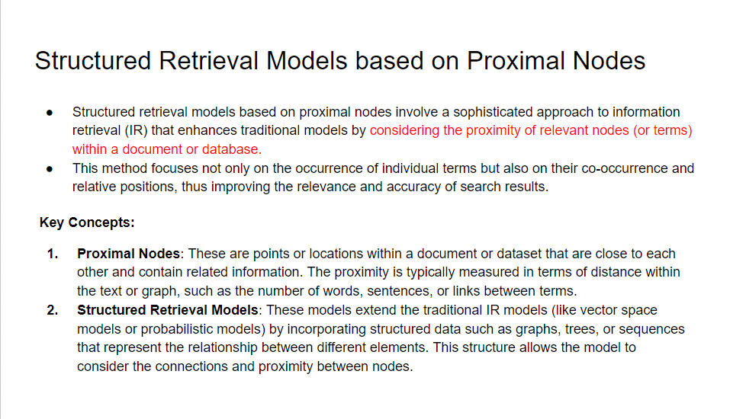

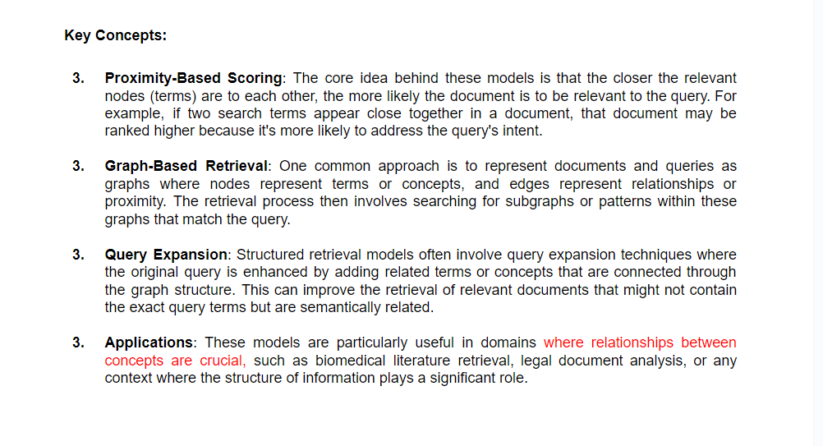

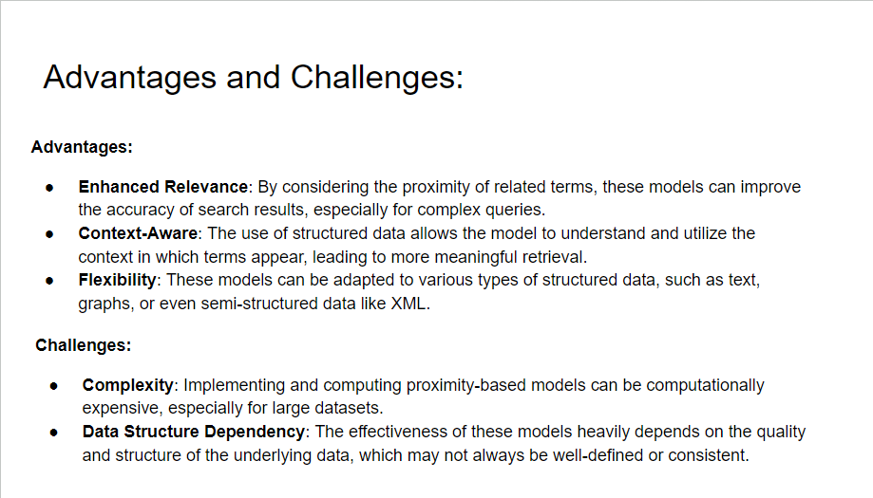

#### Module 3:

**1. Explain the types of keyword-based queries PYQ**

**Single word query**

The models dealing with such types of queries give the user the document view such that it suites form single word query

Single word = alphabets + separators.

now the separators are ignored for companion

Some characters connecting the letters are also kept as get-in,

The document is also represented as a word set by the model and further divided into letters and separators

For ranking two factors are used

Frequency: number of times the word occurs in the document

Inverse frequency: number of documents having the word

Limitation

A single-word query cannot completely define the meaning of the query, thus the context of search may not be perfect

Specific character matching may not be possible as even though they are different

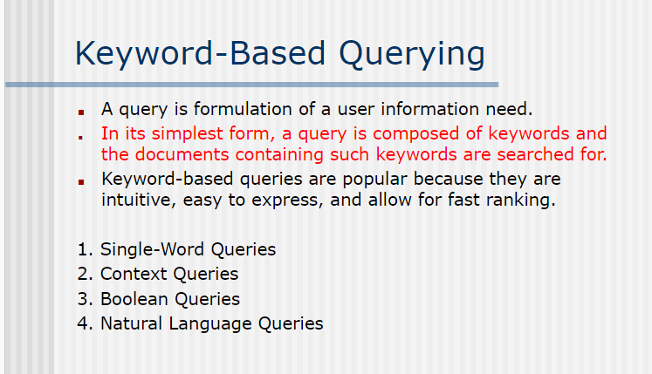

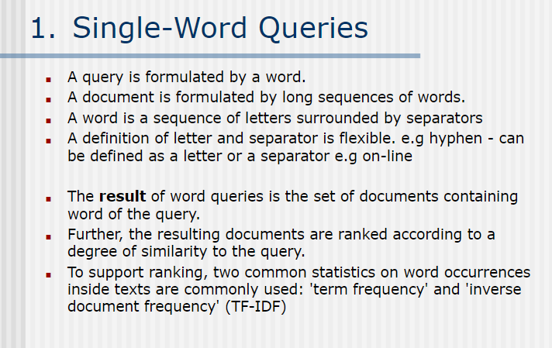

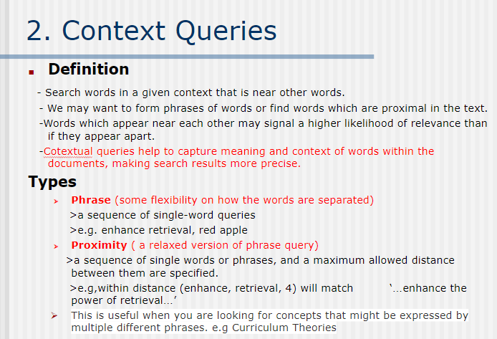

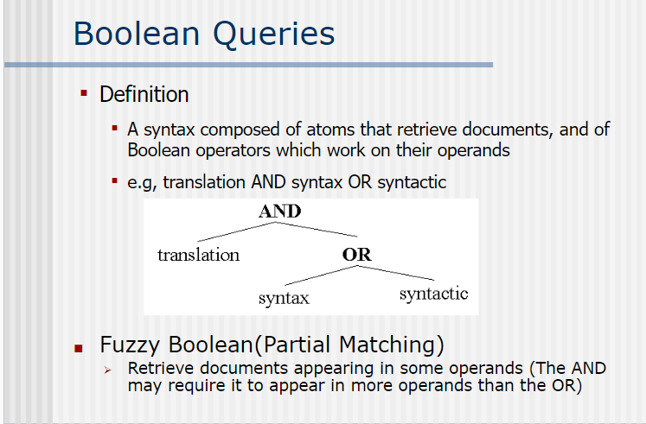

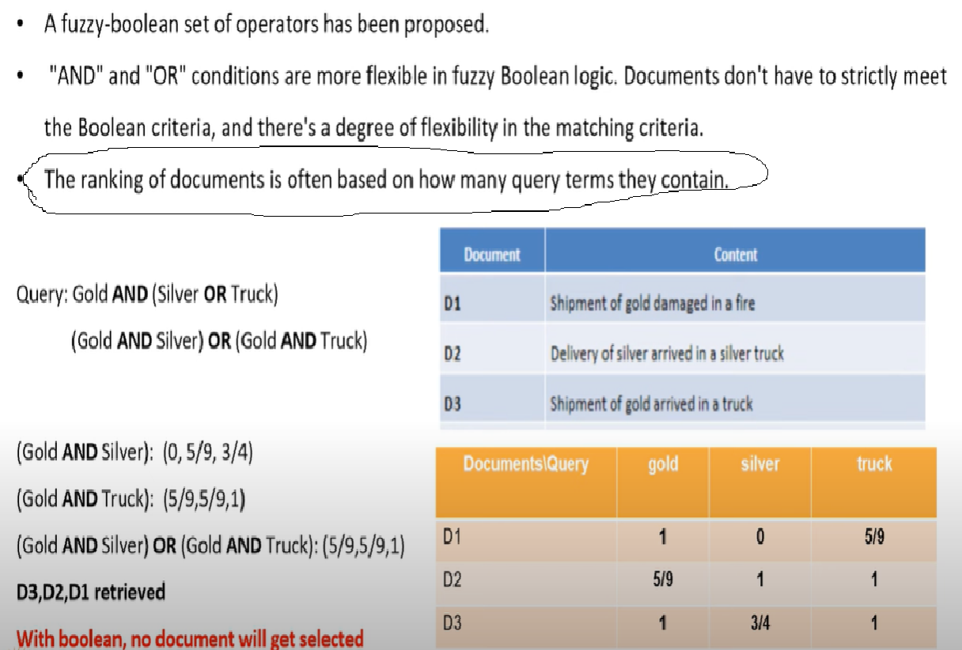

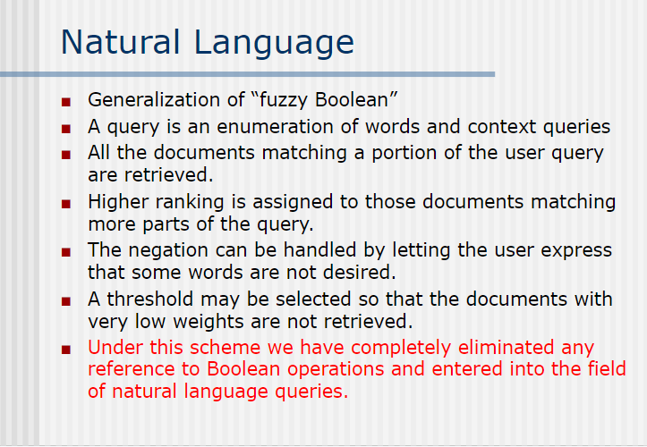

**2. Explain the various types of patterns in IR. PYQ**

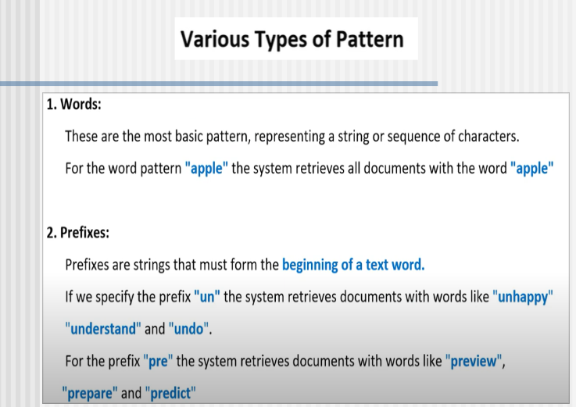

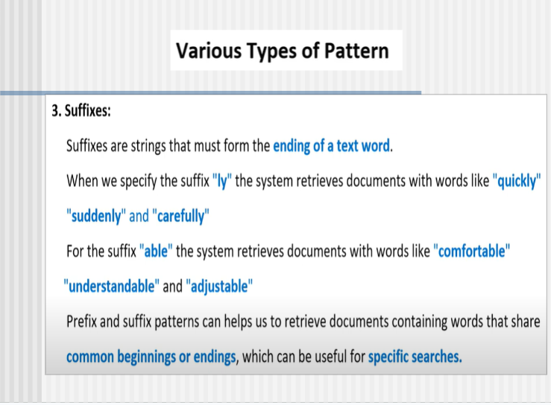

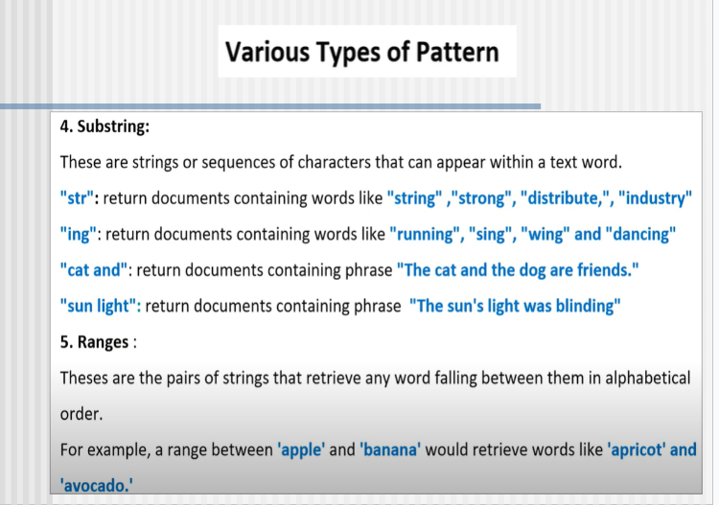

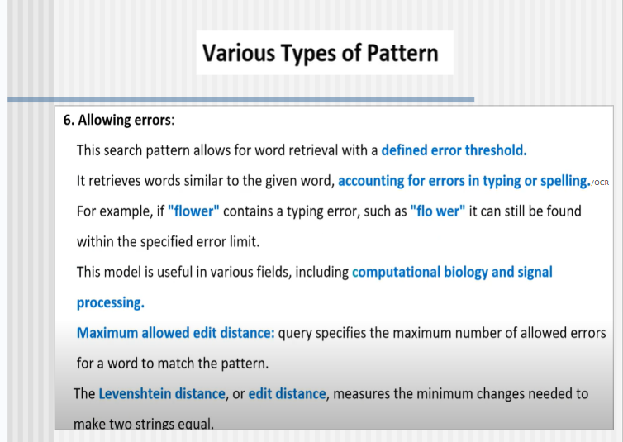

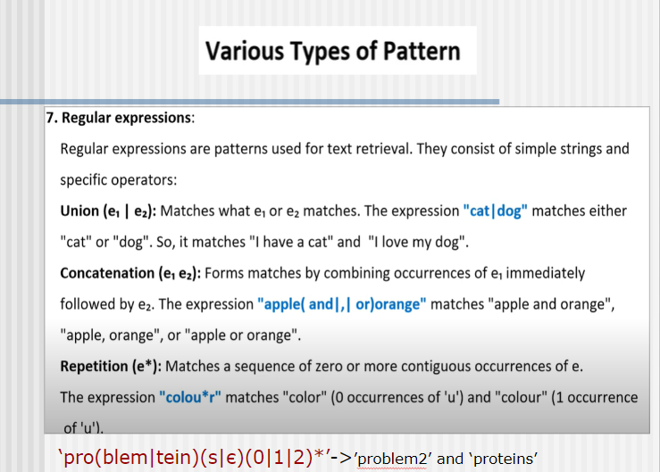

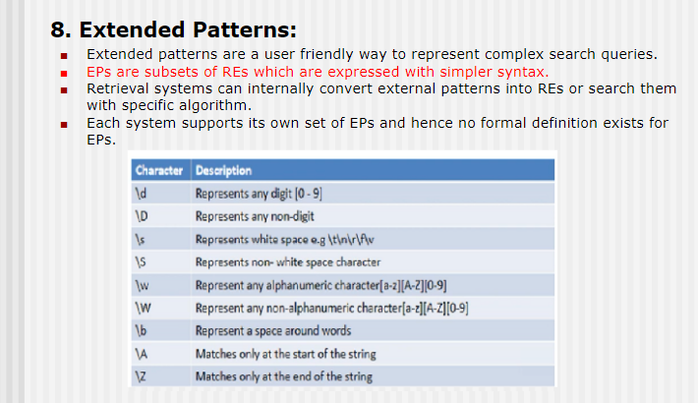

**3. Explain the three types of structures in structural queries.**

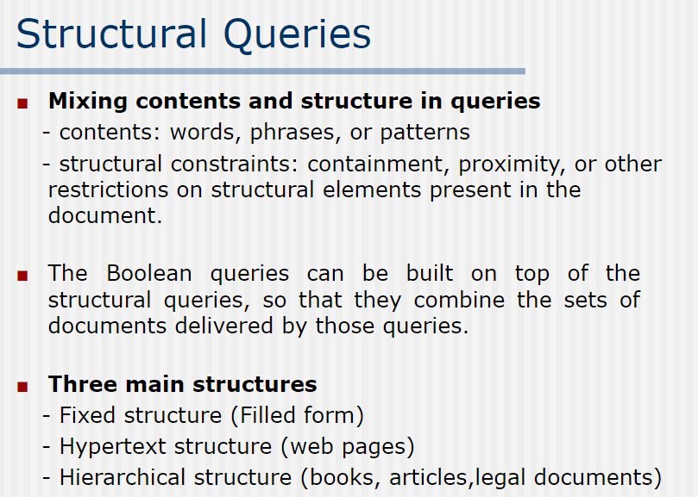

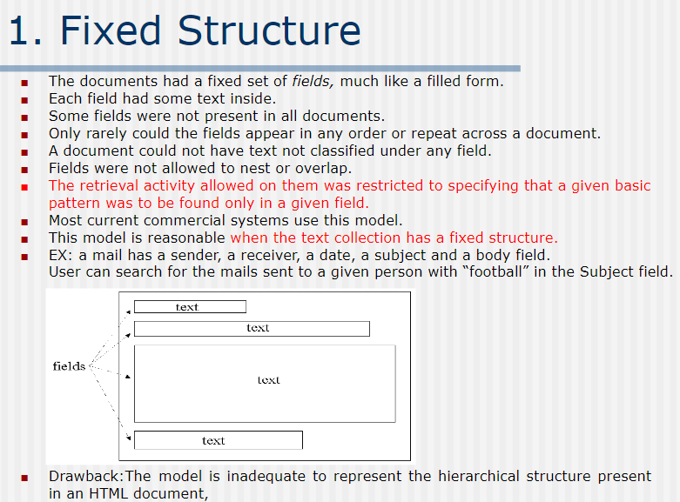

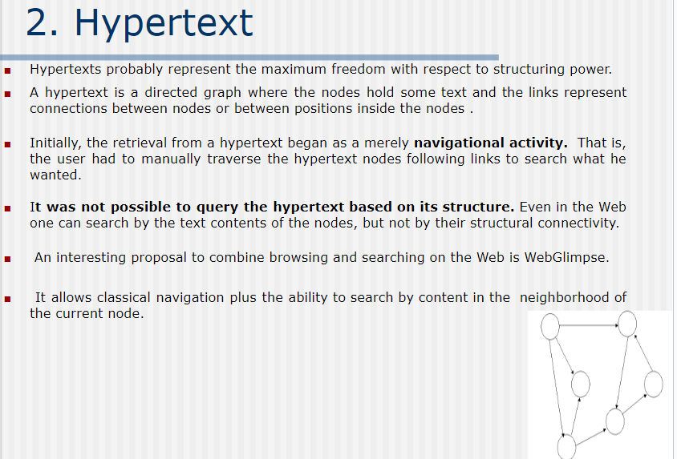

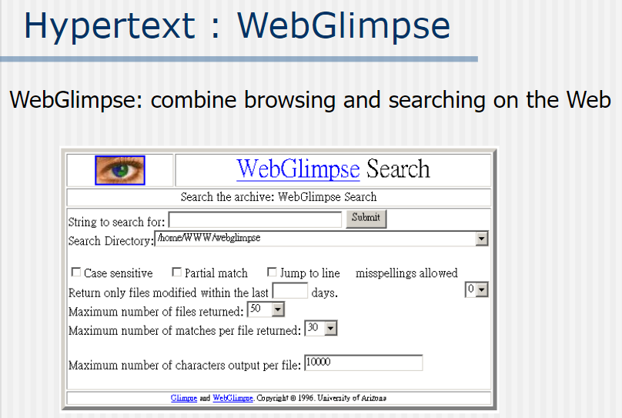

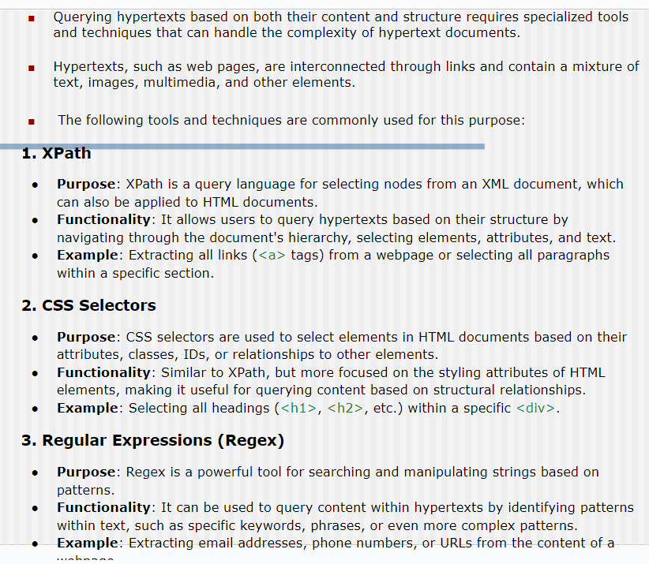

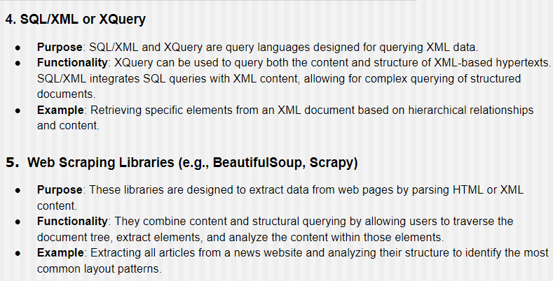

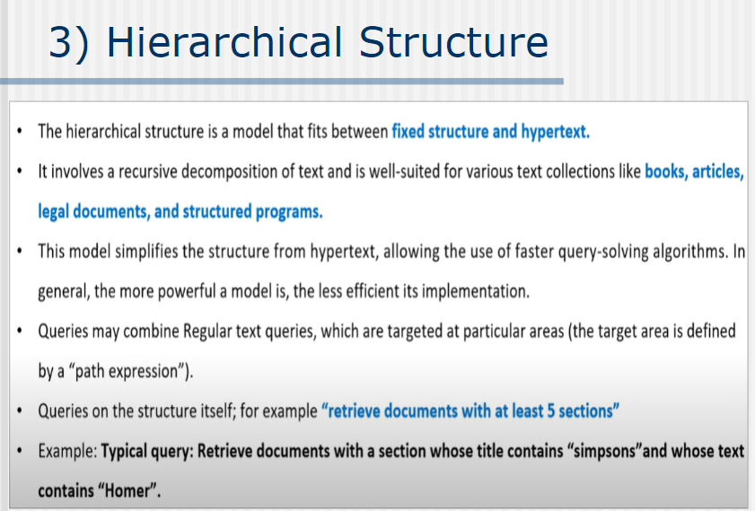

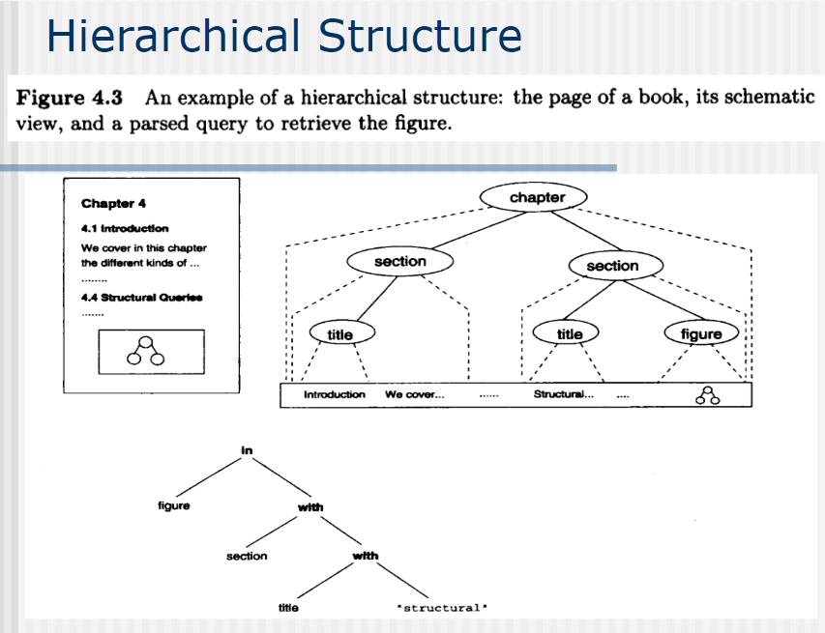

**4. Explain the different samples of hierarchical models.**

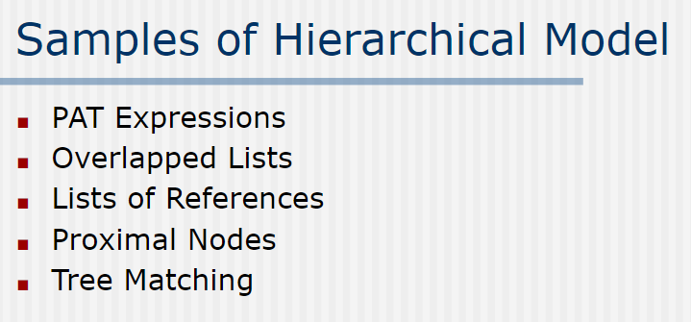

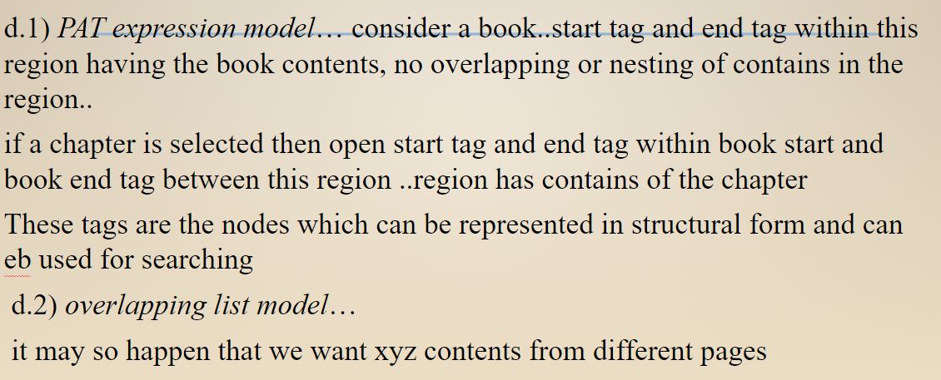

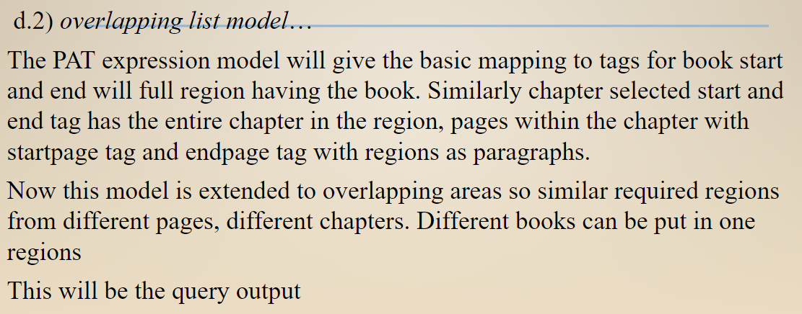

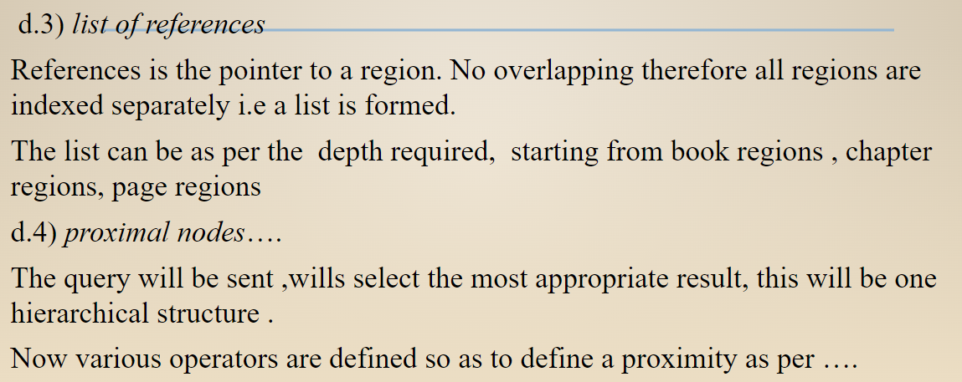

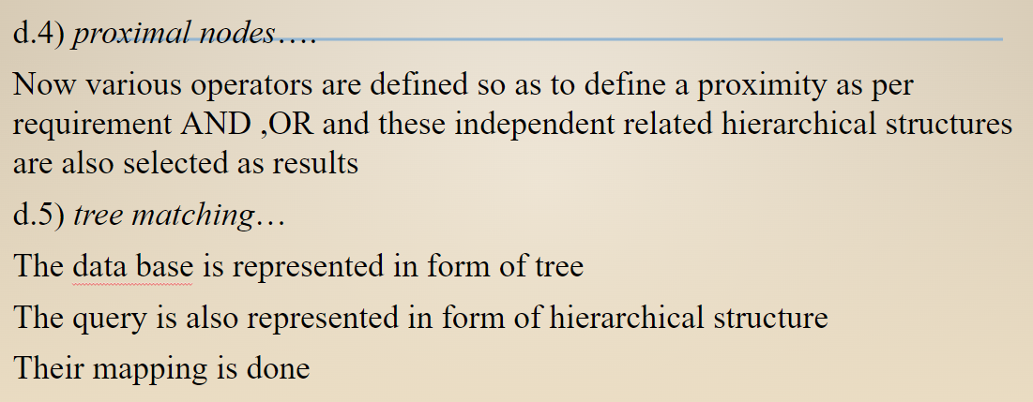

**PYQ: What are protocols in information retrieval and why are they required?**

**(GPT ANS)**

Protocols in information retrieval (IR) are standardized sets of rules or procedures that govern how data and queries are exchanged between systems, such as clients (e.g., search engines) and servers (e.g., databases). These protocols ensure smooth communication, data consistency, and interoperability between different systems and platforms in the information retrieval process.

**Key Purposes of Protocols in IR**

* **Facilitate Communication:** Protocols define how clients and servers communicate, including query formats, response structures, and error-handling mechanisms. This enables effective data exchange between users and retrieval systems.
* **Interoperability:** Different systems, such as digital libraries, search engines, or content management platforms, may use varying technologies. Protocols standardize interactions, making it possible for heterogeneous systems to work together.
* **Efficiency:** Protocols optimize the retrieval process by specifying rules for indexing, caching, and data transfer, ensuring that responses are delivered quickly and efficiently.
* **Scalability:** They help scale systems by defining methods for distributing queries and managing large datasets across multiple servers.
* **Security:** Protocols define authentication, encryption, and access control mechanisms to ensure secure data exchange.
* **Error Handling:** They provide rules for handling errors, such as invalid queries or server failures, allowing the system to recover gracefully.

**Why Protocols Are Required in Information Retrieval**

* **Standardization:** Protocols create a common language for systems to interact, reducing development complexity and ensuring uniformity.
* **Data Accessibility:** They enable users to retrieve information from diverse sources, such as databases, web repositories, or APIs, without needing to understand the underlying system's architecture.
* **Improved User Experience:** By ensuring efficient and accurate data retrieval, protocols enhance the quality of search results and overall user satisfaction.
* **Support for Advanced Features:** Protocols allow for complex functionalities, such as federated searches, query refinement, and result ranking, which would be difficult to implement without standard rules.
* **Resource Management:** They help manage computing resources by specifying how data is queried, processed, and transferred, ensuring efficient system operation.

Examples me ye niche Q5 ke protocols likho!

**5. Write a short note on Query Protocols.**

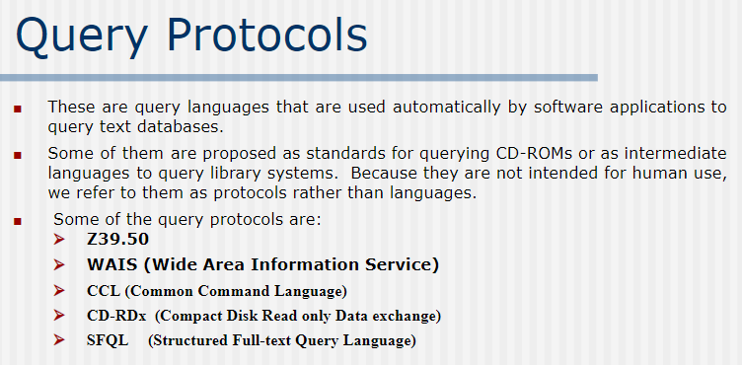

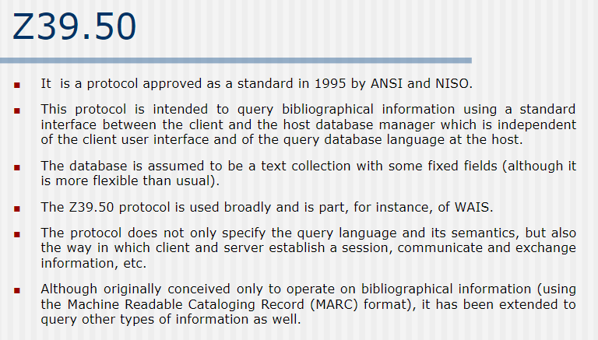

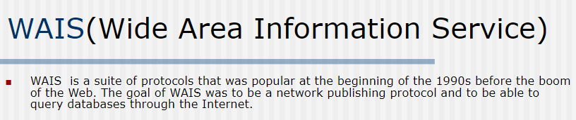

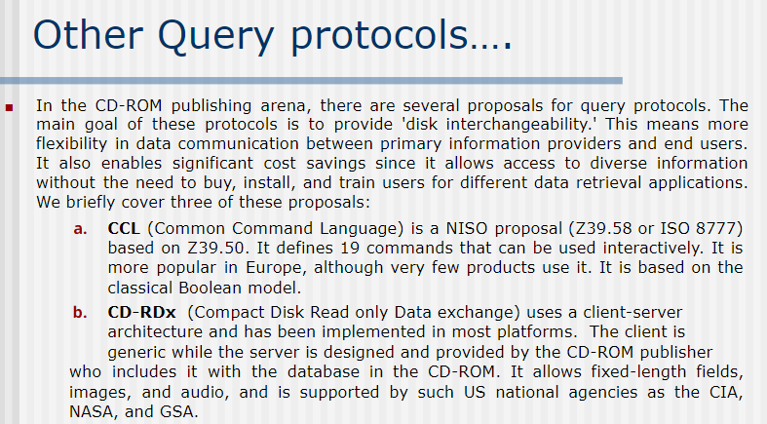

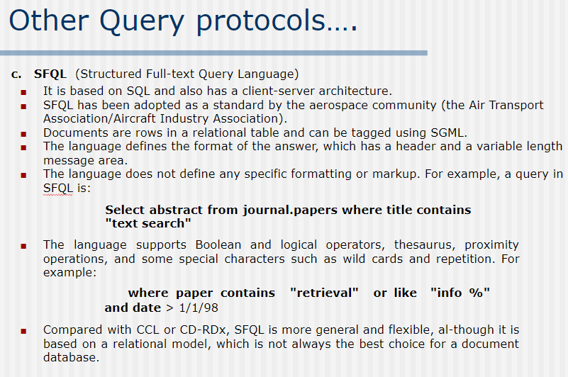

**6. What is query modification? What is the purpose of query modification?**

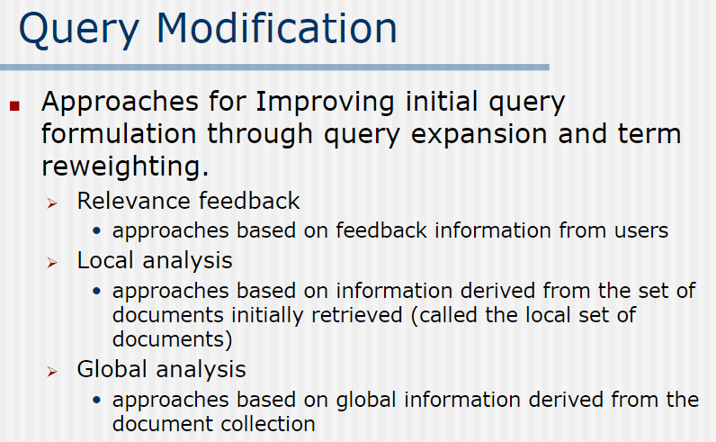

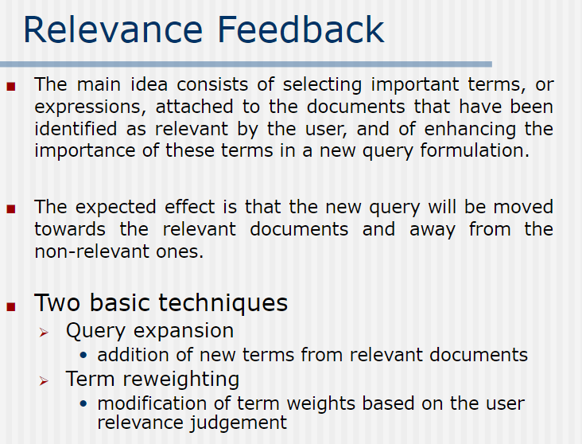

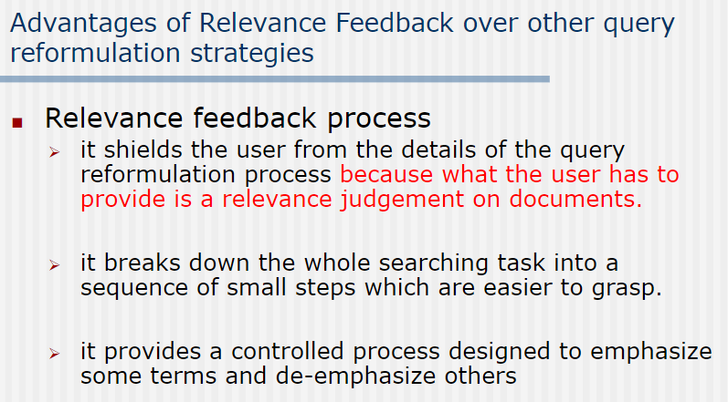

**7. Explain query expansion methods.**

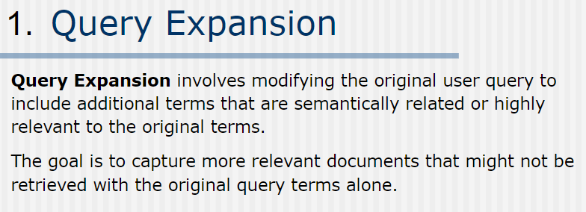

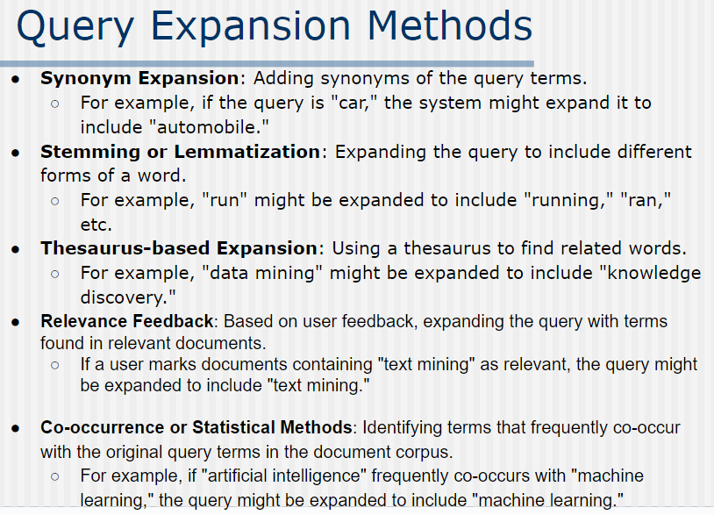

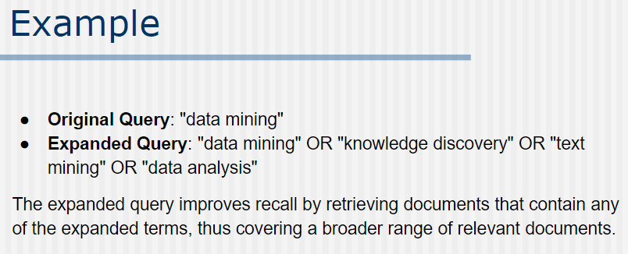

**8. Explain how term reweighting is done in a vector-space model with examples.**

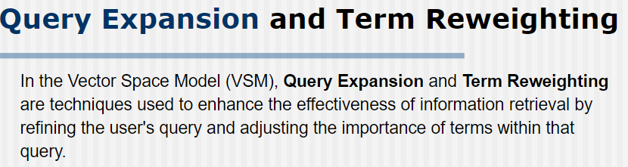

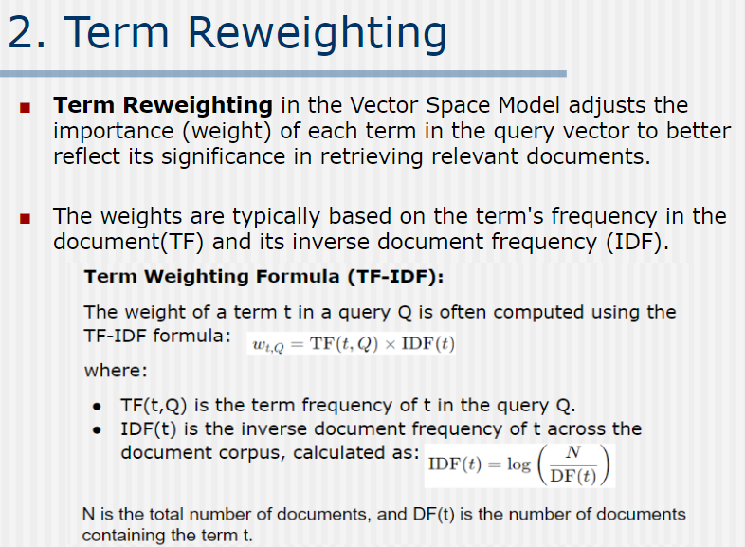

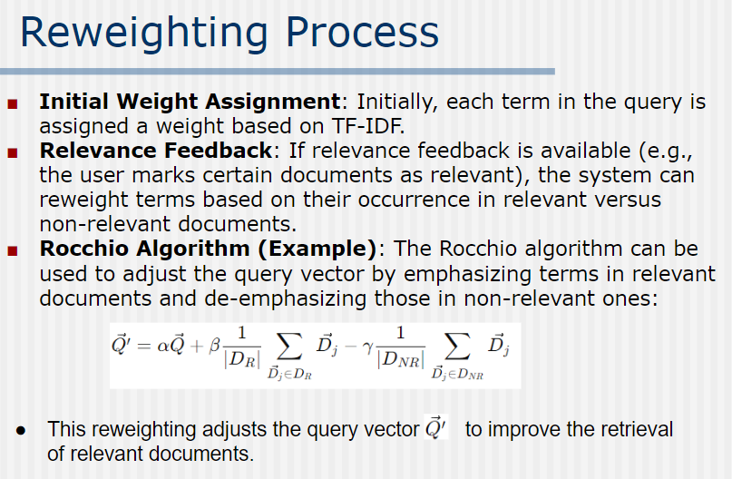

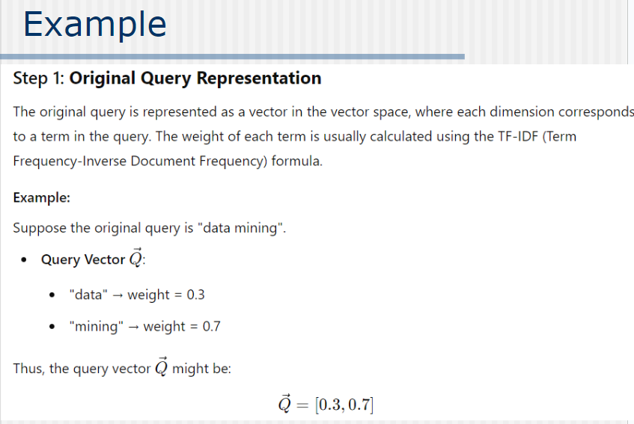

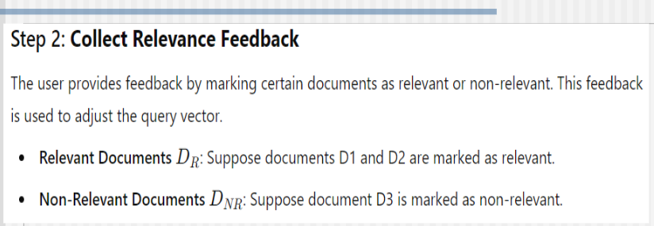

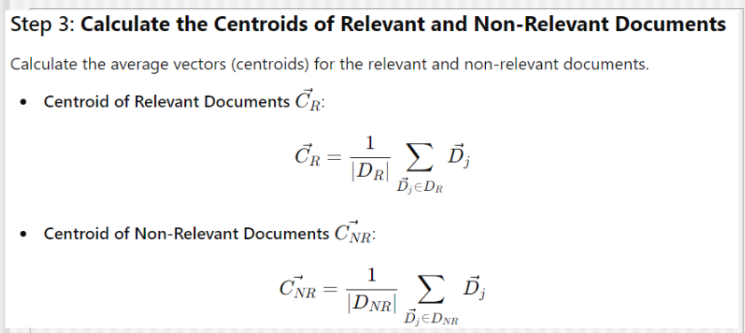

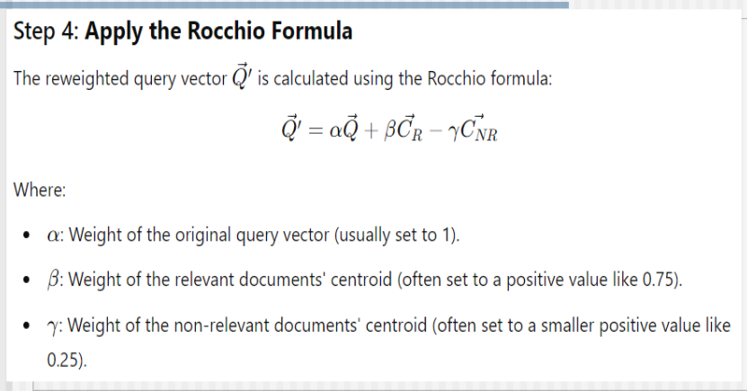

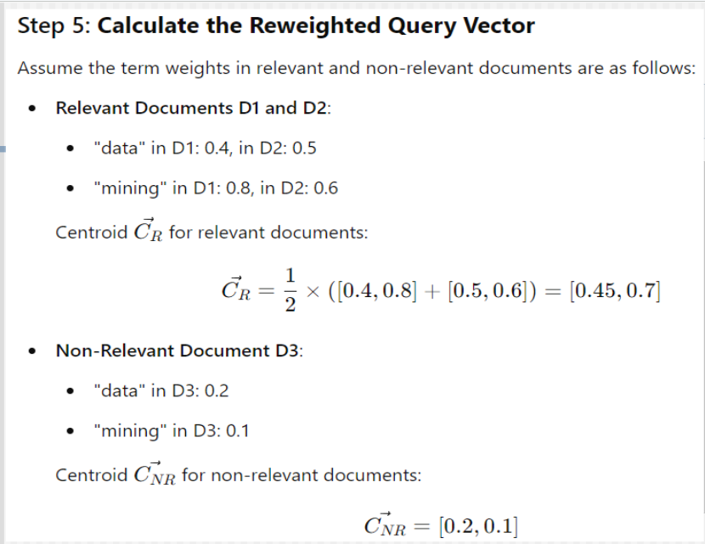

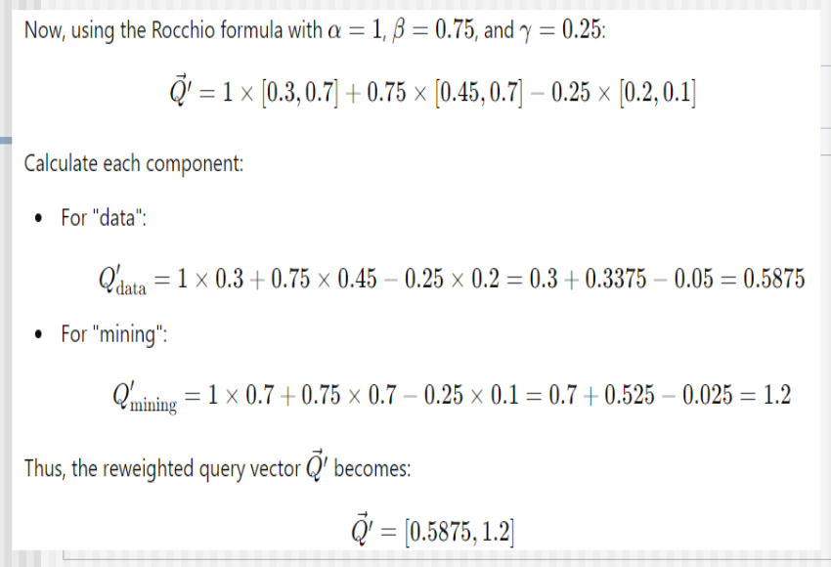

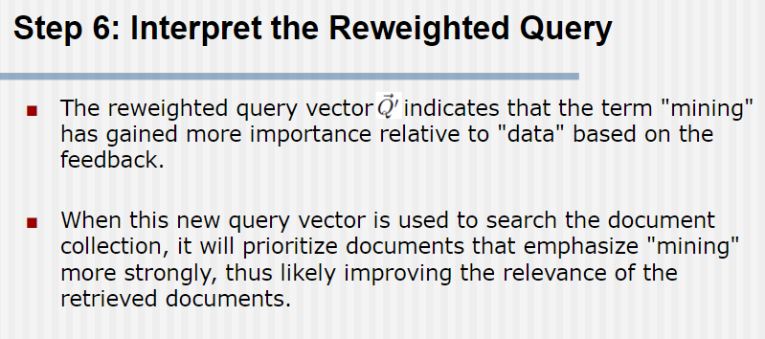

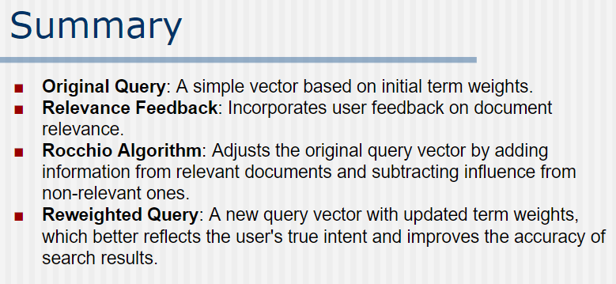

**9. Explain the term reweighing process in a probabilistic model with an example.**

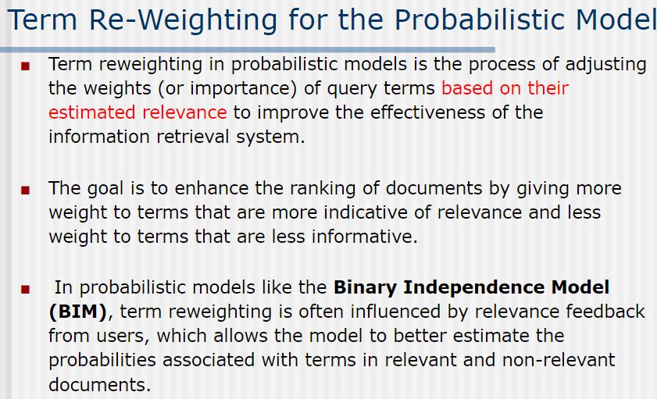

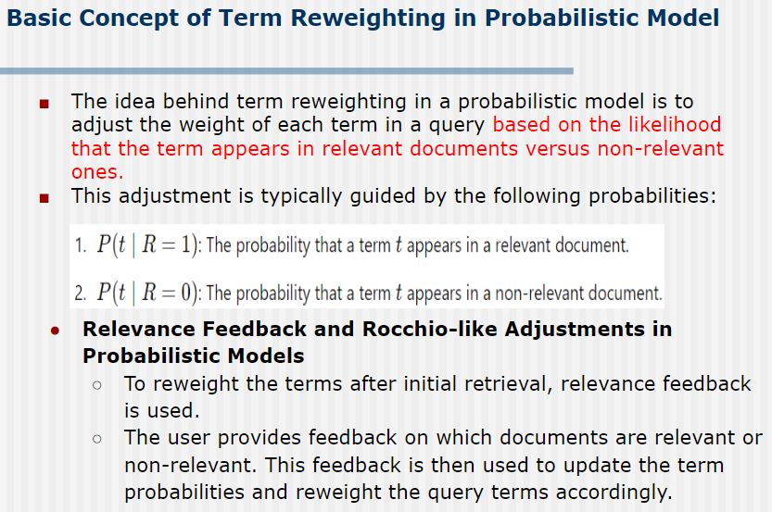

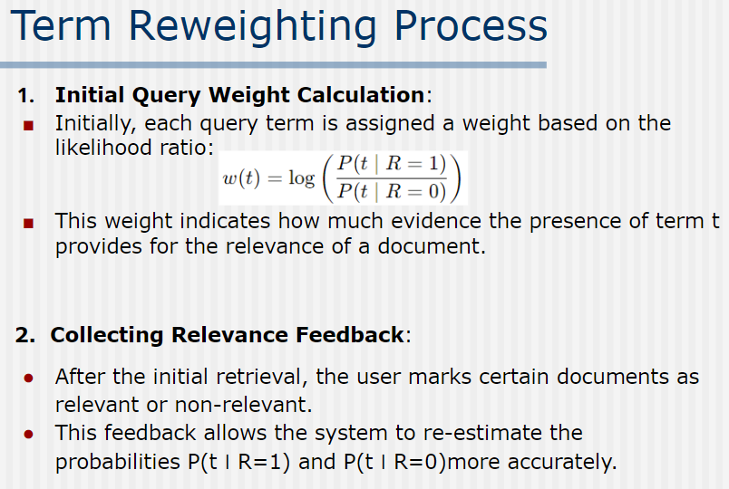

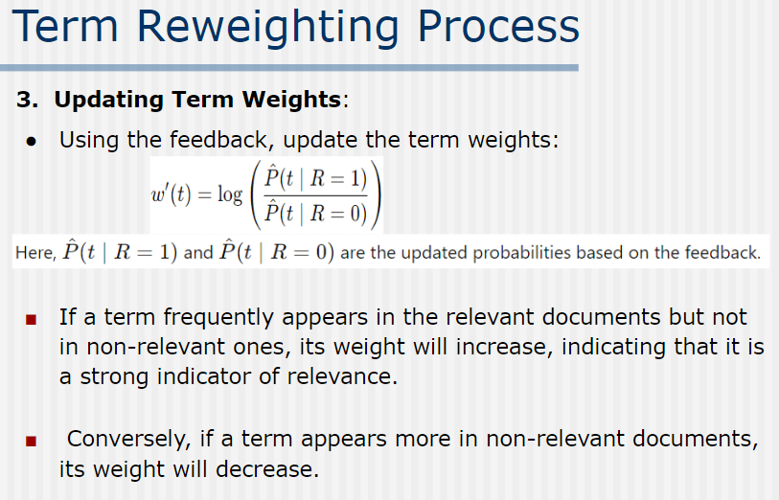

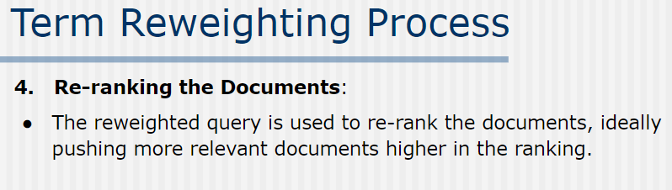

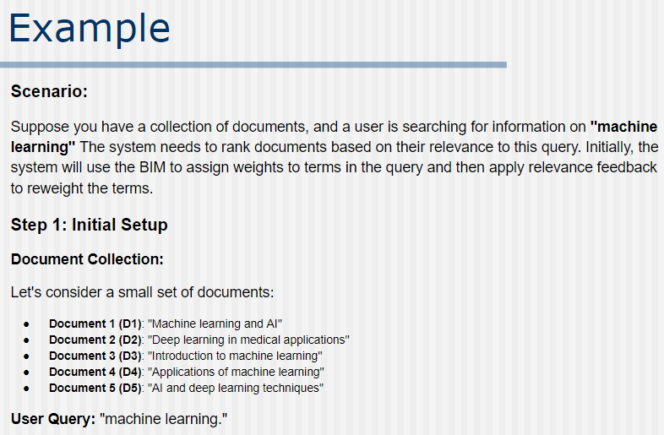

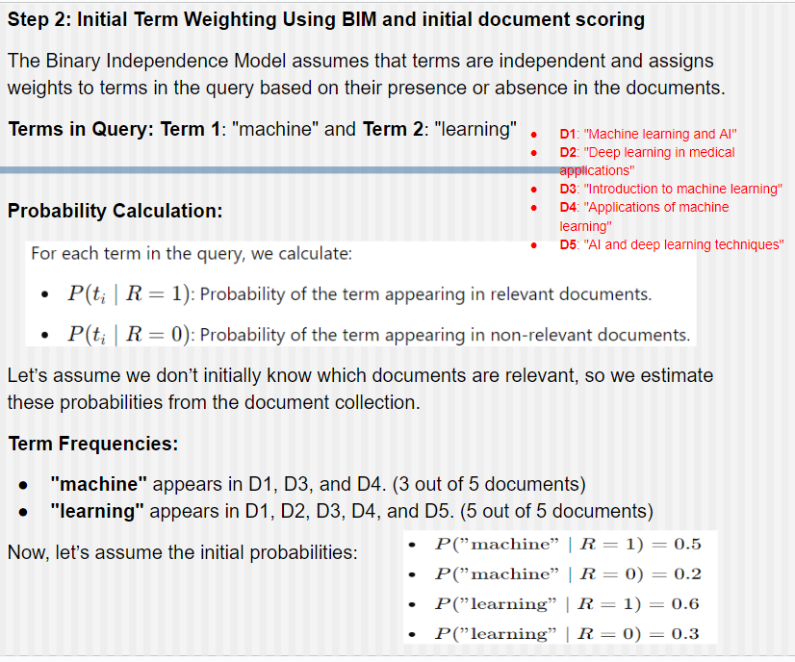

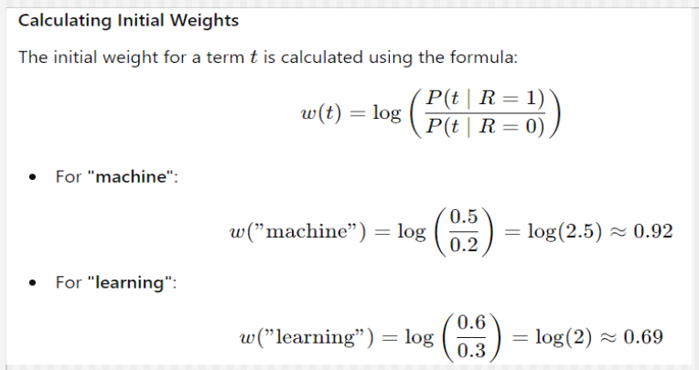

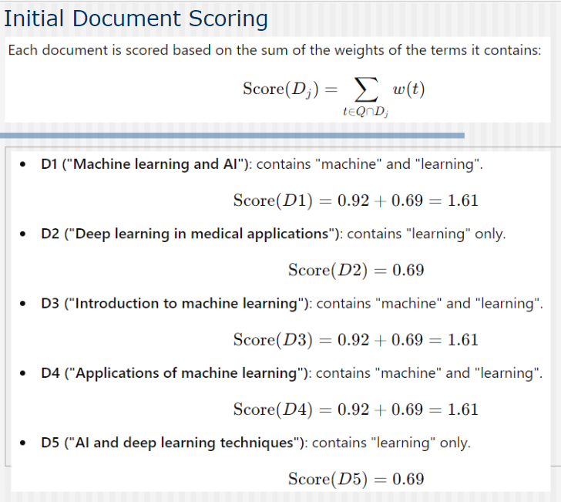

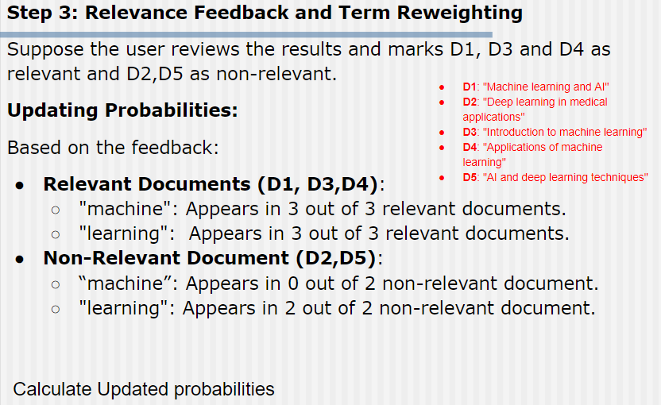

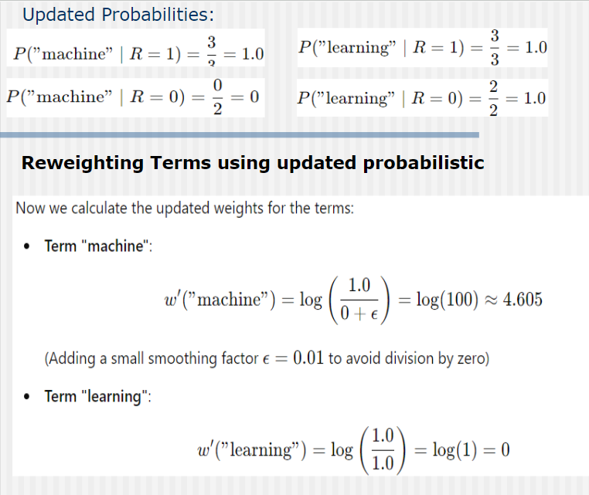

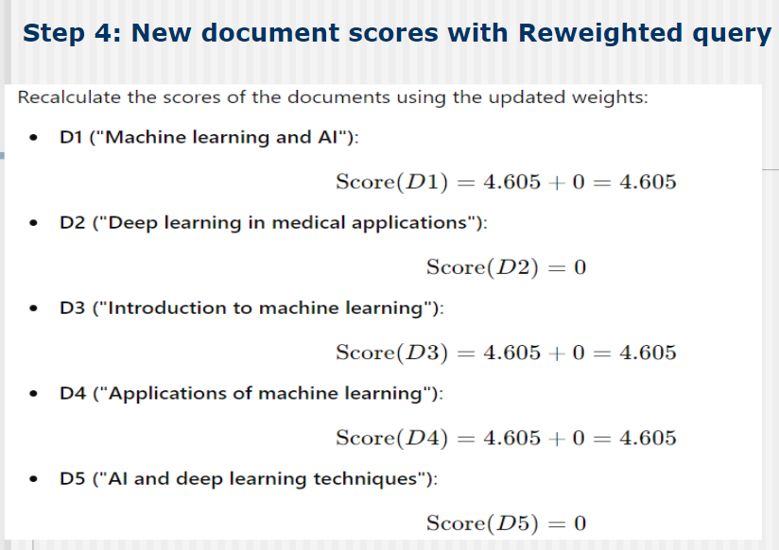

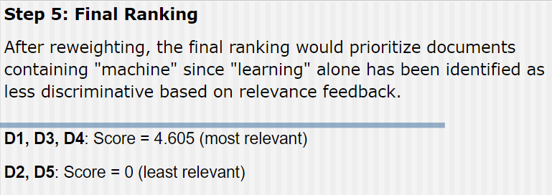

**10. What are the advantages and disadvantages of user relevance feedback techniques?**

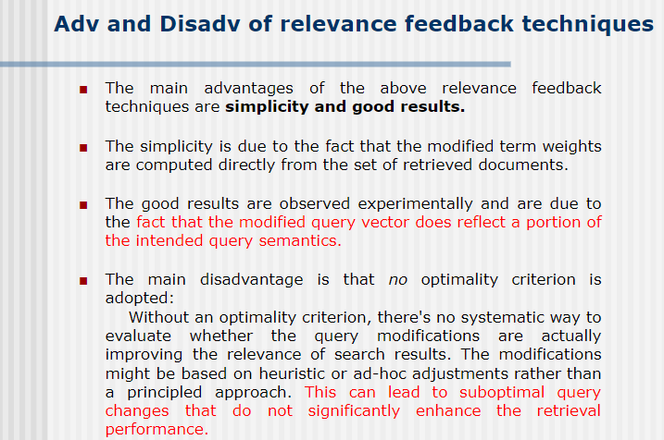

**11. What do you mean by residual collection in the IRS? Why use the residual collection in the evaluation of relevant feedback strategies?**

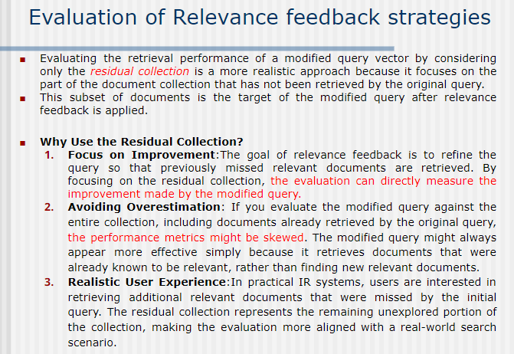

**12. Explain the key challenges in multimedia information retrieval.**

**Iska pura ans PYQ: What is meant by multimedia information retrieval**

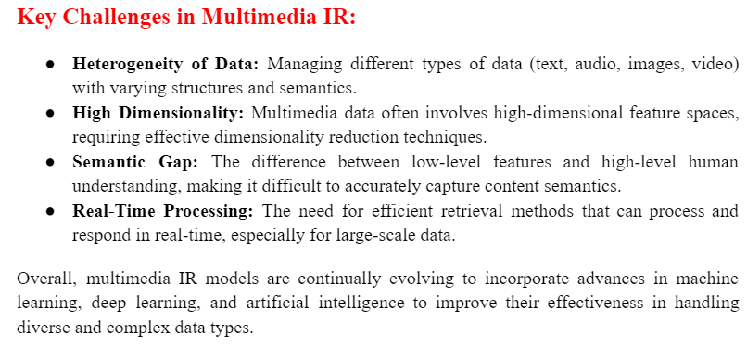

**13. State and explain the different approaches and models used in multimedia IR**

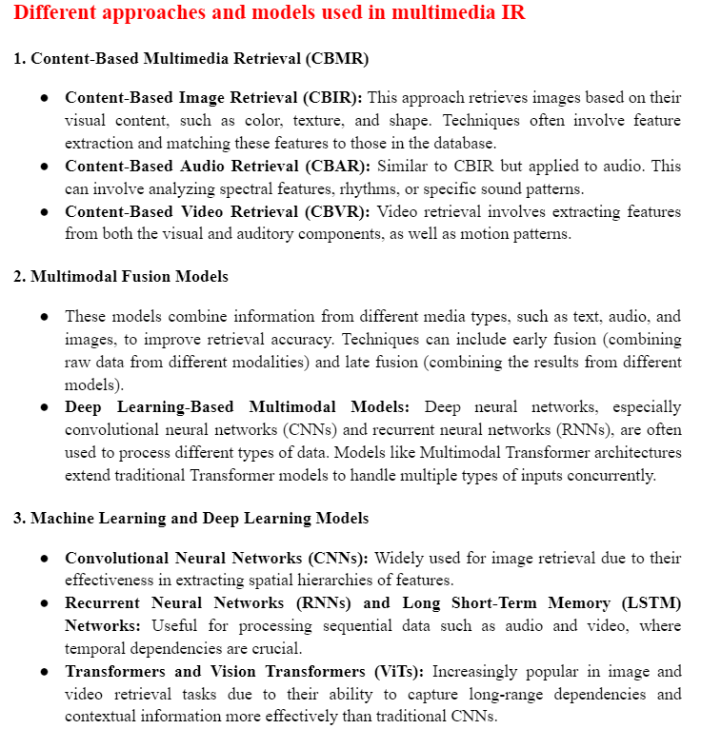

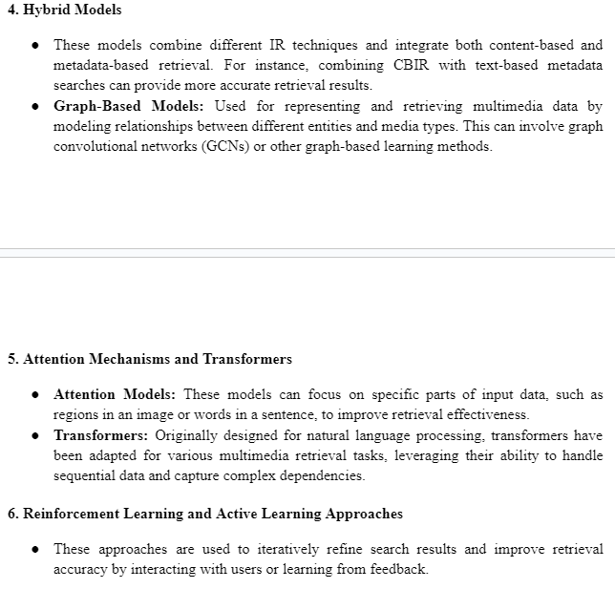

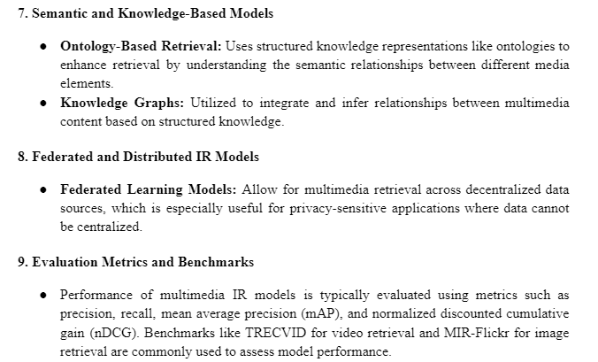

**14. Explain data modeling techniques in multimedia IR models.**

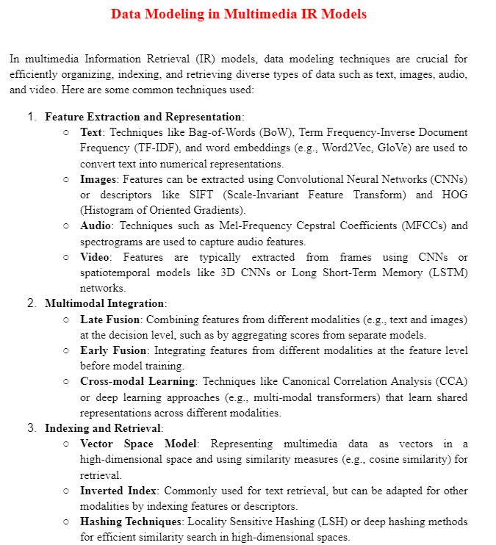

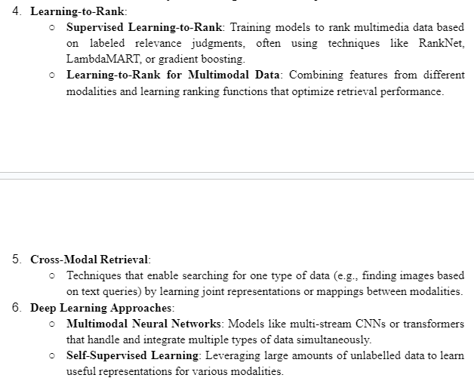

**15. Write a short note on MULTOS data model.**

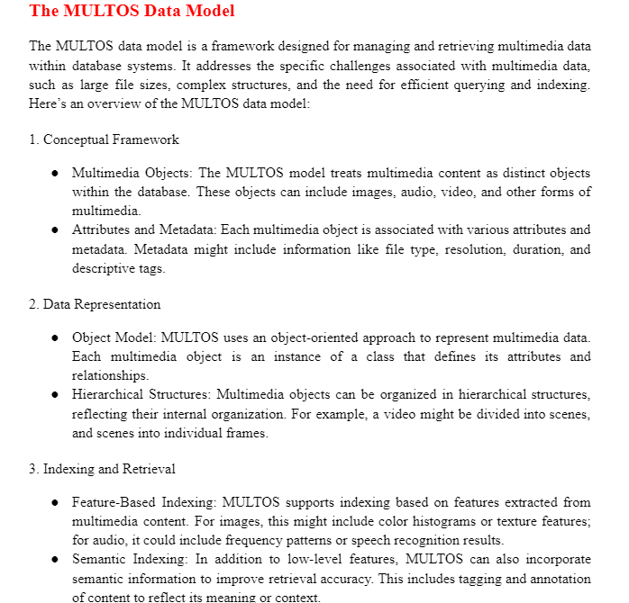

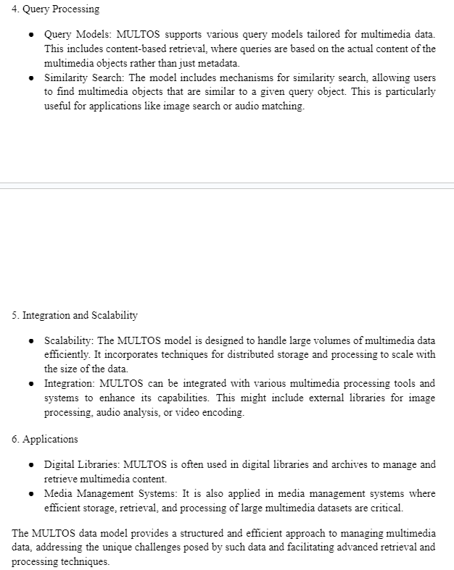

#### Module 4

**What is preprocessing and explain the text operations to be used in document preprocessing? PYQ**

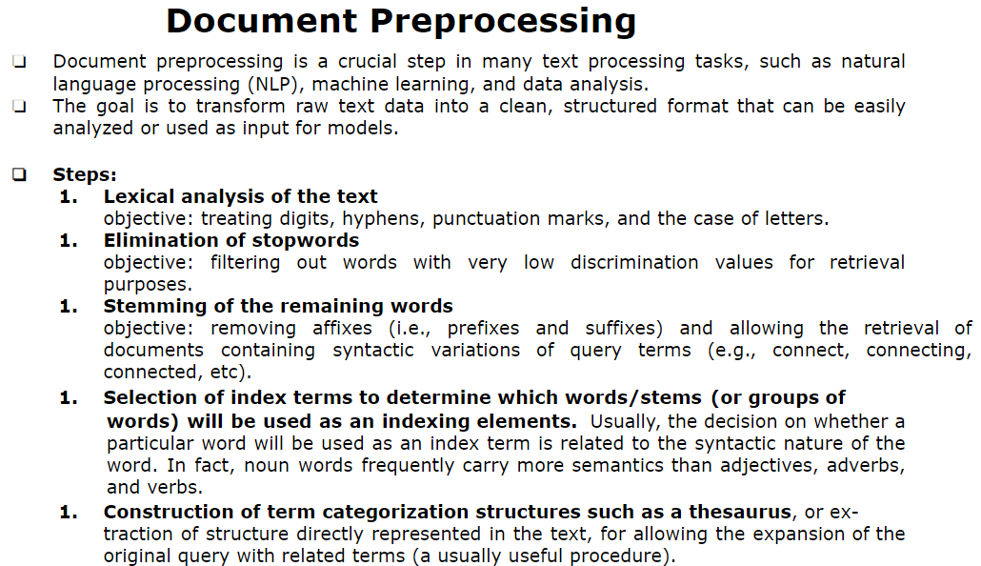

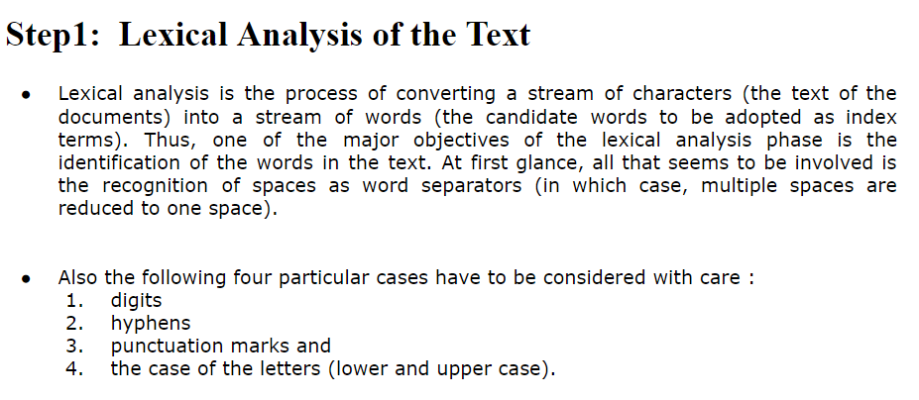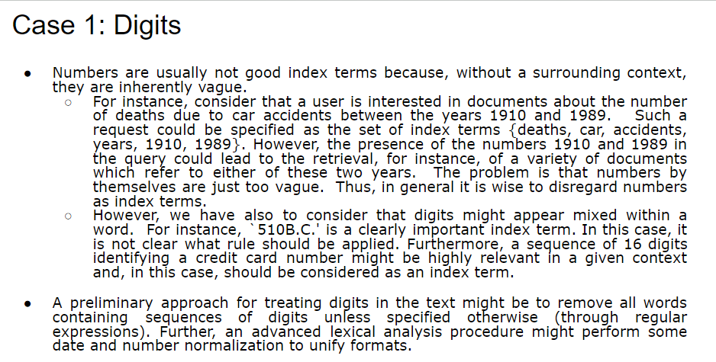

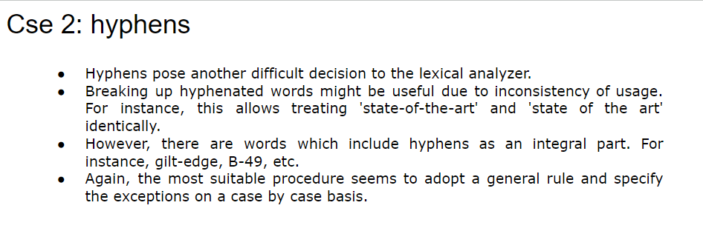

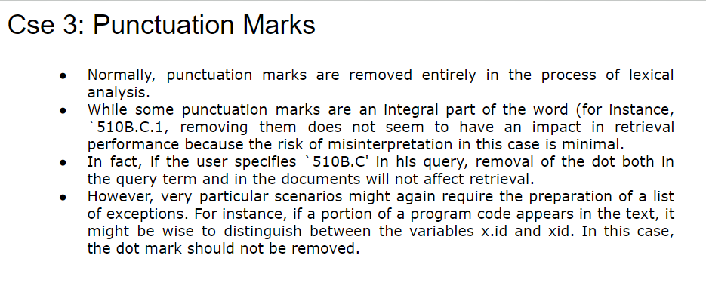

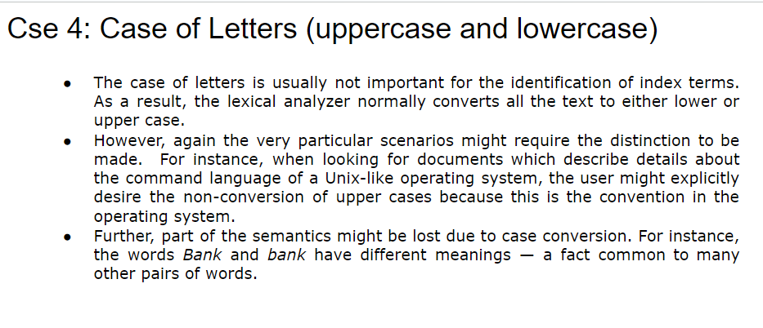

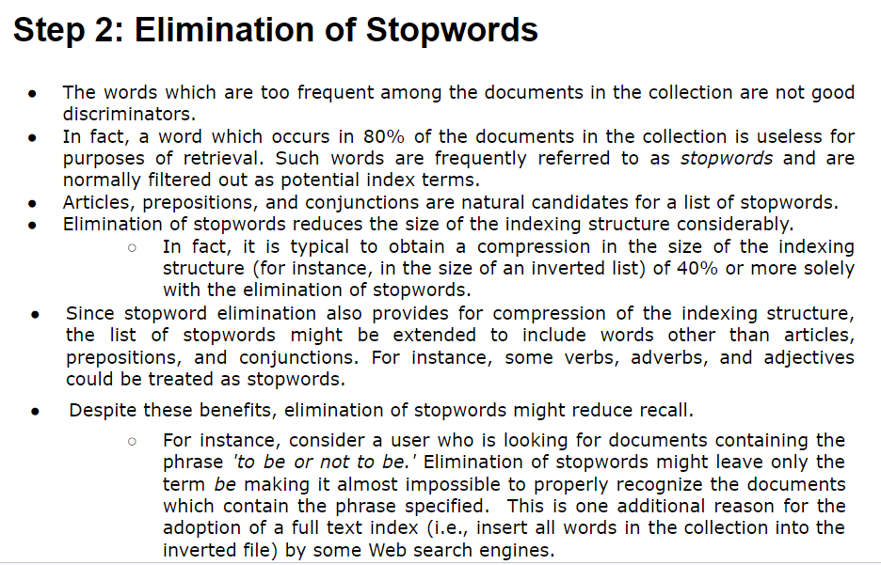

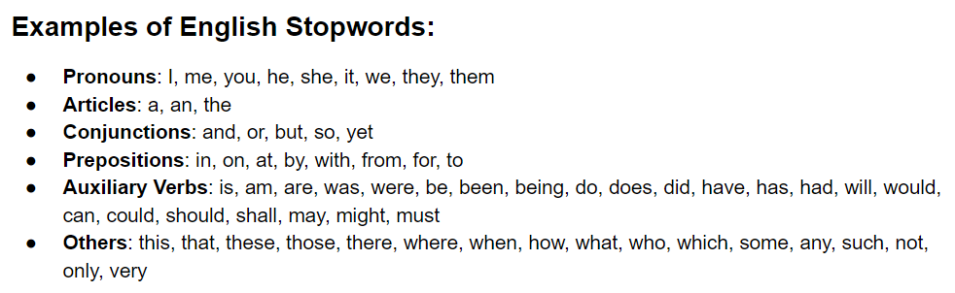

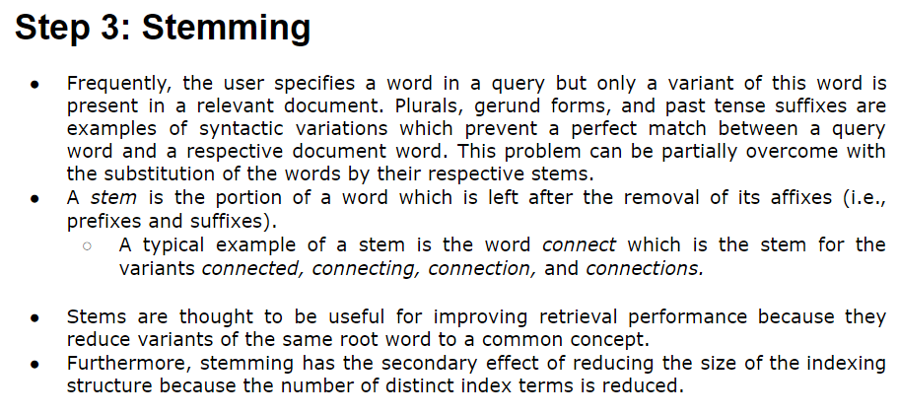

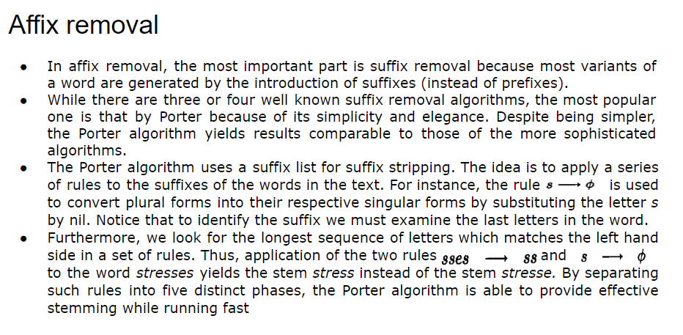

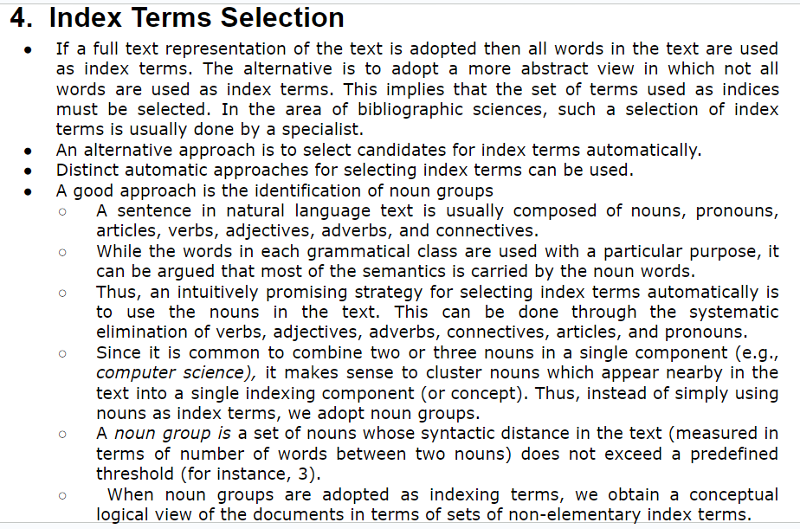

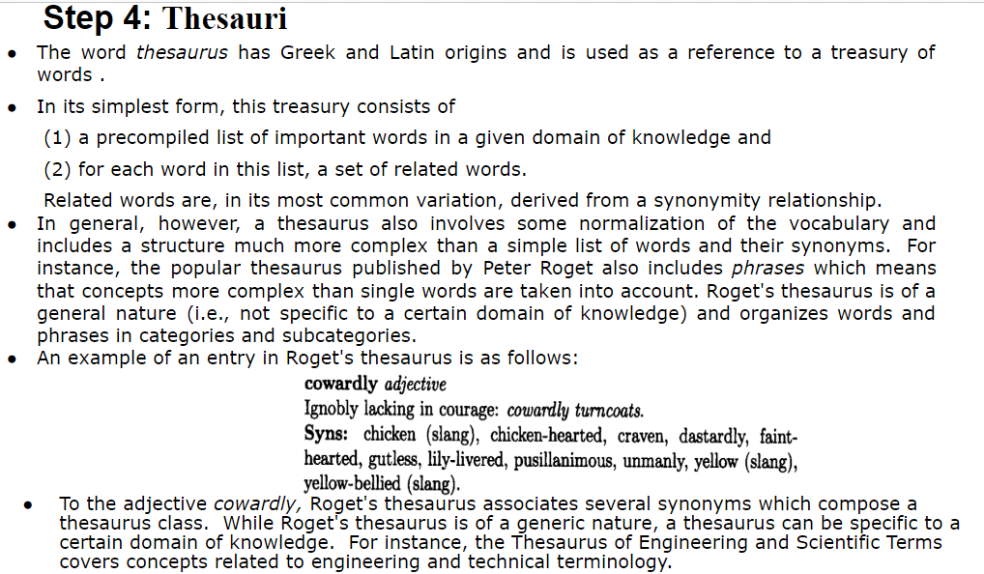

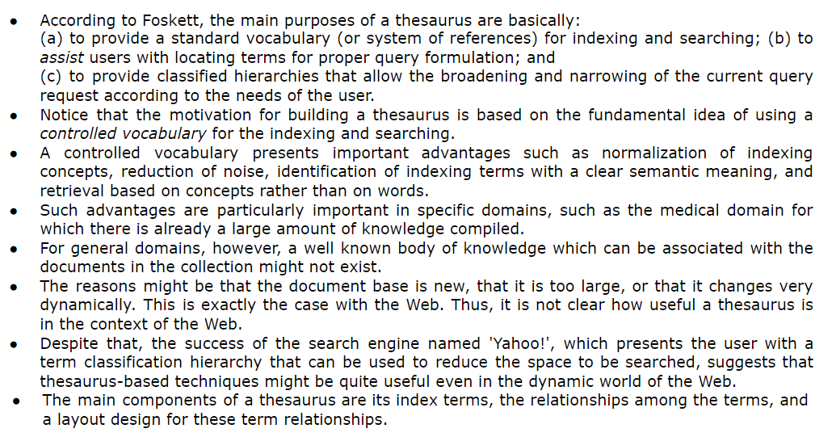

Extra Thesaurus Content

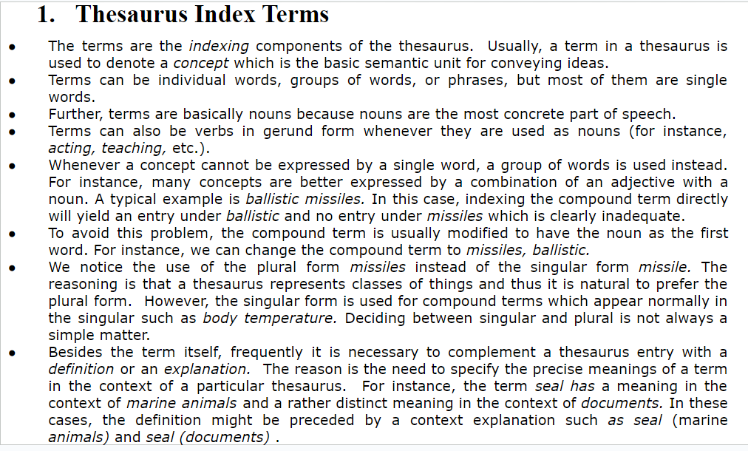

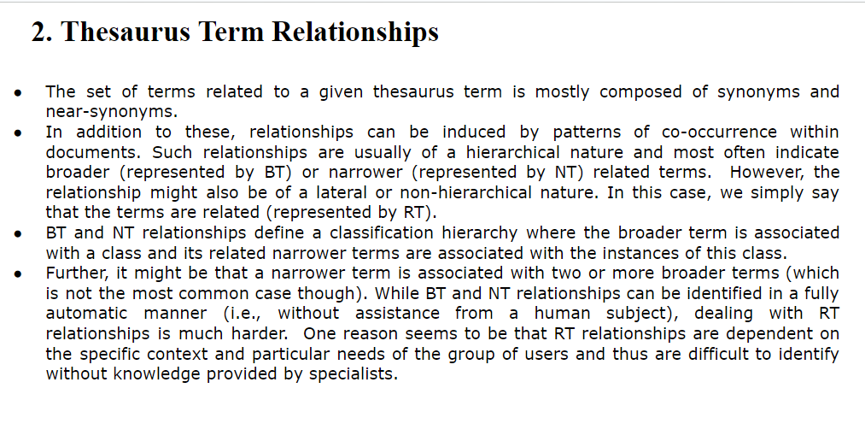

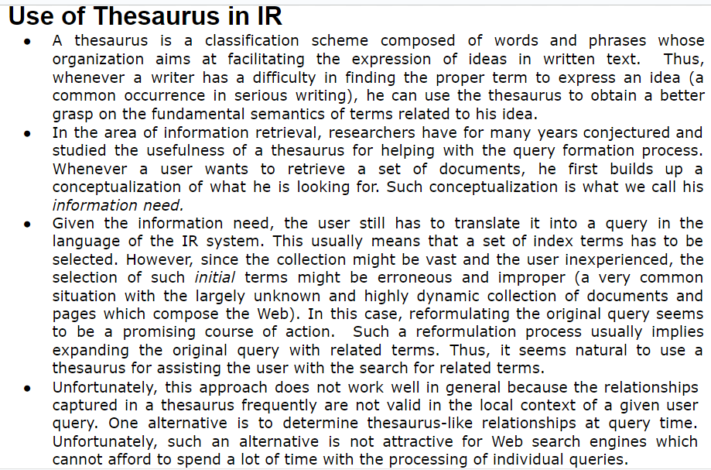

**What is a document? Explain its characteristics and Logical view of the document.**

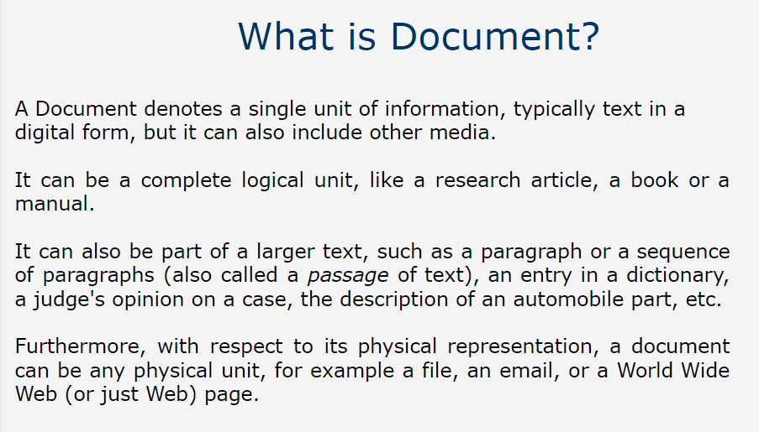

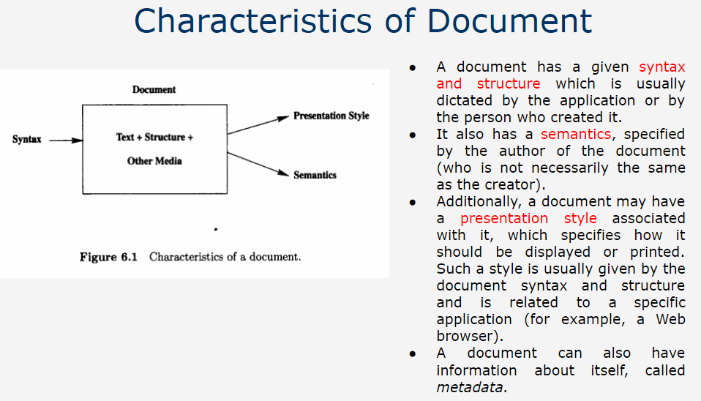

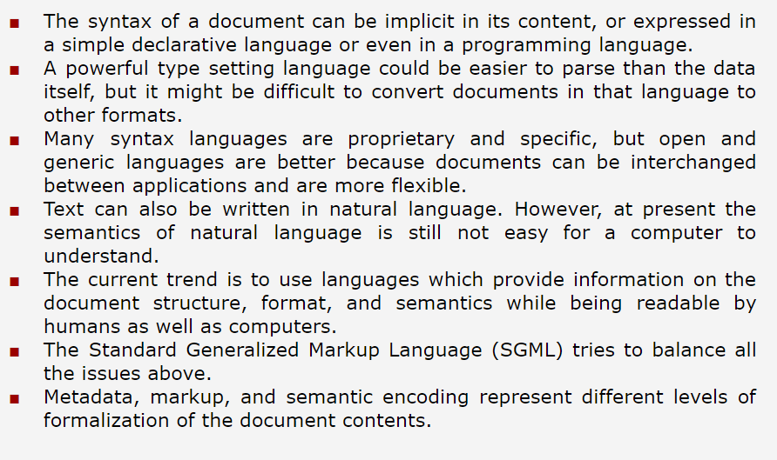

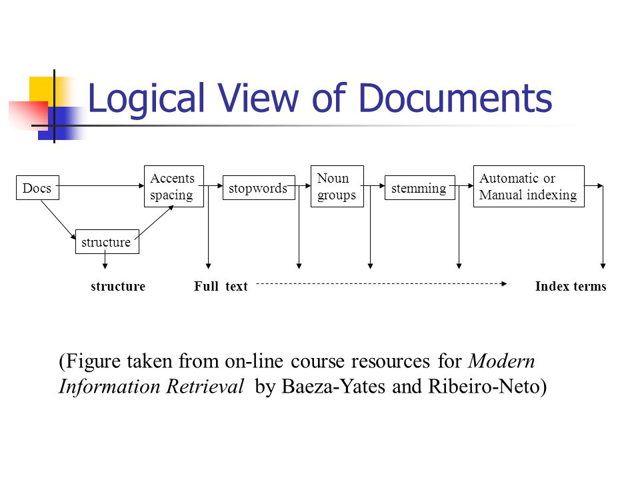

**What is Metadata and Explain its types.**

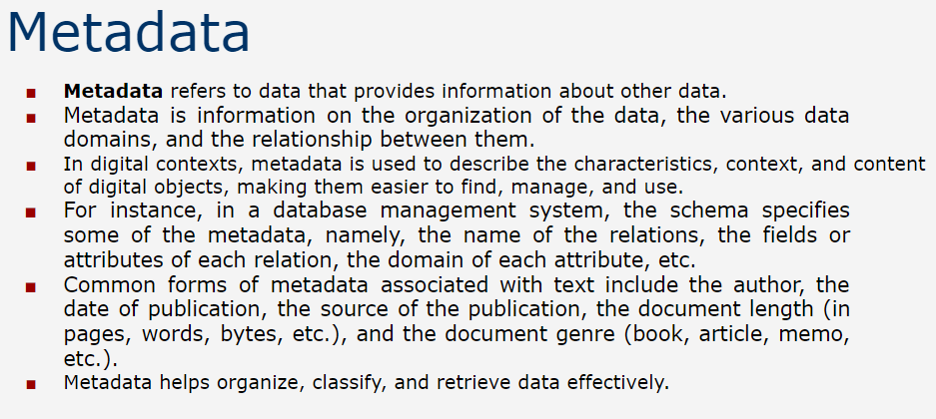

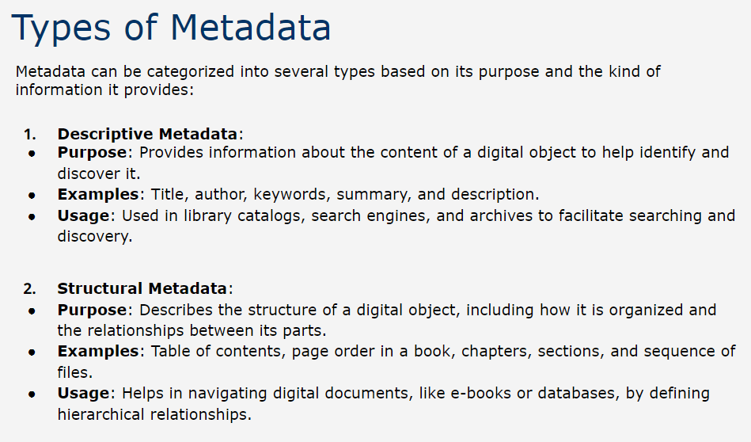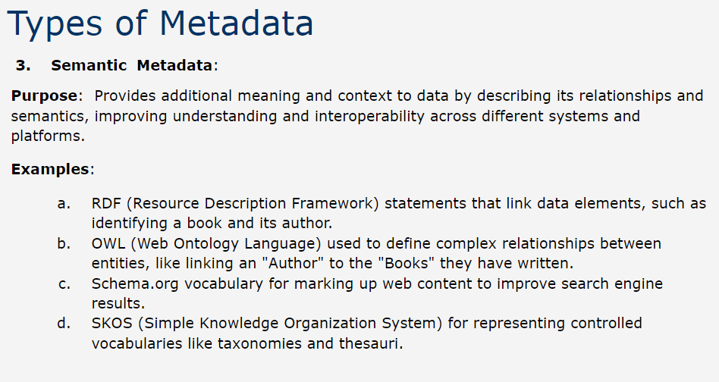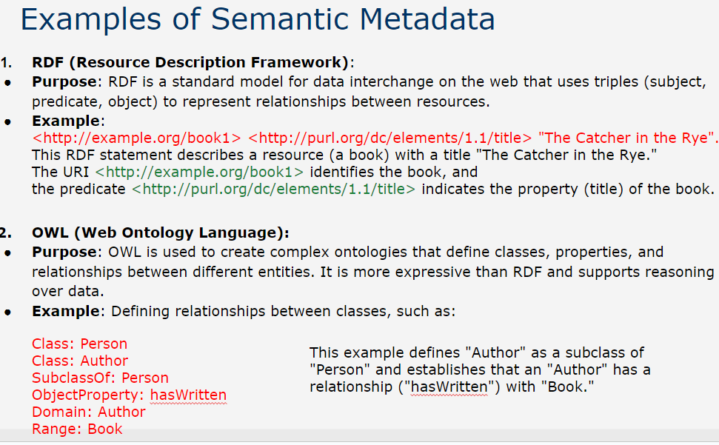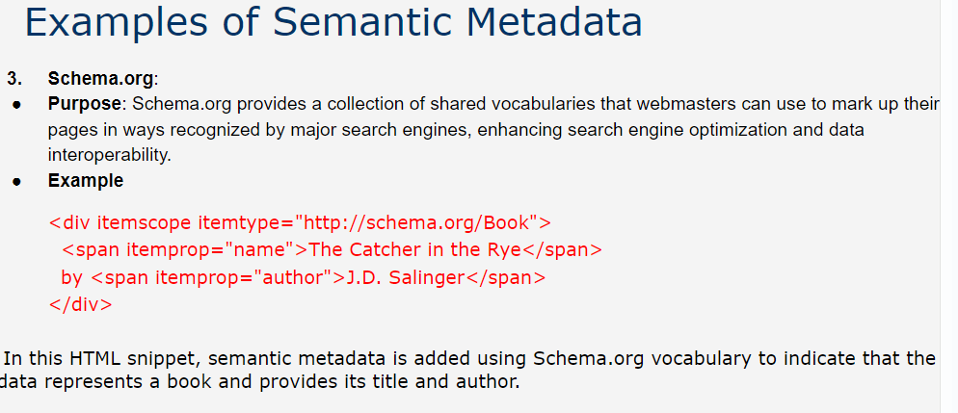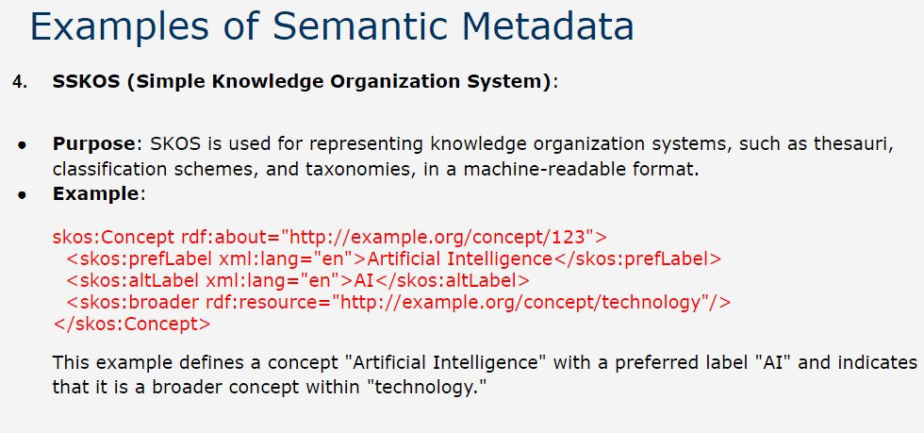

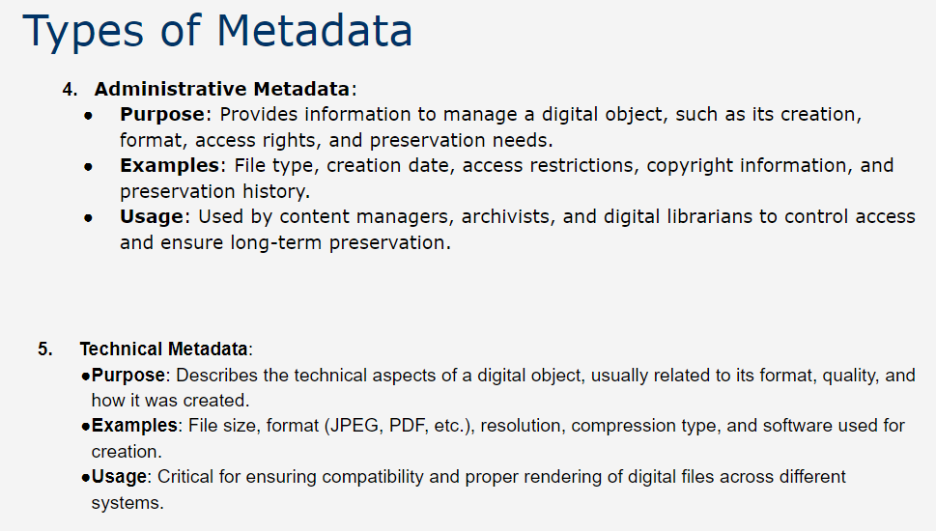

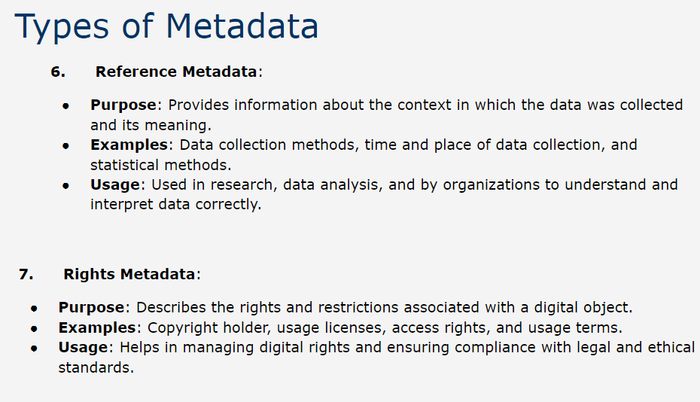

**Importance of Metadata.**

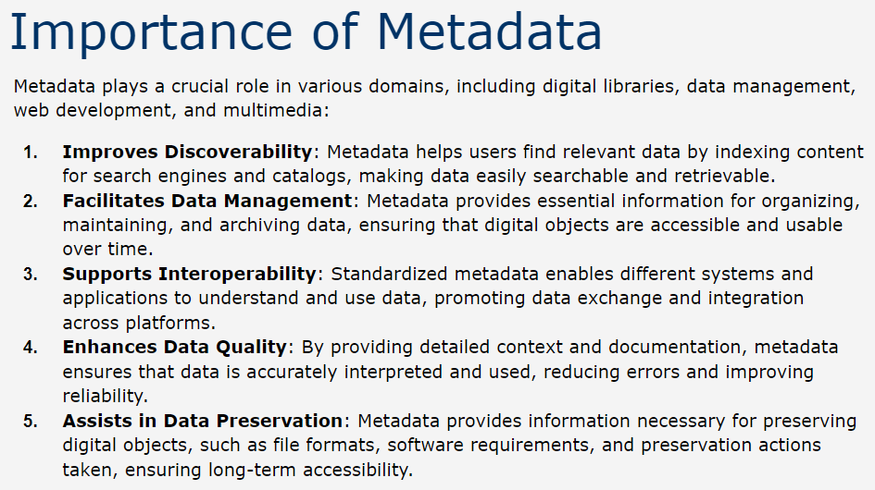

**Benefits, Usecases and Key Features of Semantic Metadata.**

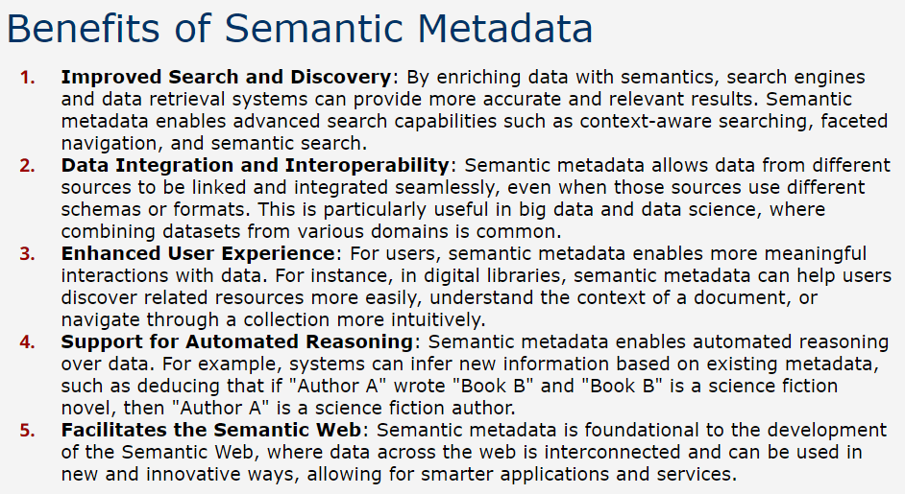

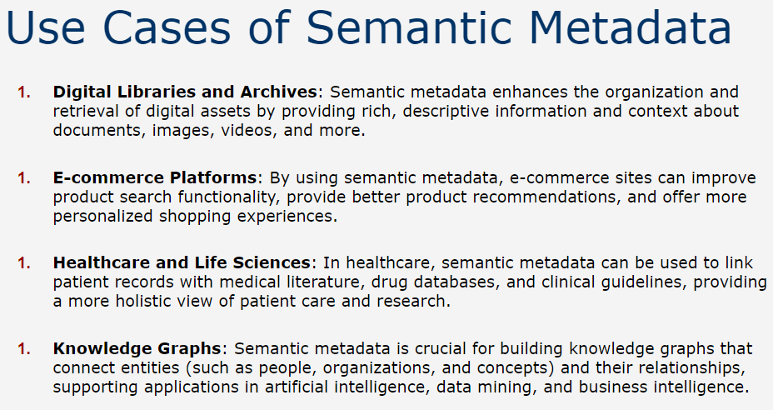

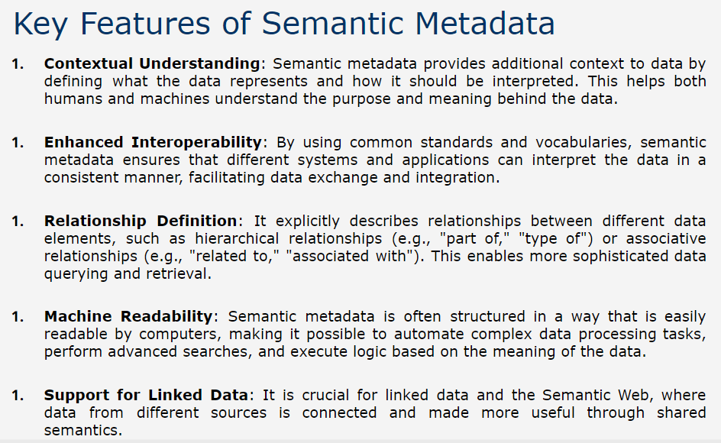

**Markup Languages and it’s types.**

* Markup languages are systems used for annotating a document in a way that is syntactically distinguishable from the text.
* They use a set of symbols or codes, called "tags," to define elements within a document, allowing for the separation of content and structure or formatting.
* To avoid ambiguity, there is an initial and ending tag surrounding the marked text.
* Markup languages are crucial in defining the layout, style, and organization of content in a wide range of applications, from web development to document processing.
* **SGML**

1. SGML (Standard Generalized Markup Language) is a standard for defining generalized markup languages for documents.
2. Developed in the early 1980s, SGML provides a powerful, flexible framework for defining document structures and types, making it a foundational technology for many other markup languages, including HTML and XML.

**Key Features**

1. **Meta-Markup Language:**

SGML is not a markup language itself but a meta-language that defines the rules for creating markup languages. This allows users to create customized document types with specific tags and rules tailored to their needs.

1. **Document Type Definition (DTD):**

A DTD in SGML defines the structure, elements, and attributes of a document type. It specifies the allowed tags, the hierarchy of those tags, and their attributes. DTDs enforce a structured, consistent format across documents of the same type.

1. **Flexibility and Extensibility:**

SGML allows for the definition of highly flexible and customizable document types. Users can define their own elements, attributes, and rules, making it suitable for a wide range of applications, from technical documentation to complex databases.

1. **Separation of Content and Structure:**

SGML separates the document's content from its structure and presentation, allowing for flexible document formatting and easy content reuse. This separation ensures that documents can be easily processed and transformed into different formats, such as HTML or PDF.

1. **Data Integrity and Validation:**

SGML provides mechanisms for ensuring data integrity and validation against the defined DTD. It ensures that documents conform to their specified structure, making it easier to manage large and complex documents.

**Components of SGML Document**

1. **Prologue:**

The prologue contains declarations that set up the document's environment, including the DTD and any entity references.

It may also include processing instructions that give hints to SGML processors about how to handle certain elements.

1. **Document Type Declaration:**

The document type declaration specifies the DTD that the document conforms to, ensuring consistent structure and element usage.

It looks like : <!DOCTYPE document SYSTEM "example.dtd">

1. **Elements:**

Elements are the building blocks of an SGML document, defined by tags.

Each element represents a part of the document structure (e.g., paragraphs, sections, titles).

Elements can have attributes that provide additional information or properties.

1. **Attributes:**

Attributes provide additional information about elements.

They are defined in the DTD and used within start tags to modify or specify details about elements.

Example: <element attribute="value">content</element>

1. **Entities:**

Entities are placeholders or references used to insert special characters, strings, or external data into the document.

There are general entities for text and special characters, and parameter entities for use in DTDs.

Example: &entity_name;

**Benefits of using SGML**

1. **Standardization:**

As an ISO standard, SGML provides a uniform way to define document types and structures, ensuring compatibility and interoperability across different systems and platforms.

1. **Customization:**

SGML's flexibility allows users to create highly customized document types, tailored to specific industries or applications (e.g., legal documents, technical manuals).

1. **Data Longevity:**

SGML documents are structured and independent of proprietary formats, making them more likely to be readable and usable in the long term.

1. **Document Integrity:**

The use of DTDs and validation ensures that documents conform to a specified structure, which is essential for managing large, complex document sets.

**Challenges of using SGML**

1. **Complexity:**

SGML's flexibility and power come at the cost of complexity, making it more challenging to learn and implement compared to simpler markup languages like HTML or XML.

1. **Overhead:**

SGML requires detailed DTDs and more extensive markup, which can lead to increased document size and processing overhead.

1. **Decline in Use:**

With the advent of XML and HTML, SGML's usage has declined significantly, as these newer languages provide simpler, more efficient solutions for most applications.

**Applications of SGML**

1. **Technical Documentation:**

SGML is widely used in industries that require highly structured, long-form documentation, such as aerospace, defense, and manufacturing.

It enables the creation of comprehensive technical manuals, standards, and specifications.

1. **Publishing:**

The publishing industry uses SGML to manage complex documents like books, journals, and magazines, allowing for automated formatting and content management.

1. **Data Exchange and Archiving:**

SGML's strict structure and validation make it ideal for archiving and exchanging data in a consistent, machine-readable format.

* **XML**

1. XML stands for eXtensible Markup Language and is a simplified subset of SGML. That is, XML is not a markup language, as HTML is, but a metalanguage that is capable of containing markup languages in the same way as SGML.
2. XML allows a human-readable semantic markup, which is also machine-readable. As a result, XML makes it easier to develop and deploy new specific markup, enabling automatic authoring, parsing, and processing of networked data.
3. In some ways, XML allows one to do many things that today are done by Java scripts or other program interfaces.
4. XML does not have many of the restrictions imposed by HTML but on the other hand imposes a more rigid syntax on the markup, which becomes important at processing time.
5. In XML, ending tags cannot be omitted. Also, tags for elements that do not have any content, like BR and IMG, are specially marked by a slash before the closing angle bracket.
6. XML also distinguishes upper and lower case, so img and IMG are different tags (this is not true in HTML).
7. In addition, all attribute values must be between quotes. This implies that parsing XML without knowledge of the tags is easier.
8. In particular, using a DTD is optional. If there is no DTD, the tags are obtained while the parsing is done
9. XML allows any user to define new tags, define more complex structures (for example, unbounded nesting with the same rules of SGML) and has data validation capabilities.
10. XML removes the requirement for the existence of a DTD, which can be parsed directly from the data. Removing the DTD places even more importance on the application documentation. This can also have a large impact on the functions that the software provides.
11. The Extensible Stylesheet Language (XSL) is the XML counterpart of Cascading Style Sheets. XSL is designed to transform and style highly-structured, data-rich documents written in XML. For example, with XSL it would be possible to automatically extract a table of contents from a document.
12. The syntax of XSL has been defined using XML. In addition to adding style to a document, XSL can be used to transform XML documents to HTML and CSS. This is analogous to macros in a word processor.
13. Another extension to XML, defined using XML, is the Extensible Linking Language (XLL). XLL defines different types of links, including external and internal links.
14. In particular, any element type can be the origin of a link and outgoing links can be defined on documents that cannot be modified. The behavior of the links is also more generic.
15. The object linked can be embedded in, or replace the document. It is also possible to generate a new context without changing the current application (for example, the object is displayed in a new window).
16. Another extension to XML, defined using XML, is the Extensible Linking Language (XLL).
17. XLL defines different types of links, including external and internal links.
18. In particular, any element type can be the origin of a link and outgoing links can be defined on documents that cannot be modified.
19. The behavior of the links is also more generic.
20. The object linked can be embedded in, or replace the document.
21. It is also possible to generate a new context without changing the current application (for example, the object is displayed in a new window).
22. Recent uses of XML include:
23. **Mathematical Markup Language (MathML):** two sets of tags, one for presentation of formulas and another for the meaning of mathematical expressions.
24. **Synchronized Multimedia Integration Language (SMIL):** a declarative language for scheduling multimedia presentations in the Web, where the position and activation time of different objects can be specified.
25. **Resource Description Format:** meta-data information for XML should be given using RDF.

* **HTML**

1. HTML is an instance of SGML. HTML was created in 1992 and has evolved during the past years, 4.0 being the latest version, released as a recommendation at the end of 1997.
2. Currently it is being extended in many ways to solve its many limitations, for example, to be able to write mathematical formulas.
3. Most documents on the Web are stored and transmitted in HTML.
4. HTML is a simple language well suited for hypertext, multimedia, and the display of small and simple documents.
5. HTML is based on SGML, and although there is an HTML DTD (Document Type Definition), most HTML instances do not explicitly make reference to the DTD.
6. The HTML tags follow all the SGML conventions and also include formatting directives.
7. HTML documents can have other media embedded within them, such as images or audio in different formats.
8. HTML also has fields for metadata, which can be used for different applications and purposes.
9. If we also add programs (for example, using Javascript) inside a page, some people call it dynamic HTML (or DHTML).

**Key components of HTML**

<!DOCTYPE html>: Declares the document type and version of HTML being used.

<html>: The root element that encompasses the entire HTML document.

<head>: Contains meta-information about the HTML document, such as its title, character set, and links to stylesheets or scripts.

<meta charset="UTF-8">: Specifies the character encoding for the document, ensuring that text is displayed correctly.

<title>: Sets the title of the webpage, which appears in the browser tab.

<body>: Contains the main content of the webpage, such as text, images, links, and other elements.

**Common components**

Headings (<h1> to <h6>): Define headings of various sizes, <h1> being the largest and <h6> the smallest.

Paragraphs (<p>): Used for blocks of text.

Links (<a>): Anchor tags create hyperlinks. The href attribute specifies the destination URL.

Images (<img>): Embeds images into the webpage. The src attribute points to the image file, and the alt attribute provides a text description.

HTML forms the backbone of web content, and it's usually styled using CSS (Cascading Style Sheets) and made interactive using JavaScript.

**CSS**

HTML (Hypertext Markup Language) and CSS (Cascading Style Sheets) work together to create and design web pages. While HTML provides the structure and content of a webpage, CSS is used to style that content—controlling its layout, colors, fonts, and overall appearance.

How HTML and CSS Work Together?

HTML Elements provide the structure and semantic meaning of the content. For example, <h1> defines a top-level heading, <p> defines a paragraph, and <a> defines a hyperlink.

CSS Selectors (header, h1, p, a, etc.) target specific HTML elements and apply styles to them. CSS rules can target elements by tag name, class, ID, or other attributes to provide precise control over styling.

* **LaTex**

**HTML vs SGML**

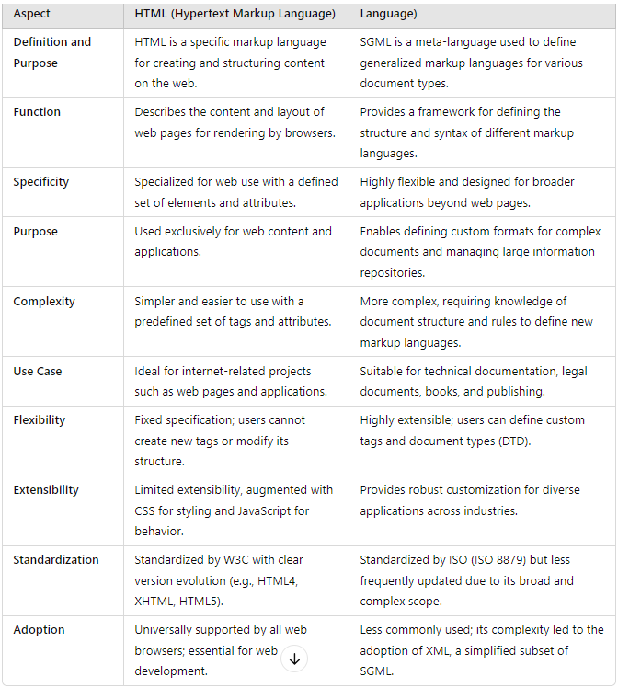

**What is multimedia and what are multimedia data formats.**

**Multimedia**

* Multimedia usually stands for applications that handle different types of digital data originating from distinct types of media.
* The most common types of media in multimedia applications are text, sound, images, and video (which is an animated sequence of images).
* The digital data originating from each of these four types of media is quite distinct in volume, format, and processing requirements (for instance, video and audio impose real time constraints on their processing).
* As an immediate consequence, different types of formats are necessary for storing each type of media.
* In contrast with text formats, most formats for multimedia are partially binary and hence can only be processed by a computer. Also, the presentation style is almost completely defined, perhaps with the exception of some spatial or temporal attributes.

Multimedia data involves various types of content like text, audio, video, images, and animations. Different formats are used to store and transmit multimedia data, each optimized for specific types of content and applications.

**1. Image Formats**

* **JPEG (Joint Photographic Experts Group)**:
  + **Extension**: .jpg, .jpeg
  + **Characteristics**: Lossy compression, good for photographs and images with gradients. Supports millions of colors.
  + **Use Cases**: Digital photography, web images where file size needs to be reduced.
* **PNG (Portable Network Graphics)**:
  + **Extension**: .png
  + **Characteristics**: Lossless compression, supports transparency (alpha channel), supports up to 24-bit color.
  + **Use Cases**: Web graphics, images requiring transparency, lossless images where quality is important.
* **GIF (Graphics Interchange Format)**:
  + **Extension**: .gif
  + **Characteristics**: Lossless compression (but limited to 256 colors), supports animations, supports transparency. GIF is good for black and white pictures, as well as pictures that have a small number of colors or gray levels (say 256)
  + **Use Cases**: Simple graphics, animations, and icons with a limited color palette.

**3. BMP (Bitmap)**:

* **Extension**: .bmp
* **Characteristics**: Uncompressed, high quality, large file sizes, supports 24-bit color. It is a direct representations of a bit-mapped (or pixel-based) display such as XBM, BMP, or PCX. However, those formats consume too much space.
* **Use Cases**: Windows-based applications, bitmap editing, image processing.

4. **TIFF (Tagged Image File Format)**:

* **Extension**: .tiff, .tif
* **Characteristics**: This format is used to exchange documents between different applications and different computer platforms. TIFF has fields for metadata and also supports compression as well as different numbers of colors.
* **Use Cases**: Professional photography, desktop publishing, scanning.

**5. WebP**:

* **Extension**: .webp
* **Characteristics**: Supports both lossy and lossless compression, smaller file sizes with high quality, supports transparency.
* **Use Cases**: Web images, particularly for faster loading times with good quality.

**Audio Formats**

* Audio must be digitalized first in order to be stored properly.
* The most common formats for small pieces of digital audio are AU, MIDI, and **WAVE.**

1. **MP3 (MPEG Audio Layer III)**:

* **Extension**: .mp3
* **Characteristics**: Lossy compression, popular for music and podcasts, balances file size and quality.
* **Use Cases**: Music streaming, portable media players, internet audio.

1. **WAV (Waveform Audio File Format)**:

* **Extension**: .wav
* **Characteristics**: Uncompressed, high-quality audio, large file sizes.
* **Use Cases**: Professional audio editing, sound engineering, archival.

1. **AAC (Advanced Audio Codec)**:

* **Extension**: .aac
* **Characteristics**: Lossy compression, better quality than MP3 at the same bit rate, widely used in streaming.
* **Use Cases**: Apple devices, streaming services, YouTube.

**4. FLAC (Free Lossless Audio Codec)**:

* **Extension**: .flac
* **Characteristics**: Lossless compression, high-quality audio, file size larger than lossy formats but smaller than uncompressed.
* **Use Cases**: High-fidelity audio, music collections, archiving.

**5. OGG (Ogg Vorbis)**:

* **Extension**: .ogg
* **Characteristics**: Open-source, lossy compression, high-quality audio.
* **Use Cases**: Open-source applications, streaming services, online audio.

**6. WMA (Windows Media Audio)**:

* **Extension**: .wma
* **Characteristics**: Lossy and lossless compression, proprietary format by Microsoft.
* **Use Cases**: Windows-based applications, streaming services.

**7. AU:**

* **File Extension**: .au
* **Characteristics**
* **Encoding Methods**:
  + **PCM (Pulse Code Modulation)**: Typically used for uncompressed audio, providing high-quality sound but with larger file sizes.
  + **μ-law (mu-law)** and **A-law**: Compression methods that reduce the file size while preserving reasonable audio quality, often used for voice recordings.
* **Audio Quality**:
  + **Bit Depth**: Can vary (e.g., 8-bit, 16-bit). Higher bit depths offer better audio quality but result in larger files.
  + **Sample Rate**: Supports various sample rates (e.g., 8 kHz, 44.1 kHz), affecting the audio's frequency response and detail.
  + The quality can be high with PCM encoding, though μ-law and A-law methods offer more compressed, lower-quality audio.
  + **File Size**:
    1. The size of AU files varies significantly based on the encoding method and audio parameters. PCM-encoded AU files are typically large, while μ-law and A-law encoded files are smaller due to compression.
* **AU Use Cases:**
* **Unix and Linux Systems**:

Historically used for system sounds and basic audio playback on Unix-based systems and workstations.

* **Early Web Audio**:

Used for simple web audio applications and early multimedia on websites before the widespread adoption of formats like MP3.

* **Voice and Telephony Applications**:

Suitable for voice recordings and telephony due to support for μ-law and A-law compression, which efficiently handle voice data.

* **Cross-Platform Compatibility**:

Used in various applications where compatibility with Unix systems was required, and for basic audio processing tasks.

* **Educational and Legacy Systems**:

Sometimes used in educational contexts or legacy systems where historical formats are relevant for understanding early digital audio technologies.

**8. MIDI Format ((Musical Instrument Digital Interface)):**

* **Extensions:** .mid, .midi
* **MIDI is an standard format to interchange music between electronic instruments and computers. For audio libraries other** formats are used such **as RealAudio or CD formats.**
* The **MIDI audio format** is not an audio format in the traditional sense but rather a **digital standard for encoding musical performance data.**
* **Use Cases:** Its compact size, flexibility, and universal compatibility make it an essential tool in music production, live performance, and educational applications. MIDI allows musicians and producers to create complex compositions and control multiple instruments, all while maintaining a small file size and providing high levels of editability and creative freedom.

**Formats for Animation or moving objects**

1. **MPEG Format:**

**File Extension**: .mp4

**Characteristics**:

* **Supports Video and Audio**: MP4 is a multimedia format that can store video, audio, subtitles, and images, making it versatile for animations with sound.
* **High Compression Efficiency**: Uses modern video codecs like H.264 or H.265, which provide high-quality video at smaller file sizes.
* **Wide Compatibility**: Supported by nearly all devices and platforms, making it ideal for sharing and streaming video content.

**Use Cases**:

* Complex animations, animated videos, web video, social media, streaming services, and video marketing.

**2. GIF (Graphics Interchange Format)**

* **File Extension**: .gif
* **Characteristics**:
  + **Supports Animation**: GIFs can display a series of images in sequence, creating simple animations or looping effects.
  + **Limited Color Palette**: Uses an 8-bit color palette, allowing up to 256 colors per frame. This limitation makes GIFs suitable for simple graphics and animations but less ideal for high-quality images.
  + **No Sound**: GIFs do not support audio, making them best for silent animations.
  + **Lossless Compression**: Compresses images without losing quality, but the color limitation can reduce the visual quality of complex images.
* **Use Cases**:
  + Web graphics, memes, simple animations, and social media posts due to their small size and widespread browser support.

**3. MOV (QuickTime Movie)**

* **File Extension**: .mov
* **Characteristics**:
  + **Supports Video and Audio**: Similar to MP4, MOV can contain high-quality video and audio, often used for professional editing.
  + **High Quality and Large Files**: Provides high-quality video suitable for professional environments, though often results in larger files than MP4.
  + **Flexible Codec Support**: Can support a variety of video and audio codecs.
* **Use Cases**:
  + Professional animation production, video editing, and post-production workflows, particularly on Apple devices and software like Final Cut Pro.

**4. FLV (Flash Video)**

* **File Extension**: .flv
* **Characteristics**:
  + **Supports Animation and Video**: Was widely used for online video streaming and animation.
  + **Highly Compressed**: Uses formats like Sorenson Spark or VP6, making it suitable for fast streaming but often at lower quality.
  + **Legacy Format**: Flash is no longer widely supported due to security concerns, and its use has declined in favor of formats like MP4.
* **Use Cases**:
  + Historically used for web animations, interactive content, and video streaming, especially in Flash-based websites.

**5. AVIF (AV1 Image File Format)**

* **File Extension**: .avif
* **Characteristics**:
  + **Supports Animation**: Allows for animated sequences similar to GIF and APNG.
  + **Advanced Compression**: Uses AV1 codec for efficient compression, providing high-quality images at smaller sizes.
  + **Full Color and Transparency Support**: Supports HDR, transparency, and wide color gamut, making it suitable for high-quality animations.
* **Use Cases**:
  + Web animations, high-quality image sequences, and scenarios where bandwidth and storage efficiency are crucial.

**Textual Images and it’s retrieval**

* The images of documents that contain mainly typed or typeset text are called textual images and are obtained by scanning the documents, usually for archiving purposes — a procedure that also makes the images (and their associated text) available to anyone through a computer network.
* The fact that a large portion of a textual image is text can be used for retrieval purposes and efficient compression.
* We have seen that the most popular image formats include some form of compression embedded in them. In the case of textual images, further compression can be achieved by extracting the different text symbols or marks from the image, building a library of symbols for them, and representing each one (within the image) by a position in the library.
* As many symbols are repeated, the compression ratio is quite good. Although this technique is lossy (because the reconstructed image is not equal to the original), the reconstructed image can be read without problems.
* Additional information can be stored to reproduce the original image, but for most applications this is not needed.
* If the image contains non-textual information such as logos or signatures, which might be necessary to reproduce, they may be extracted through a segmentation process, stored, and compressed separately. When needed, the textual and non-textual parts of the image can be combined and displayed together.

**Retrieval**

* At creation time or when added to the database, a set of keywords that describe the image is associated with it (for example, metadata can be used). Later, conventional text retrieval techniques can be applied to those keywords. This alternative is valid for any multimedia object.
* Use OCR to extract the text of the image. The resultant ASCII text can be used to extract keywords, as before, or as a full-text description of the image. Depending on the document type, the OCR output could be reasonably good or actually quite bad (consider the first page of a newspaper, with several columns, different font types and sizes). In any case, many typos are introduced and a usual keyword-based query might miss many documents (in this case, an approximate search is better, but also slower).
* Use the symbols extracted from the images as basic units to combine image retrieval techniques (see Chapter 12) with sequence retrieval techniques (see Chapter 8). In this case, the query is transformed into a symbol sequence that has to match approximately another symbol sequence in the com- pressed image. This idea seems promising but has not been pursued yet.

**HyTime**

HyTime stands for Hypermedia/Time-based Structuring Language. It is a standard for representing hypermedia (like text, graphics, audio, and video) and time-based multimedia content in digital form.

HyTime is built on top of SGML (Standard Generalized Markup Language) and provides a framework for describing the structure of multimedia documents and the relationships between their components.

**Key Characteristics:  
1. Markup Language Standard:**

HyTime is an international standard (ISO/IEC 10744) developed to provide a framework for representing complex multimedia documents. It leverages SGML, which means it uses a descriptive, structured approach to document creation.

**2. Support for Hypermedia:**

The format is designed to handle hypertext and hypermedia, allowing for the creation of links and connections between various forms of data. This includes links between text, images, audio, video, and more, much like what is seen on the modern web but with a much more generalized scope.

**3. Time-Based Media:**

HyTime has strong support for representing time-based information, such as audio and video. It provides mechanisms to describe synchronization and sequencing, allowing complex multimedia presentations to be structured and navigated easily.

**4. Extensibility:**

HyTime is highly extensible, which allows it to be adapted for different domains and use cases. This flexibility makes it suitable for a wide range of applications beyond just multimedia, including technical documentation and complex data modeling.

**5. Architectural Forms:**

One of the core concepts of HyTime is architectural forms, which are abstract, reusable templates that define the structure and semantics of various media types and their relationships. These forms allow for the reuse and consistent representation of data structures across different documents and applications.

**6. Interoperability and Reusability:**

HyTime is designed to promote interoperability between different systems and to enable the reuse of information across various platforms. This is achieved through its reliance on SGML and its focus on defining the logical structure of documents rather than their presentation.

**Use Cases:**

**1. Technical Documentation:**

HyTime is often used in environments where technical documents need to integrate various types of data (e.g., text, diagrams, CAD files, etc.) with temporal and spatial relationships. This makes it valuable in sectors like aerospace, defense, and manufacturing, where technical documents are complex and often require multimedia elements.

**2. Digital Libraries and Archives:**

Digital libraries and archives that store multimedia collections can use HyTime to manage metadata, navigation, and temporal relationships among media elements, enhancing searchability and accessibility.

**3. Multimedia Authoring and Publishing:**

Authors and publishers of multimedia content, including eBooks and educational materials, can use HyTime to define the structure of their documents and the synchronization of multimedia components, providing a richer user experience.

**4. Interactive and Hyperlinked Documents:**

HyTime can be used to create documents that require interactive elements or hyperlinks, similar to HTML but with more complex data structuring and time-based controls.

**5. Content Repositories and Knowledge Management Systems:**

In knowledge management systems where content needs to be highly structured, reusable, and capable of linking various types of media, HyTime provides a robust framework for organizing and accessing information.

**Document Clustering**

Document clustering is the operation of grouping together similar (or related) documents in classes. In this regard, document clustering is not really an operation on the text but an operation on the collection of documents.

The operation of clustering documents is usually of two types: global and local.

1. In a global clustering strategy, the documents are grouped accordingly to their occurrence in the whole collection.
2. In a local clustering strategy, the grouping of documents is affected by the context defined by the current query and its local set of retrieved documents.

Clustering methods are usually used in IR to transform the original query in an attempt to better represent the user information need. From this perspective, clustering is an operation which is more related to the transformation of the user query than to the transformation of the text of the documents.

### Local Document Clustering

* **Definition**: Clusters specific subsets of documents retrieved from a query to improve search result organization.
* **Steps**:
  + **Initial Query and Retrieval**: User submits a query, retrieves top-N relevant documents.
  + **Clustering Retrieved Documents**: Groups similar documents into themes or subtopics.
  + **Labeling and Presentation**: Labels clusters with descriptive terms for easier navigation.
  + **Query Refinement (Optional)**: User explores clusters to refine query results.
* **Example**:
  + Query: "Apple" retrieves documents on Apple Inc., the fruit, and cultural references.
  + Clusters formed:
    - Cluster 1: Technology/Apple Inc. (e.g., iPhone, Steve Jobs, Apple Music).
    - Cluster 2: Fruit (e.g., apple pie, cultivation, varieties).
    - Cluster 3: Culture (e.g., mythology, Beatles).
  + User selects relevant cluster for more specific results.

### K-Means Clustering Process

1. **Document Representation (Vectorization)**:
   * Convert documents into vectors using TF-IDF or word embeddings (e.g., Word2Vec, GloVe, BERT).
   * Example: TF-IDF assigns higher values to terms relevant to document content.
2. **Initialization of Centroids**:
   * Randomly initialize centroids representing clusters like Technology, Fruit, and Culture.
3. **Cluster Assignment**:
   * Assign documents to nearest centroids using similarity metrics (cosine similarity/Euclidean distance).
4. **Centroid Update**:
   * Update centroids by averaging vectors in each cluster.
5. **Iteration**:
   * Repeat assignment and updating until centroids stabilize.
6. **Final Clusters**:
   * Clusters formed based on document similarity:
     + **Cluster 1**: Technology (Apple Inc.)
     + **Cluster 2**: Fruit (Apple)
     + **Cluster 3**: Culture (Mythology, Music).
7. **Interpretation**:
   * Label clusters using dominant terms/themes.

### Global Document Clustering

Global document clustering is the technique of grouping a large corpus of documents into clusters based on content similarity, without a specific query in mind. It is used to organize massive document sets, improve search efficiency, and enable content categorization. Unlike **local clustering** (focused on query results), global clustering spans the entire dataset.

### Example Scenario:

Consider 100,000 articles categorized into these topics:

1. **Technology**: AI, gadgets, software development.
2. **Health**: Fitness, nutrition, disease research.
3. **Sports**: Football, tennis, Olympics.
4. **Politics**: Elections, government policies.

Goal: Group these articles into clusters reflecting their topics.

### Step-by-Step Process:

#### Step 1: Data Collection & Preprocessing

1. **Tokenization**: Split text into words.
   * "AI is transforming smartphones" → ["AI", "is", "transforming", "smartphones"].
2. **Stopword Removal**: Remove unimportant words (e.g., "is", "the").
3. **Stemming/Lemmatization**: Convert words to root forms (e.g., "transforming" → "transform").
4. **TF-IDF Vectorization**: Represent documents numerically.  
   Example: Document vectors encode the importance of terms like "AI" or "gadgets".

#### Step 2: Vector Representation

* Preprocessed documents are converted into high-dimensional vectors.
* Example:
  + Document 1 (Technology): High values for "AI" and "gadgets".
  + Document 3 (Health): High values for "diet" and "exercise".

#### Step 3: Clustering Algorithm

* **Algorithm**: K-Means Clustering.
* **Number of Clusters**: K=4K = 4K=4 (Technology, Health, Sports, Politics).

#### Step 4: K-Means Clustering Steps

1. **Initialize Centroids**: Start with random centroids, one per cluster.
   * Example: Centroid 1 (near Technology documents).
2. **Assign Documents**: Compute similarity between documents and centroids.
   * Assign each document to the closest centroid.
   * Initial assignment:
     + Cluster 1 (Tech): Documents 1, 2, 9.
     + Cluster 2 (Health): Documents 3, 4, 10.
     + Cluster 3 (Sports): Documents 5, 6.
     + Cluster 4 (Politics): Documents 7, 8.
3. **Update Centroids**: Recalculate centroids as the mean of vectors in each cluster.
4. **Iterate Until Convergence**: Repeat assigning documents and updating centroids until clusters stabilize.

#### Step 5: Final Clusters

* Cluster 1 (Technology): AI, gadgets, software development (Documents 1, 2, 9).
* Cluster 2 (Health): Diet, fitness, health research (Documents 3, 4, 10).
* Cluster 3 (Sports): Football, tennis, Olympics (Documents 5, 6).
* Cluster 4 (Politics): Elections, policies, relations (Documents 7, 8).

### Applications:

1. **Search Optimization**:
   * Quickly direct a query like "AI" to Cluster 1 (Technology).
2. **Organized Results**:
   * Show search results grouped by clusters.
3. **Recommendations**:
   * Recommend similar articles within a cluster (e.g., health-related content).

**Conclusion**: Global document clustering (e.g., K-Means) organizes datasets into coherent groups, enhancing search, organization, and discovery in large collections.

#### Module 5

1. Short note on sequential searching (Same as 5)
2. Write short note on Information retrieval in digital libraries - GPT

**Definition**:

* Information retrieval (IR) in digital libraries refers to the process of locating, accessing, and retrieving relevant information or documents stored in a digital format. It helps users search through vast collections efficiently.

**Key Components**:

* **Metadata**: Cataloging and indexing documents using metadata like titles, authors, and keywords.
* **Search Mechanism**: Using algorithms like Boolean search, keyword matching, or semantic search to retrieve documents.
* **Ranking**: Displaying results in order of relevance using ranking methods like TF-IDF or machine learning models.

**Techniques Used**:

* **Full-text Search**: Searching entire documents for matches to query terms.
* **Query Expansion**: Broadening search terms to include synonyms or related terms.
* **Natural Language Processing (NLP)**: Understanding user intent through techniques like stemming, lemmatization, and entity recognition.

**Advantages**:

* **Efficient Access**: Quickly retrieves specific documents from large collections.
* **Remote Accessibility**: Digital libraries enable users to access information anytime, anywhere.
* **Search Personalization**: Adapts results based on user preferences and history.

**Challenges**:

* **Scalability**: Handling large-scale collections and maintaining search speed.
* **Relevance**: Ensuring that retrieved documents match user intent.
* **Interoperability**: Integrating diverse formats and standards across digital libraries.

**Applications**:

* **Academic Research**: Providing access to scholarly articles, e-books, and dissertations.
* **Archives and Historical Data**: Enabling the retrieval of digitized manuscripts and archives.
* **Public Libraries**: Facilitating access to general knowledge and cultural resources.

**Examples**:

* Systems like Google Scholar, JSTOR, and PubMed specialize in information retrieval for digital libraries.

**Evaluation Metrics**:

* Metrics such as **precision**, **recall**, and **F1-score** are used to assess the effectiveness of IR systems in digital libraries.

**Relevance in Modern Libraries**:

* Digital libraries heavily rely on IR to offer seamless, user-friendly access to their vast collections, ensuring that users find valuable resources efficiently.

**Conclusion**:

* Information retrieval is a cornerstone of digital libraries, bridging the gap between vast digital collections and user needs. Its evolution through advanced algorithms and AI ensures enhanced access and usability for a global audience.

1. Describe Metasearchers and its merits with example

* A metasearch engine (also called a meta-searcher) is a type of search tool that sends a user's query to multiple search engines and databases, aggregates the results, and presents them in a unified, ranked list.
* Unlike traditional search engines like Google or Bing, which maintain their own databases of indexed content, metasearch engines rely on the results from other search engines. They don't store web pages but instead retrieve data in real time from external search engines.

Working of meta search:

1. **Query Submission:** A user enters a search term or phrase into the metasearch engine.
2. **Query Dispatching:** The metasearch engine sends this query to several other search engines (e.g., Google, Bing, Yahoo), specialized databases (such as academic repositories), or even other metasearch engines.
3. **Result Aggregation:** Once the external search engines provide their results, the metasearch engine aggregates them. The process typically involves removing duplicate results and then ranking the results based on relevance.
4. **Display of Results:** The results from the various search engines are then presented in a single, unified list, allowing users to see the combined information in one place.

Merits:

1. **Access to a Broader Range of Results:** Since metasearch engines pull data from multiple search engines, users have access to more comprehensive and diverse information sources.
2. **Time Efficiency:** Users save time by not needing to visit multiple search engines or platforms individually. The metasearch engine collects and presents all the information in one place.
3. **Mitigation of Algorithm Bias:** Traditional search engines use specific algorithms that influence the ranking of search results. By aggregating from different sources, metasearch engines mitigate the influence of any one search engine’s ranking algorithm, offering more balanced results.
4. **Privacy:** Some metasearch engines, such as DuckDuckGo or StartPage, are designed to provide enhanced privacy by not tracking user activity or using personalized search algorithms, which are common in traditional search engines.
5. **Diverse Sources and Perspectives:** By pulling results from a variety of platforms, metasearch engines can expose users to diverse opinions, sources, and perspectives, which can be particularly useful in academic research, political analysis, or news aggregation.
6. Describe the process of creating Inverted index with example. How can this process be optimized using block addressing?

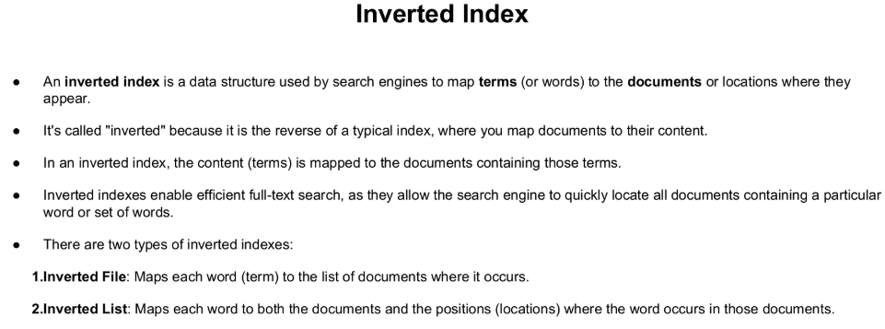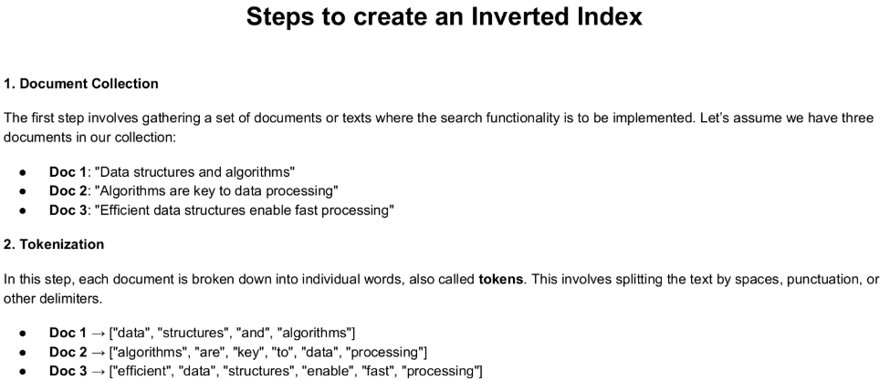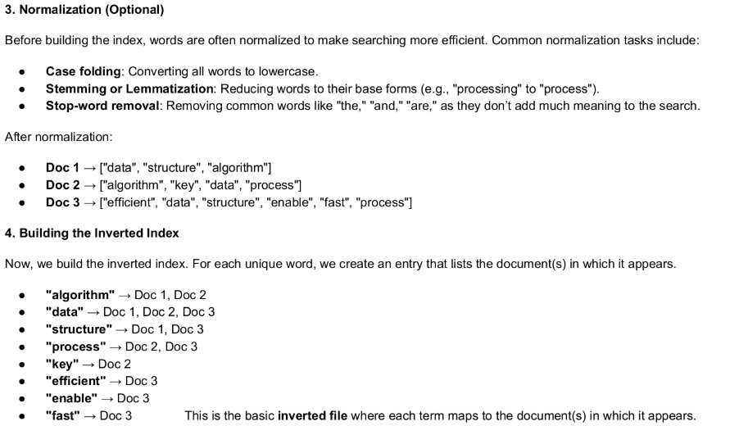

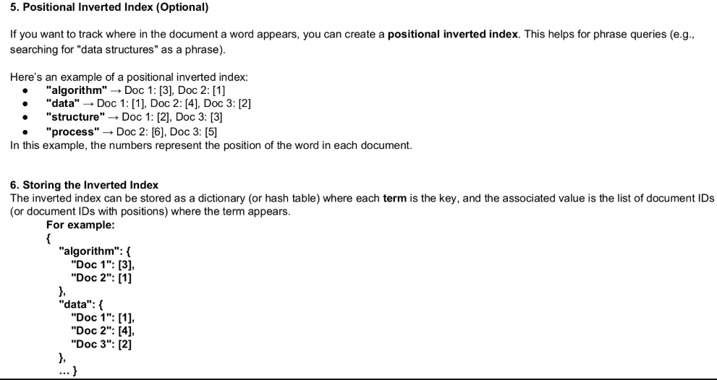

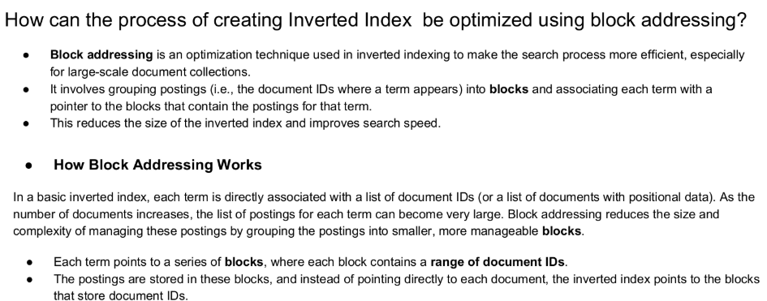

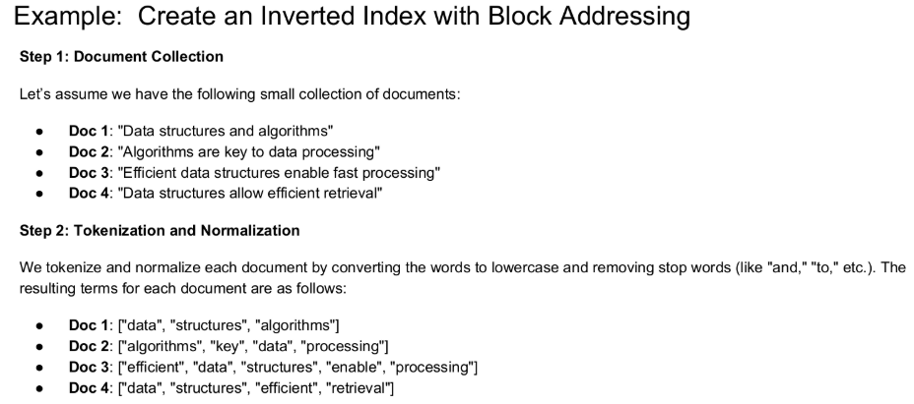

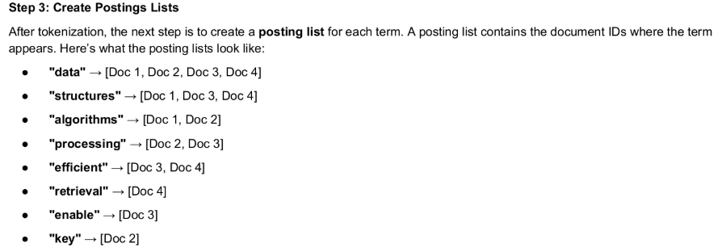

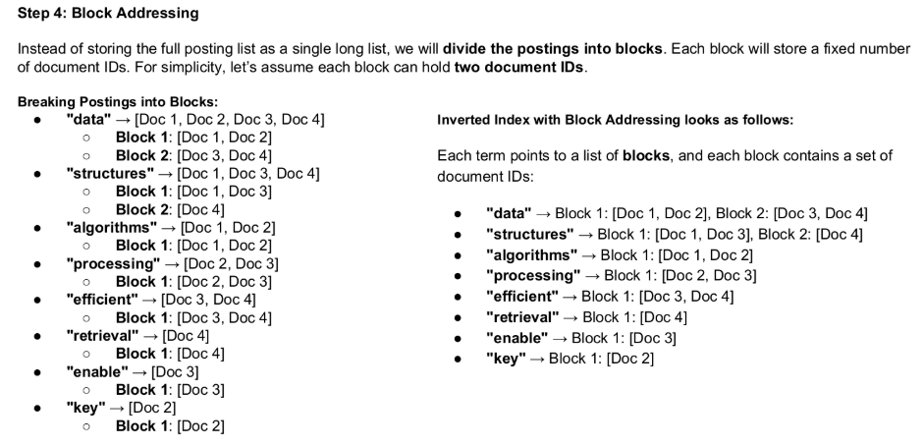

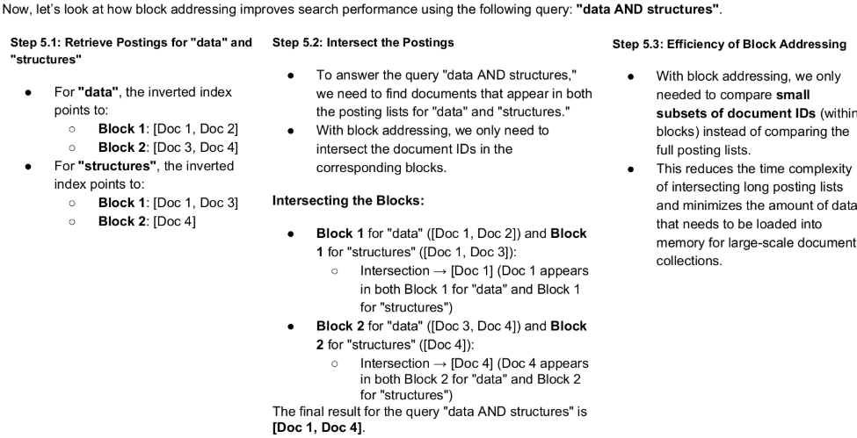

1. Describe sequential searching. Explain any one algorithm for the same. - GPT

**Definition**:

* Sequential searching in IRS refers to the process of examining each document or item in a dataset one by one to locate relevant information that matches a user's query.

**Purpose in IRS**:

* Used for retrieving documents from collections that are not indexed or structured.
* Applicable for small datasets or when other methods fail.

**Characteristics**:

* Linear approach: Each document is scanned sequentially.
* Simple but inefficient for large-scale collections.
* Does not rank results based on relevance.

**Steps in Sequential Searching**:

* Start at the beginning of the document collection.
* Compare the query terms with each document's metadata, content, or keywords.
* Stop when a match is found or continue until the end of the collection.

**Advantages in IRS**:

* **Simplicity**: Requires no advanced preprocessing or data structure.
* **No Index Dependency**: Works even when the dataset lacks indices.
* **Flexibility**: Effective for ad-hoc searches in unsorted data.

**Disadvantages in IRS**:

* **Time Complexity**: O(n)O(n)O(n) for a dataset with nnn documents, making it inefficient for large datasets.
* **No Relevance Ranking**: Cannot prioritize documents based on the quality of the match.
* **Not Scalable**: Ineffective for large-scale systems like search engines.

**Applications in IRS**:

* Prototype systems or proof-of-concept retrieval designs.
* Quick searches in small digital libraries or datasets.
* Backup search mechanism for index failures.

**Example**:

* In a collection of five documents:  
  ["AI Basics," "Machine Learning Guide," "Information Retrieval," "Data Science Overview," "NLP Techniques"],  
  searching for "Information Retrieval" involves scanning each title until a match is found.

**Algorithm** (Iterative):

* Input: Document collection DDD, query QQQ.
* For each document ddd in DDD:
  + Compare QQQ with ddd.
  + If a match is found, return ddd.
* If no match is found, return "not found."

**Conclusion**:

* Sequential searching is foundational in information retrieval but lacks efficiency and scalability for modern IRS. It serves as a fallback mechanism or an introductory method to teach retrieval basics. Advanced methods like inverted indices and vector space models are preferred for performance and relevance.

1. Write short notes on Multimedia indexing approach, interface support search process **GPT**

**Multimedia Indexing Approach**

Multimedia indexing refers to the process of organizing and retrieving multimedia data (images, videos, audio, text, etc.) efficiently using indexing techniques. As multimedia content grows exponentially in size and diversity, efficient indexing methods are critical for facilitating effective search, retrieval, and management of such content.

**Purpose of Multimedia Indexing**

* **Efficient Retrieval:** Enable quick and accurate access to relevant multimedia content.
* **Organization:** Structure multimedia data for better usability and storage management.
* **Search Optimization:** Support advanced searching techniques like content-based retrieval.
* **Scalability:** Handle large-scale multimedia databases efficiently.

**Approaches to Multimedia Indexing**

**1. Text-Based Indexing:**

* Relies on textual metadata associated with multimedia objects (e.g., tags, captions, descriptions).
* Example: Indexing an image using its file name or description.
* **Advantages:**
* Simple and widely supported.
* Can use existing text indexing algorithms like inverted indexing.
* **Disadvantages:**
* Dependent on the accuracy and completeness of metadata.
* Metadata creation can be time-consuming and error-prone.

**2. Content-Based Indexing:**

* Utilizes the actual content of multimedia objects for indexing.
* Example: Indexing an image based on features like color, texture, or shape.
* **Steps:**
* **Feature Extraction:**
* Extract low-level features from the multimedia object (e.g., color histograms for images, spectral features for audio).
* **Feature Representation:**
* Represent the extracted features as numerical data or vectors.
* **Feature Matching:**
* Use similarity measures to compare features of different multimedia objects.

**Advantages:**

* Does not require manual metadata creation.
* Suitable for large and diverse datasets.

**Disadvantages:**

* Computationally expensive.
* Complex to implement.

**3. Semantic Indexing:**

* Leverages higher-level concepts or semantics for indexing multimedia data.
* Example: Tagging an image as "beach" based on visual and contextual analysis.
* **Techniques:**
* Use machine learning and AI to map low-level features to semantic concepts.
* **Advantages:**
* More accurate and meaningful retrieval results.
* Bridges the gap between low-level features and user intent.
* **Disadvantages:**
* Requires sophisticated models and training data.
* Difficult to generalize across domains.

**4. Hybrid Indexing:**

* Combines multiple approaches (e.g., text-based and content-based indexing) for better performance.
* Example: Indexing a video using both textual metadata (title, tags) and visual features (frame analysis).
* **Advantages:**
* Balances the limitations of individual methods.
* More robust and versatile.

**Steps in Multimedia Indexing**

**1. Data Collection:**

* Gather multimedia content from sources such as databases, websites, or sensors.

**2. Preprocessing:**

* Standardize the data format, resolution, and quality (e.g., resizing images or normalizing audio signals).

**3. Feature Extraction:**

* Identify distinguishing features based on the content type:
* Images: Color, texture, edge features.
* Videos: Keyframes, motion vectors.
* Audio: Pitch, frequency spectrum.
* Text: Keywords, frequency of terms.

**4. Feature Representation:**

* Represent features in a form suitable for indexing, such as vectors or descriptors.

**5. Index Construction:**

* Create an index structure to store and organize feature data efficiently.
* Common structures:
* Trees (e.g., KD-Trees for spatial data).
* Hash tables for fast lookups.
* Inverted indices for textual data.

**6. Search and Retrieval:**

* Query the index to retrieve relevant multimedia objects.
* Query types:
* Text-based (e.g., keywords).
* Content-based (e.g., "find images similar to this one").
* Hybrid queries combining text and content.

**7. Relevance Feedback:**

* Use user feedback to refine and improve indexing and retrieval.

**Characteristics of Multimedia Indexing**

* **Diversity of Data:**
* Handles different types of media (images, videos, audio, text).
* **Scalability:**
* Designed to support large-scale databases.
* **Efficiency:**
* Optimized for quick retrieval and minimal storage overhead.
* **Accuracy:**
* Aims to reduce irrelevant results and improve precision.
* **Interactivity:**
* Supports user interaction for refining searches and improving results.

**Applications**

* **Search Engines:**
* Multimedia search in Google Images, YouTube, or Spotify.
* **Digital Libraries:**
* Indexing multimedia collections in archives and research databases.
* **Social Media Platforms:**
* Organizing and retrieving user-uploaded photos, videos, and audio clips.
* **Surveillance:**
* Indexing and searching video footage for security and monitoring.
* **Healthcare:**
* Indexing medical images (e.g., X-rays, MRIs) for diagnosis and research.
* **Entertainment:**
* Organizing multimedia content in streaming services (e.g., Netflix, Spotify).

**Advantages of Multimedia Indexing**

* **Improved Retrieval Speed:**
* Enables faster access to relevant content.
* **Enhanced User Experience:**
* Facilitates intuitive and accurate search interfaces.
* **Resource Optimization:**
* Reduces redundant data access and improves storage management.

**Challenges**

* **High Computational Cost:**
* Feature extraction and semantic analysis can be resource-intensive.
* **Ambiguity in Semantics:**
* Bridging the gap between low-level features and high-level user intent is complex.
* **Scalability:**
* Handling massive and heterogeneous datasets efficiently is challenging.

In conclusion, multimedia indexing combines various approaches and technologies to organize and retrieve multimedia content effectively. Its utility spans diverse domains, making it a cornerstone of modern information systems.

1. Describe concept of text search engine.

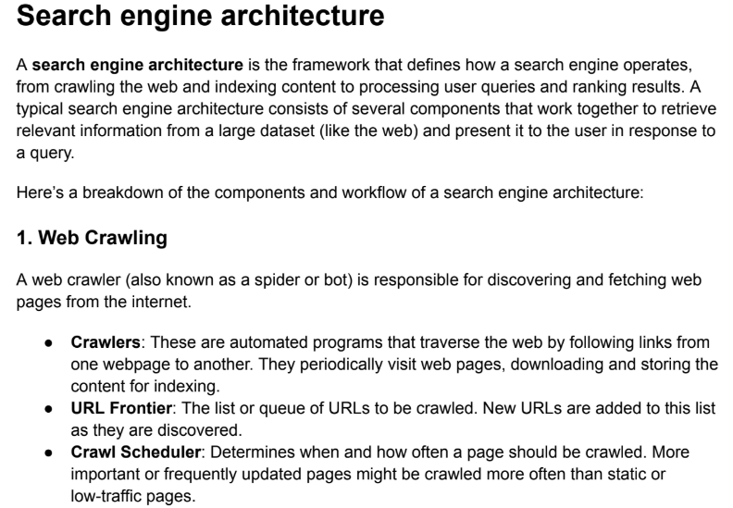

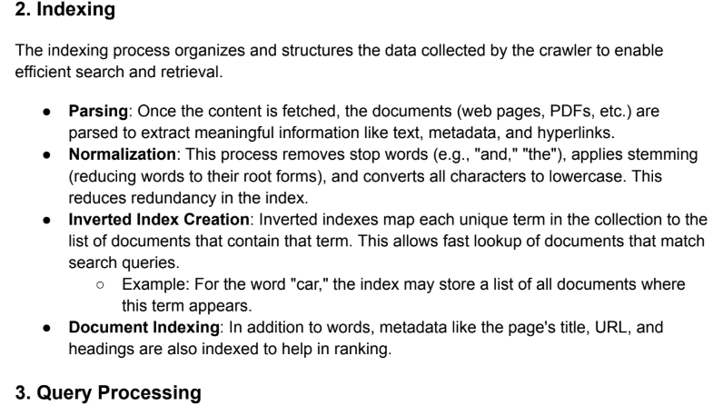

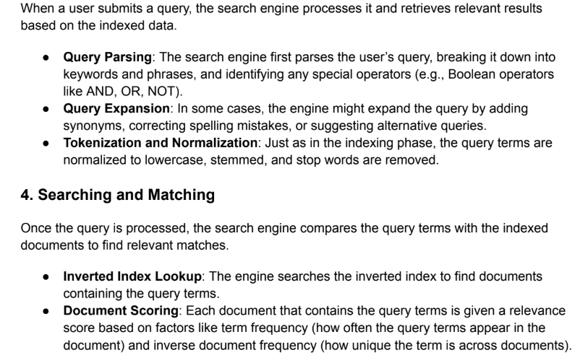

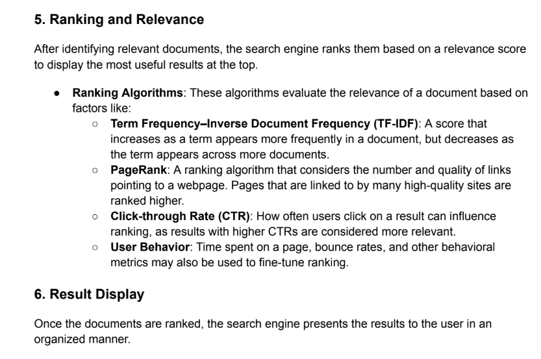

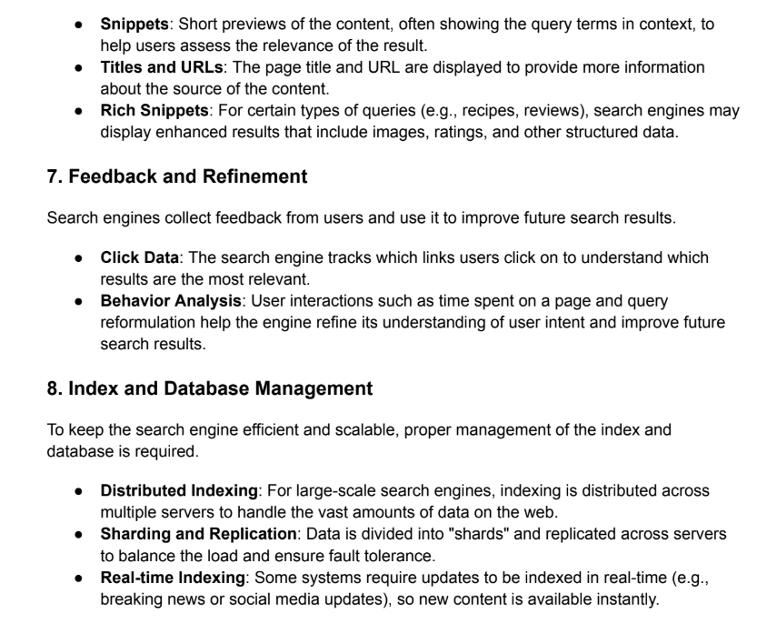

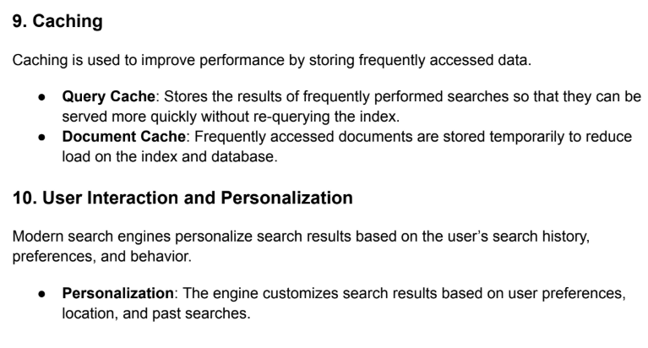

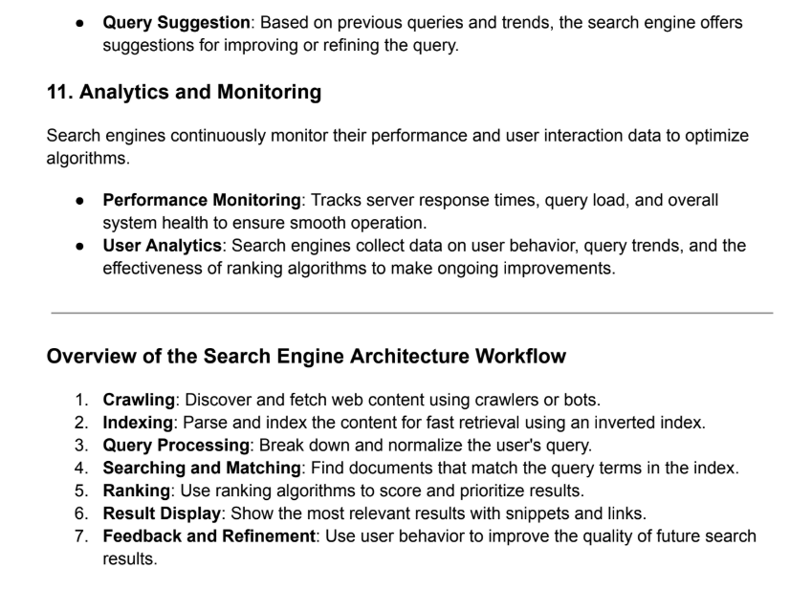

1. Explain inverted file indexing with suitable examples. (Same as 4)
2. Explain Search engine architecture. (Same as 7)
3. What are the different parameters to judge quality of information **GPT**

**Parameters to Judge the Quality of Information:**

Evaluating the quality of information is crucial in Information Retrieval Systems (IRS) to ensure that retrieved data is reliable, accurate, and useful for users. Information quality can be assessed using a variety of parameters, depending on the context, such as academic research, decision-making, or casual queries. Below are the key parameters to evaluate the quality of information:

**1. Relevance**

Definition: Measures how well the information meets the user’s query or satisfies their specific need.

**Key Indicators:**

* Contains the required content or answers the question.
* Aligns with the user's context, such as academic, technical, or casual needs.

Example: A user searching for "machine learning in healthcare" should retrieve articles specific to applications of machine learning in healthcare, not generic content about AI.

**2. Accuracy**

* Definition: Refers to the correctness and reliability of the information.
* Key Indicators:
* Free from factual errors and inconsistencies.
* Verified against trusted sources or supported by evidence.

Example: A research paper should include accurate statistics, validated methodologies, and correct citations.

**3. Authority**

* Definition: Evaluates the credibility of the source or author providing the information.
* Key Indicators:
* Author credentials, expertise, and reputation.
* Publisher or platform reliability (e.g., peer-reviewed journals, recognized institutions).

Example: A report from the World Health Organization (WHO) is more authoritative than an unverified blog post.

**4. Timeliness**

* Definition: Refers to how current and up-to-date the information is.
* Key Indicators:
* The publication date and relevance to the time-sensitive topic.
* Applicability in the context of recent developments.

Example: For topics like "COVID-19 treatments," recent studies hold more value than outdated research.

**5. Completeness**

* Definition: Assesses whether the information is comprehensive and provides all necessary details.
* Key Indicators:
* Covers multiple aspects of the topic.
* Includes supporting data, evidence, and context.

Example: A complete report on climate change should discuss causes, effects, and mitigation strategies rather than focusing on just one aspect.

**6. Consistency**

* Definition: Evaluates whether the information is free from contradictions and aligns with other credible sources.
* Key Indicators:
* Matches data or conclusions found in other trusted documents.
* Maintains logical coherence throughout the content.

Example: Financial statistics reported by multiple government databases should align with each other.

**7. Accessibility**

* Definition: Refers to the ease with which users can access, interpret, and use the information.
* Key Indicators:
* Availability in the required format (e.g., text, graphs, videos).
* Language simplicity and clarity.

Example: A well-designed dashboard with filters and visualization tools is more accessible than raw datasets.

**8. Objectivity**

* Definition: Ensures that the information is unbiased and free from personal opinions or agenda-driven distortions.
* Key Indicators:
* Neutral tone and presentation of facts.
* Avoidance of persuasive or promotional language unless explicitly stated.

Example: A scientific article presenting experimental results without favoring a specific outcome is objective.

**9. Verifiability**

* Definition: Refers to whether the claims or facts in the information can be cross-checked or validated independently.
* Key Indicators:
* References, citations, or links to original sources.
* Data supported by empirical evidence.

Example: A statement like "The global population is 8 billion" should link to a trusted database such as United Nations Population Data.

**10. Precision**

* Definition: Measures the specificity of the information in answering the user's query.
* Key Indicators:
* Focused and direct response without irrelevant data.
* Avoids generalizations when specificity is required.

Example: A medical query about "symptoms of diabetes" should not include unrelated health conditions.

**11. Novelty**

* Definition: Refers to the uniqueness and originality of the information.
* Key Indicators:
* Presents new insights, findings, or perspectives.
* Avoids redundancy with existing, well-known information.

Example: A groundbreaking study on AI algorithms provides higher novelty than summarizing existing technologies.

**12. Format and Presentation**

* Definition: Refers to how the information is structured and displayed for user comprehension.
* Key Indicators:
* Clear headings, well-organized sections, and readable formats.
* Includes visual aids such as graphs, charts, or infographics when needed.

Example: A research report with properly labeled diagrams is easier to interpret than a cluttered text document.

**13. Scalability and Scope**

* Definition: Assesses whether the information addresses both the broader and specific contexts of the query.
* Key Indicators:
* Broad enough to give an overview but detailed enough for specific insights.

Example: An encyclopedia article on "machine learning" provides a general introduction, while a technical research paper focuses on algorithms.

**Application in Information Retrieval Systems:**

In IRS, these parameters play a pivotal role in evaluating and improving the performance of retrieval models and systems. They ensure that users can access high-quality, relevant, and trustworthy information efficiently, fostering better decision-making and satisfaction.

1. SN on scalar and metrics clusters
2. What is query specification? Describe direct manipulation and natural language in the context of boolean query formation

**Query Specification in Information Retrieval Systems**

Query specification refers to the process by which users express their information needs to an Information Retrieval System (IRS). It involves translating a user's search intent into a structured query that the system can interpret to retrieve relevant information. Effective query specification ensures that the system delivers results that closely align with the user's needs.

The specification process often involves:

Selecting appropriate keywords or terms.

Defining relationships between terms using logical operators (e.g., AND, OR, NOT).

Refining the query based on the retrieval model or system interface.

In the context of Boolean query formation, query specification uses Boolean operators to form expressions that define the relationships between search terms explicitly. Boolean queries are logical, rule-based statements that instruct the system on how to combine terms to filter results.

**Direct Manipulation in Query Specification**

Direct manipulation refers to query specification techniques that allow users to construct or refine their queries interactively, often with visual aids or user-friendly interfaces, without requiring explicit knowledge of Boolean syntax.

**Characteristics:**

* Visual Representation: Interfaces use drag-and-drop elements, sliders, or filters to represent search terms and logical operators.
* Ease of Use: Suitable for non-technical users, as it eliminates the need to write complex query syntax.
* Immediate Feedback: Systems may provide real-time previews of results or query structures, helping users refine queries dynamically.

Example:

A graphical interface where users select terms from a list and connect them using AND, OR, or NOT through buttons or dropdowns.

Search engines offer "Advanced Search" options with checkboxes for including or excluding terms and dropdowns for specifying relationships (e.g., "must include," "should include").

**Application in Boolean Query Formation:**

* Users specify their search needs interactively. For instance:
* Include documents with "machine learning" AND "healthcare".
* Exclude results containing "outdated."
* Direct manipulation simplifies Boolean query formation by abstracting complex logic into intuitive visual tools.

**Natural Language in Query Specification**

Natural language query specification involves users expressing their search intent in everyday language, as they would in a conversation, without needing to know Boolean operators or system-specific syntax.

**Characteristics:**

* Ease of Use: Users can articulate queries naturally, making it accessible to a broader audience.
* System Interpretation: The IRS processes and interprets the natural language query, mapping it to Boolean logic or other retrieval mechanisms.
* Conversational Approach: Some systems use AI and NLP techniques to engage in a dialogue for query clarification.

Example:

A user enters:

"Find articles about machine learning applications in healthcare but not those related to COVID-19."

The system translates this into a Boolean query:

(machine learning AND healthcare) AND NOT (COVID-19).

**Application in Boolean Query Formation:**

* Systems use Natural Language Processing (NLP) to parse the query, identify key terms, and determine logical relationships.
* NLP tools analyze sentence structure, semantics, and context to create a structured Boolean query.

**Advantages:**

* Removes the need for users to learn Boolean syntax.
* Encourages more expressive and complex queries.
* Reduces the learning curve for inexperienced users.

**Comparison of Direct Manipulation and Natural Language Approaches**

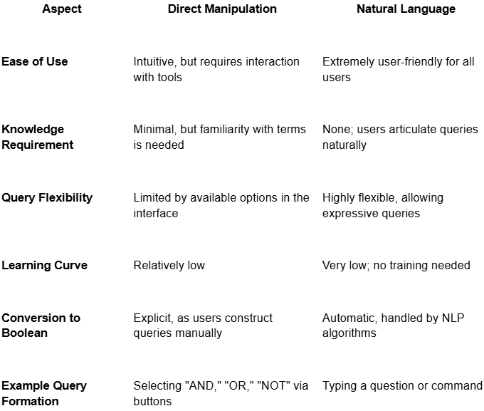

1. SN on Web information retrieval system(Same as search engine)
2. SN on automatic feature extraction

### Automatic Feature Extraction

Automatic Feature Extraction refers to the process of identifying and transforming raw data into a set of meaningful and non-redundant features without human intervention. It simplifies and improves the performance of machine learning models by reducing dimensionality and focusing on relevant data attributes.

#### How It Works:

1. **Input Data**:
   * Can be structured (e.g., tables) or unstructured (e.g., images, text, audio).
2. **Transformation**:
   * Algorithms analyze raw data and extract features that capture underlying patterns or representations.
   * Techniques vary based on the data type and application.
3. **Output Features**:
   * A reduced set of variables that are most informative for the target task, such as classification, clustering, or prediction.

#### Techniques for Automatic Feature Extraction:

1. **For Text Data**:
   * **TF-IDF (Term Frequency-Inverse Document Frequency)**: Extracts key terms based on their importance.
   * **Word Embeddings**: Converts words into vector representations (e.g., Word2Vec, GloVe).
2. **For Image Data**:
   * **Convolutional Neural Networks (CNNs)**: Automatically detect edges, textures, and shapes through layers.
   * **Pre-trained Models**: Use models like VGG, ResNet, or EfficientNet to extract features.
3. **For Time-Series Data**:
   * **Fourier Transform**: Captures frequency-based features.
   * **Wavelet Transform**: Analyzes temporal changes in the signal.
4. **For Tabular Data**:
   * **AutoEncoders**: Neural networks that learn compressed representations of the data.
   * **Tree-based Methods**: Random forests and gradient boosting algorithms can rank features by importance.
5. **For Audio Data**:
   * **MFCC (Mel-Frequency Cepstral Coefficients)**: Extracts spectral features relevant to sound.
   * **Spectrograms**: Convert audio signals into image-like representations for further processing.

#### Benefits:

* **Efficiency**: Reduces the manual effort of identifying relevant features.
* **Accuracy**: Focuses on significant attributes, improving model performance.
* **Generality**: Can adapt to various types of data and applications.
* **Dimensionality Reduction**: Removes irrelevant or redundant information.

#### Applications:

1. **Computer Vision**: Face recognition, medical imaging, object detection.
2. **Natural Language Processing (NLP)**: Sentiment analysis, machine translation.
3. **Healthcare**: Disease prediction based on patient data.
4. **Finance**: Fraud detection and risk assessment
5. SN on A Generic Multimedia indexing approach

### Generic Multimedia Indexing Approach

A **Generic Multimedia Indexing Approach** is a methodology to organize and retrieve multimedia content (images, audio, video, text) efficiently. It focuses on creating a unified framework that can handle the diverse nature of multimedia data and facilitate effective searching and retrieval.

#### Steps in a Generic Multimedia Indexing Approach:

1. **Data Acquisition**:
   * Collect multimedia content from various sources (e.g., web, sensors, repositories).
2. **Feature Extraction**:
   * Extract meaningful features from each media type:
     + **Images/Videos**: Color histograms, texture, shape, deep features (e.g., CNN embeddings).
     + **Audio**: MFCCs, spectral features, pitch.
     + **Text**: Keywords, phrases, semantic embeddings (e.g., Word2Vec, BERT).
3. **Feature Representation**:
   * Convert extracted features into a common numerical format (e.g., vectors) for uniform handling.
   * Normalize and preprocess features for consistency.
4. **Indexing**:
   * Organize the feature representations into efficient data structures for fast retrieval:
     + **Spatial Indexing**: KD-trees, R-trees for image and video features.
     + **Hashing**: Locality-sensitive hashing (LSH) for approximate nearest neighbors.
     + **Inverted Index**: Used for text-based features and tags.
5. **Storage**:
   * Use databases optimized for multimedia, such as NoSQL (e.g., MongoDB) or multimedia-specific DBMSs.
6. **Similarity Matching**:
   * Define similarity measures to compare query features with indexed features:
     + **Cosine Similarity**: For text or embeddings.
     + **Euclidean Distance**: For spatial features.
     + **Dynamic Time Warping (DTW)**: For audio or temporal sequences.
7. **Multimodal Fusion**:
   * Combine features from different media types for cross-media retrieval (e.g., text-image, audio-video).
8. **Retrieval and Ranking**:
   * Match user queries (text, images, or voice) with indexed features.
   * Rank results based on relevance using ranking models (e.g., weighted combinations, machine learning models).

#### Advantages:

* **Scalability**: Handles large-scale multimedia datasets.
* **Unified Framework**: Manages multiple types of media in a cohesive manner.
* **Efficient Retrieval**: Reduces search time with optimized indexing and similarity matching.
* **Cross-media Retrieval**: Supports queries across different types of data.

#### Applications:

1. **Search Engines**: Multimedia search on platforms like Google Images or YouTube.
2. **Digital Libraries**: Accessing multimedia content in archives.
3. **E-commerce**: Visual search for products using images.
4. **Healthcare**: Retrieving medical images or videos based on symptoms or descriptions.
5. SN on statistical text compression and dictionary based text compression

### Text Compression: Statistical vs. Dictionary-Based

Text compression techniques reduce the size of text data by encoding it efficiently while preserving the original information. Two widely used approaches are **Statistical Text Compression** and **Dictionary-Based Text Compression**.

### 1. Statistical Text Compression

#### Overview:

* Relies on the statistical properties of the text to assign shorter codes to frequently occurring characters or patterns.
* Operates on probabilities and frequencies.

#### Techniques:

1. **Huffman Coding**:
   * Builds a binary tree based on the frequency of characters.
   * Frequently used characters get shorter codes, and rare characters get longer codes.
   * Example:
     + For "AAABBCC", A (most frequent) gets 0, B gets 10, and C gets 11.
2. **Arithmetic Coding**:
   * Encodes the entire message into a single floating-point number between 0 and 1.
   * Higher precision but computationally intensive.
3. **Prediction by Partial Matching (PPM)**:
   * Predicts the next character based on context and adjusts the encoding probabilities dynamically.

#### Advantages:

* Highly efficient for texts with skewed frequency distributions.
* Produces minimal redundancy.

#### Disadvantages:

* Computationally expensive for large-scale text.
* Not ideal for dynamic or streaming data.

### 2. Dictionary-Based Text Compression

#### Overview:

* Uses a dictionary (explicit or implicit) to replace repeated patterns with shorter references or codes.
* Operates by detecting substrings and encoding them efficiently.

#### Techniques:

1. **Lempel-Ziv (LZ)**:
   * Variants include LZ77, LZ78, and LZW.
   * Example:
     + For "ABABAB", LZ78 encodes it as:
       - Dictionary: {A, B, AB}
       - Output: (A), (B), (AB), (AB)
2. **Dynamic Dictionaries**:
   * Dictionary evolves as the text is parsed.
   * Example: LZW builds the dictionary on-the-fly.
3. **Static Dictionaries**:
   * Predefined dictionary based on known text patterns (e.g., codebooks in multimedia).

#### Advantages:

* Efficient for repetitive patterns.
* Easy to implement and computationally faster than statistical methods.

#### Disadvantages:

* Less effective for highly diverse texts or small inputs.
* Requires additional storage for the dictionary.

### Applications:

* **Statistical**: File compression (e.g., ZIP using Huffman), data transmission where precision is critical.
* **Dictionary-Based**: General-purpose compression tools (e.g., gzip, PNG compression).

#### 

### Module 6

**AIR (Audio)**

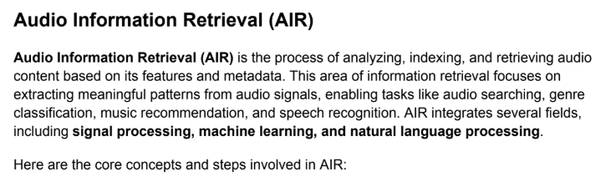

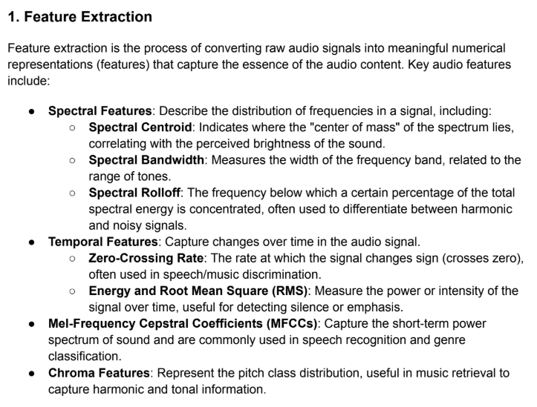

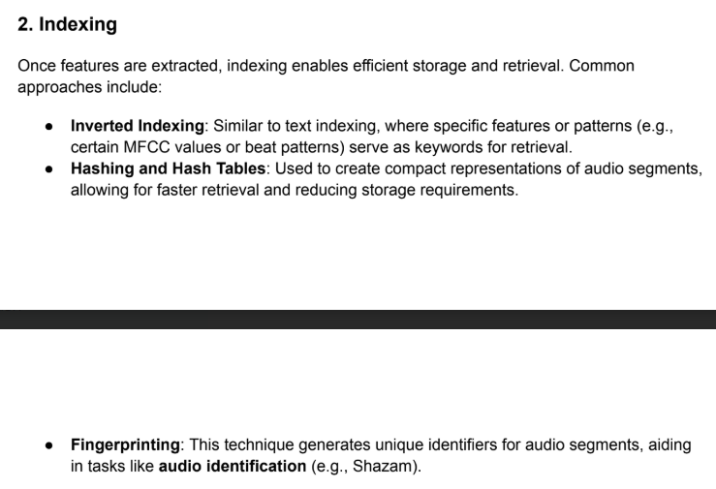

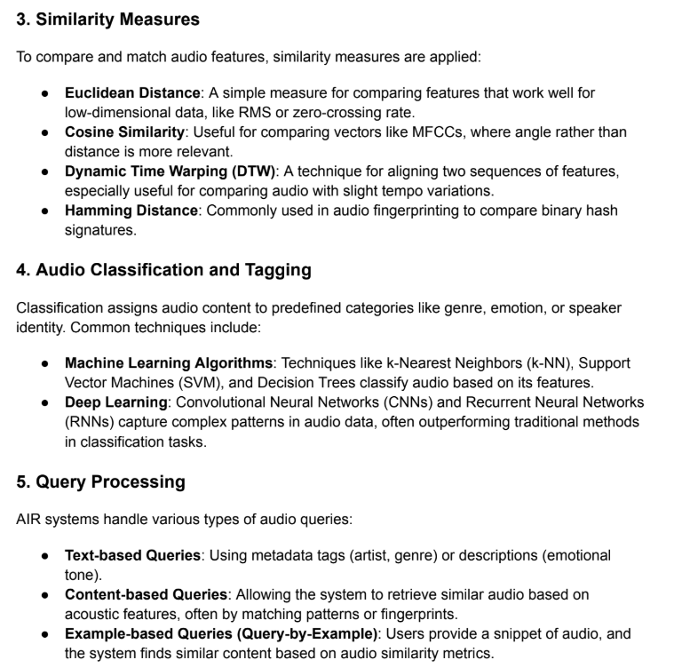

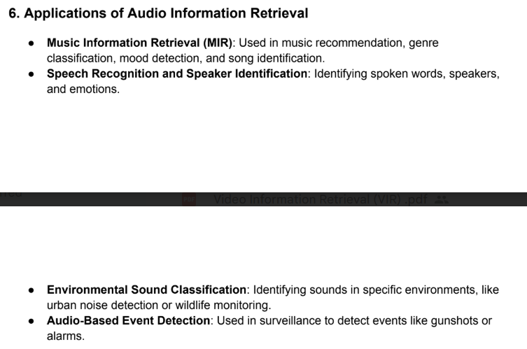

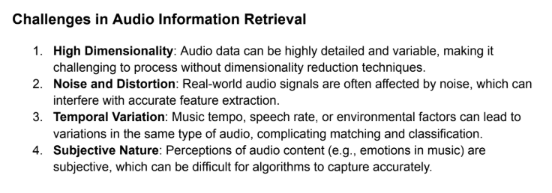

**IIR (Image)**

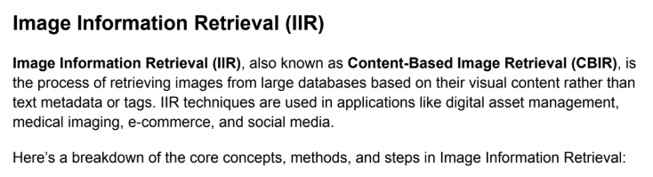

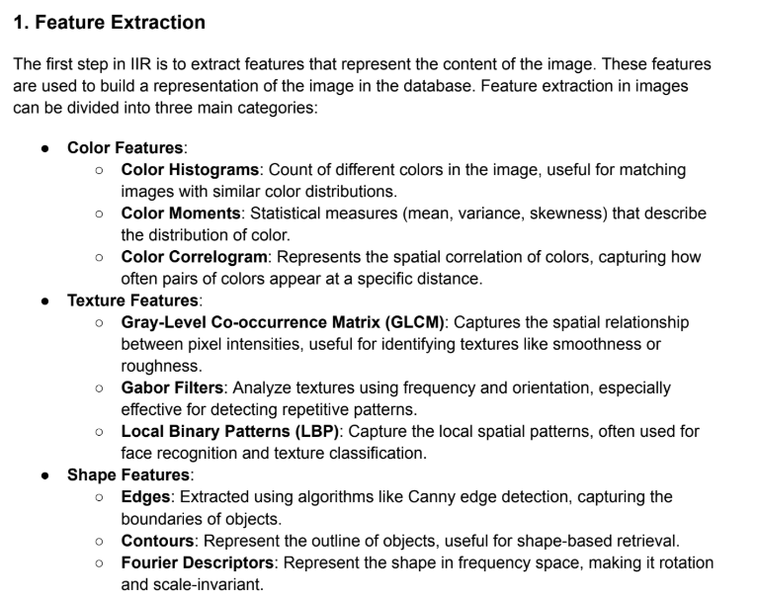

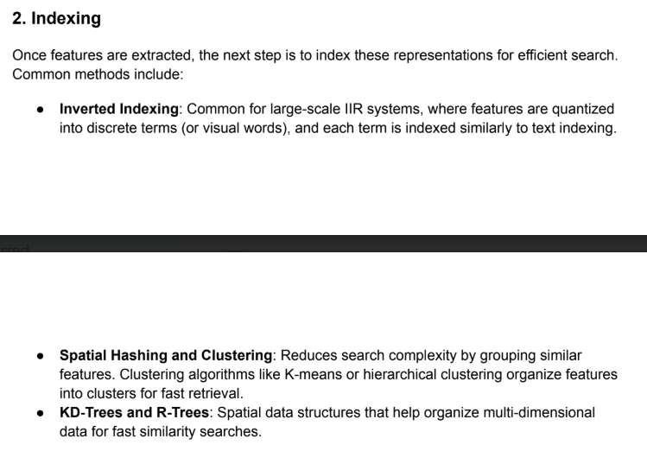

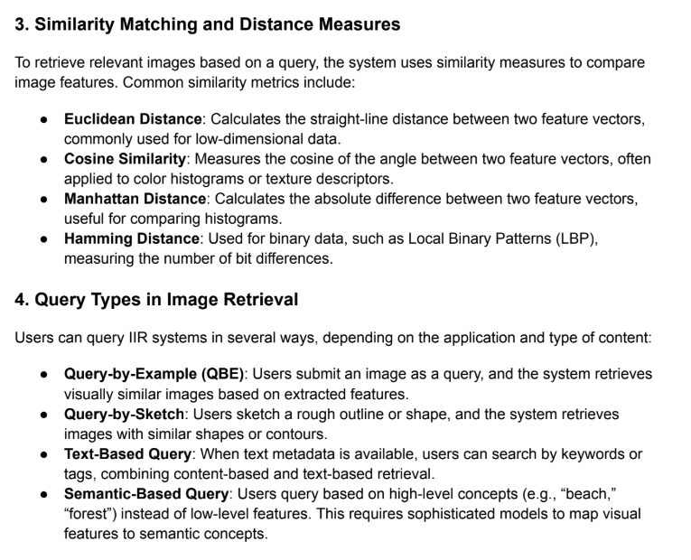

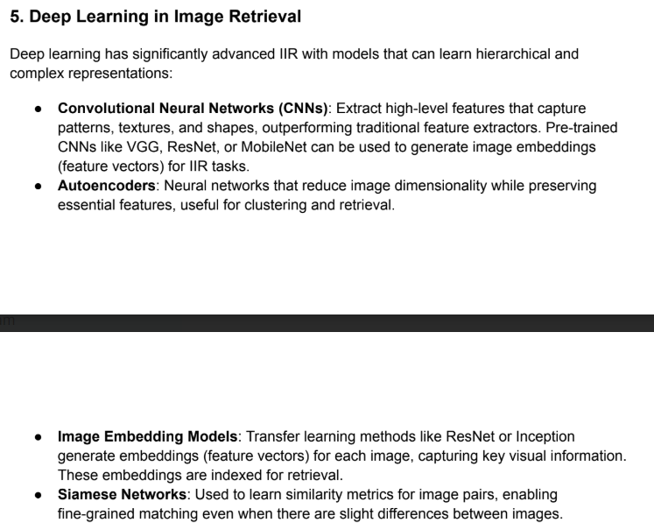

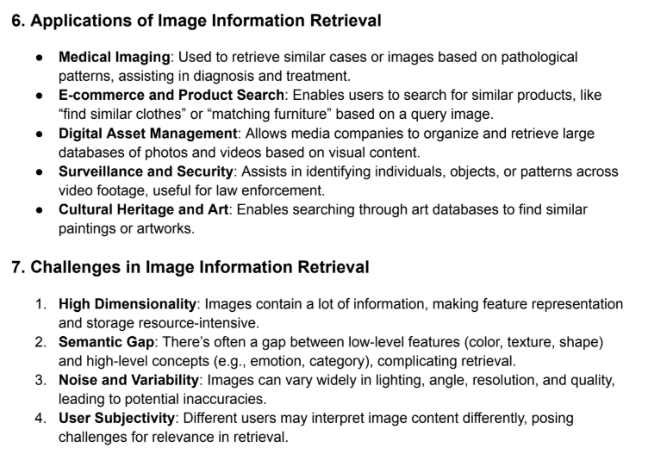 **VIR (Video) / Explain the process of Video information retrieval (PYQ)**

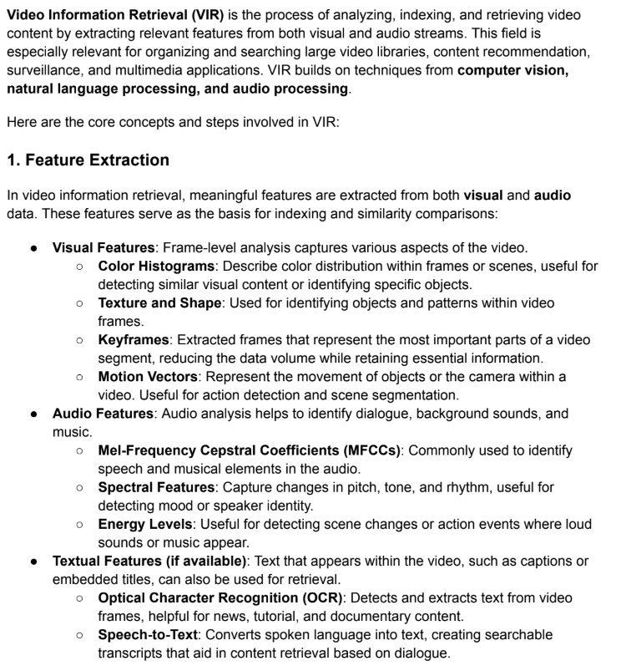

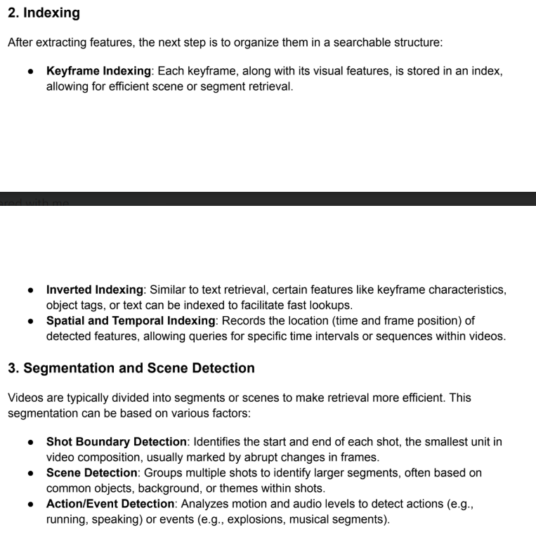

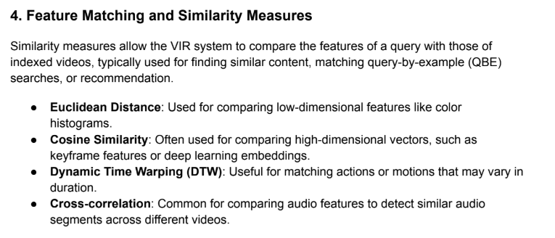

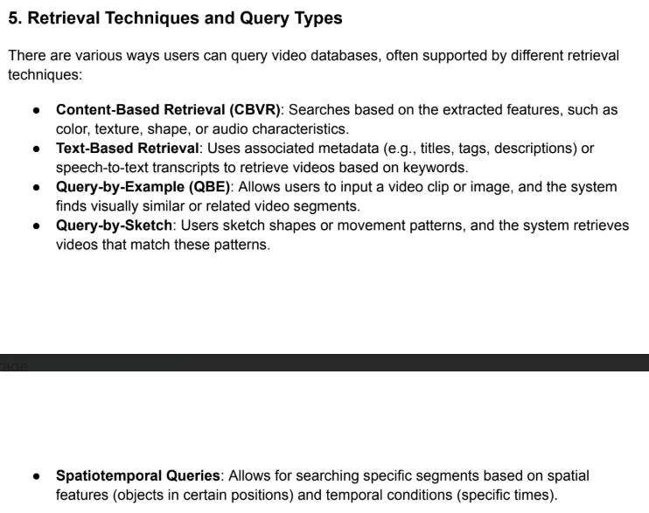



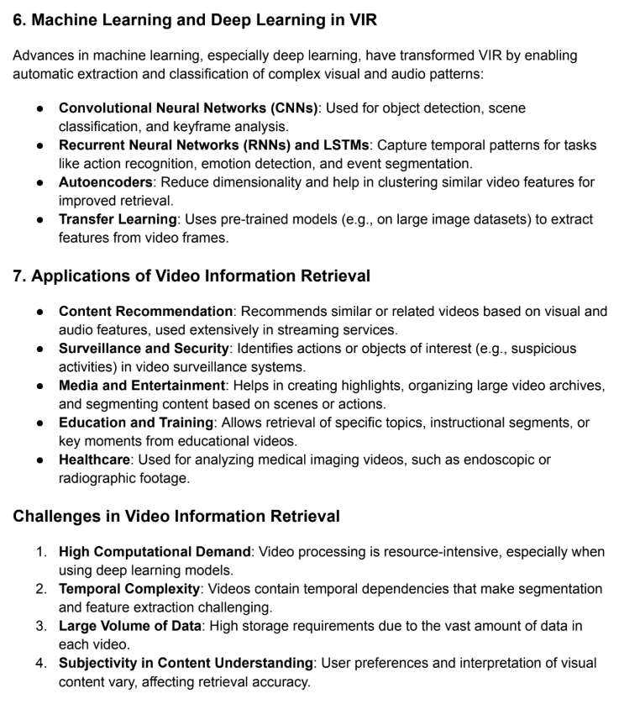

**User Interface Requirement ( good and bad interface) PYQ**  
**1) Interface**

* We have **IRS**. To this, we as a user have to connect.
  1. **Input**: Data to be given to the system, called the input interface.
  2. **Output**: Data to be read from the system, called the output interface.
  3. These interfaces must be **user interfaces**:
     + Designed from the user's point of view.
     + Should make the user comfortable using input and output devices.
  4. Taking it a step further: **User Interactive Design**
     + Making the devices comfortable, enjoyable, and usable for the user.
     + Ensuring the user feels comfortable interacting with the devices.

### 2) Interactive Design

#### 2.1) General Definition

* The process of designing usable interactive products.

#### 2.2) What to Consider for Interactive Design

1. **Who** is going to use them? (Diverse types of users)
2. **How** are they going to use them? (Touch, speech, voice, etc.)
3. **Where** will they be used? (Near, remote locations, etc.)
4. **Activities** users will perform with the product:
   * Enter, select, read, etc.
5. Applications of systems (e.g., computers):
   * Programming, typing, messaging, gaming, watching movies, net surfing, controlling power plants, making slides, education, shares, banking, railway booking, and more.
6. Consider applying points 1-4 to the **IRS system**.

#### 2.2) Additional Considerations

* **Diverse interactions**:
  + Different input and output devices (e.g., for touch, speech, action, signal types).

#### 2.3) Conclusion

* Systems with varying functions.
* Diversified users.
* Different usage angles for the product.
* Environments tailored to requirements.
* Varied input and output devices.

#### 2.4) Solution

* **Optimization** of the user's interaction with the environment, system, and product.

#### 2.5) How to Provide Optimization?

1. Consider what people are good and bad at.
2. Adapt to the users' current way of doing things.
3. Listen to user feedback.
4. Use tried-and-tested user-based techniques during process design.
5. Design products that support users' everyday communication and interaction.
6. Create spaces for human communication and interaction with the product.

#### 2.6) Conclusion

* Promotes using a range of methods, techniques, and frameworks.

### 3) Components of Interactive Design

1. **Graphic Design**: For GUI and page layout.
2. **Product Design**: For system design phases.
3. **Aesthetics Design**: For look and feel.
4. **Information System**: For collecting and providing the right information.
5. **Human-Computer Interaction**: To understand interactions from the user's perspective.
6. **Cognitive Engineering**: To analyze how the user thinks and behaves.
7. **Human Factor Science**: For human aspect requirements.
8. **Social Science**: For understanding user interactions with others.
9. **Computer Science**: For computer design aspects.
10. **Psychological Study**: For analyzing human emotions and moods.
11. **Informatics**: For collecting required data.

### 4) Who is Involved in Interaction Design?

1. Designers must know:
   * Business, technical, manufacturing, and marketing aspects.
2. They should understand:
   * Users, technology, and their interactions.
   * User actions and reactions.
   * Communication and interaction methods.
   * Emotional responses.

#### 4.1) Conclusion

* Interaction design requires a **multi-disciplinary team**, pooling together the skills of:
  + Engineers, designers, programmers, psychologists, sociologists, artists, toy makers, and others.

#### 4.2) Advantages

1. Diverse skill sets are brought together.
2. Encourages creativity and originality in designs.
3. Facilitates discussions from multiple viewpoints.

#### 4.3) Disadvantages

1. Larger teams may lead to confusion, misunderstandings, or breakdowns in communication.
2. Different thinking styles may hinder communication within the team.

### 5) Process of Interaction Design

1. **Identifying User Needs**
   * Focus on user experiences (good or bad).
   * Determine the product's intended use (e.g., reading, writing, listening, searching).
2. **Establishing Requirements**
   * Define the requirements to meet user needs.
   * Reassess requirements based on user experience with similar products.
   * Consider the type of users and the environment of use.
3. **Developing Alternative Designs**
   * Generate multiple designs to meet requirements.
   * Evaluate these designs with pilot users.
4. **Building Interactive Versions**
   * Create prototypes for user feedback.
   * Use methods such as walkthroughs, interviews, feedback forms, and observations.
5. **Evaluating Throughout the Process**
   * Introduce evaluation points during design.
   * Methods include interviews, feedback, observation, and questionnaires.
   * Study user environments, cultural differences, and social interactions.

### 6) User Experience

#### 6.1) Good vs. Poor Design

* Aim: To develop interactive products that are **usable**.
* Features:
  + Easy to learn.
  + Effective to use.
  + Enjoyable user experience.

#### 6.2) Key Points

1. **System Design**: Quantitative and qualitative parameters are measurable.
2. **Interactive Design**:
   * Depends on understanding human behavior, mental models, and user satisfaction.
   * Not reliant on documented standards and specifications.

#### 6.3) Conclusion

* Interactive design requires **more thinking and analysis** than system design.

### 7) How to Make a Good Interactive Design

1. Examine existing systems in the application domain.
2. Identify well-designed and poorly designed products.
3. Compare their successes and failures.
4. Define attributes for comparison:
   * Examples: Feeling (happy, frustrated), process flow (simple, confusing), data access (fast, slow), and more.
5. Assign values to these attributes and quantify them.

#### 7.1) Attributes and Their Values

* **Feeling**: Happy, satisfactory, confused, frustrated.
* **Process Flow**: Simple, acceptable, confusing, irritating.
* **Response**: Immediate, delayed, missed, confusing.
* **Time Delay**: Acceptable, varying, beyond patience.